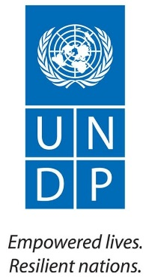

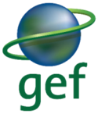

Country: Ethiopia
PROJECT DOCUMENT

Project Title: | Promoting Sustainable Rural Energy Technologies (RETs) for Household and Productive Uses
UNDAF Outcome(s): | Outcome 2: By 2016, private sector-led Ethiopian manufacturing and service industries, especially small- and medium-scale enterprises, have sustainably improved their competitiveness and employment creation potentials.  Outcome 5: By 2016, the governance systems, use of technologies and practices, and financing mechanisms that promote a low carbon climate resilient economy and society are improved at all levels
UNDP Strategic Plan Environment and Sustainable Development Primary Outcome:
Growth and development are inclusive and sustainable, incorporating productive capacities that create employment and livelihoods for the poor and excluded.

Expected CP Outcome(s): same as UNDAF outcomes.

Executing Entity/Implementing Partner: Ministry of Water, Irrigation and Energy (MoWIE)

Implementing Entity/Responsible Partners: Ministry of Water, Irrigation and Energy (MoWIE) and United Nations Capital Development Fund (Responsible Partner for Component 3)
Brief Description

This project complements the Ethiopian Energy Policy, the Ethiopian Climate Resilient Green Economy Strategy, the Initial National Communication of Ethiopia to the UNFCCC and the Sustainable Energy for All (SE4All) initiative. The project aims to reduce Ethiopia’s energy-related CO₂ emissions by approximately 2 million tonnes CO₂e by promoting renewable energy and low greenhouse gas (GHG)-producing technologies as a substitute for fossil fuels and non-sustainable biomass utilisation in the country, with a focus on rural household appliances for cooking, lighting and heating. The activities proposed in the project are designed to remove barriers that hamper the wide-scale use of off-grid renewable energy technologies in households and productive uses in rural areas of Ethiopia, where extending the grid is simply not feasible in the short-run and where the ability to pay for larger-scale solutions is often limited.

The project consists of four components and will be implemented over a period of five years.

Component 1: Strengthened Regulatory and Legal Framework based on National Standards
Component 2: Rural Public Awareness Campaign on Renewable Energy Technologies
Component 3: Sustainable Financial Mechanism (SFM) for RETs for rural households – UNCDF CleanStart
Component 4: Business Incubator to Promote Greater Entrepreneurship for Investment in RETs
This UNDP and MoWIE -implemented, GEF-financed project will seek to implement a more private sector-driven and market-based approach towards promoting renewable energy technologies in rural communities in Ethiopia. The four components consist of a combination of de-risking instruments (Component 1) and market-enabling activities (Component 2 and Component 4) that will combine together with a financial support mechanism (Component 3) to help transform the market for off-grid renewable energy technologies in rural communities.

The project budget consists of USD 4,091,781 of GEF grant funding, USD 900,000 from UNDP, USD 980,000 co-financing from UNCDF CleanStart global programme, and co-financing from the Government of Ethiopia (MoWIE, MoFED, FeMSEDA/EDP) of USD 35,179,954 as well as further co-financing from the Development Bank of Ethiopia with a loan of USD 20 million, HIVOS, SNV, ABPP (in-kind) USD 6,185,945 and RET Enterprises (in-kind and cash) USD 6,000,000.

Approximately 800,000 additional households (4 million people) will benefit from the project by being enabled to invest in approximately 200,000 small-scale solar PV products (about 2.5 MWp total capacity) and approximately 600,000 improved cook-stoves.

Programme Period: 2015-2020  Atlas Award ID: 00086749  Project ID: 00093964  PIMS # 5200  Start date: 07/2015  End Date: 06/2020  Management Arrangements NIM  LPAC Meeting Date 28/07/2015 |  |  | Total resources required: US$ 73,137,680  Total allocated resources: US$ 73,137,680  Regular UNDP: US$ 500,000  UNDP (in-kind): US$ 400,000  GEF: US$ 4,091,781  UNCDF CleanStart*: US$ 980,000  Co- finance:  Government (in-kind) US$ 17,688,667 Government (Grant) US$ 11,491,287  Private Sector (Investment) US$ 2,800,000  Private Sector (in-kind) US$ 3,000,000  Others  DBE (loan) US$ 20,000,000  HIVOS, SNV, ABPP (in-kind) US$ 6,185,945  RET Enterprises (in-kind and cash) US$ 6,000,000

_______________________________
Note: * Parallel grant funding from the UNCDF CleanStart global project that will be implemented under the DIM modality to support Component # 3 of the project to leverage additional financing from financial institutions.

Agreed by (Government): MoFED
Date/Month/Year

Agreed by (Executing Entity/Implementing Partner): MoWIE
Date/Month/Year

Agreed by (Responsible Party for component # 3): DBE
Date/Month/Year

Agreed by (UNDP):
Date/Month/Year

Table of Contents
Table of Contents 4
Definitions 5
Section I: Elaboration of the Narrative 8
Part I: Situation Analysis 8
I. Context and Global Significance 8
II. Threats, Root Causes and Impacts 15
III. Long-Term Solution and Barriers to Achieving the Solution 18
IV. Stakeholder Analysis 22
V. Baseline Analysis 32
Part II: Strategy 36
I. Project Rationale and Policy Conformity 36
II. Project Goal, Objective, Outcomes and Outputs/Activities 40
III. Indicators and Risks 61
IV. Cost-Effectiveness 63
V. Country Ownership: Country Eligibility and Country Drivenness 65
VI. Project Consistency with National Priorities and Plans 66
VII. Innovativeness, Sustainability and Replicability 66
Part III: Management Arrangements 69
I. Project Implementation Arrangements 69
II. Financial and Other Procedures 74
III. Audit Clause 74
Part IV: Monitoring Framework and Evaluation 75
I. Monitoring and Reporting 75
Part V: Legal Context 79
Section II: Project Results Framework 80
Section III: Total budget and work plan 85
Section IV: Additional Information 91
List of References 91
List of Tables 93
List of Figures 93
List of internal Annexes 94
Annex 1: Additional Stakeholder Analysis 95
Annex 2: Analysis of financial service providers 99
Annex 3: Current status of standards and regulations 105
Annex 4: Calculation of GHG Emission Reductions 107
Annex 5: Key Features for Terms of Reference of Key Project Personnel 112
Annex 6: UNDP Environmental and Social Screening 114
Annex 7: Co-Finance Letters…………………………………………………………………………………………………………………………… 121
Annex 8: Letter of Agreement between UNDP and the Ministry of Water, Irrigation and Energy………………………… 130
Annex 9: Letter of Endorsement from GEF Operational Focal Point…………………………………………………………………… 13
3

Definitions
Project refers to the UNDP-implemented, GEF-financed project, “Promoting Sustainable Rural Energy Technologies (RETs) for Household and Productive Uses”, unless another specific project is mentioned in context.

Improved cook-stoves (ICS) are fuel-efficient stoves using solid biomass.

Small-scale solar technologies are mainly solar lanterns with or without mobile phone charger (typically 4-8 Wp), micro-solar home systems with one or more detached LED lamps and mobile phone chargers operating at low voltage (e.g. 5 or 12 V, typically 5 to 20 Wp), and solar home systems with voltage inverter to run common appliances (e.g. 240 V, up to 200 Wp).

Rural Energy Technologies (RETs) consist of improved cook-stoves and small-scale solar technologies, although cook-stoves operating on biogas or biofuels and other solar applications such as solar stoves, solar cookers and solar water pumping are also included, especially in the context of technology providers and financing mechanisms.

RET enterprises are micro-, small- and medium-scale enterprises that are producing, assembling, distributing, importing, installing, servicing or in any other way conducting business with RETs. Individual entrepreneurs are covered by the definition of micro-enterprises having less than 5 employees.

Abbreviations
AAIT Addis Ababa Institute of Technology
ADC Austrian Development Cooperation
AEMFI Association of Ethiopian Micro-Finance Institutions
AETDPD Alternative Energy Technology Development and Promotion Directorate
APR Annual Project Review
AWP Annual Work Plan
BFDCD Bio-Fuel Development Coordination Directorate (MoWIE)
BIU Business Incubation Unit
CAGR Compound annual growth rate
CO Country Office (UNDP)
CRGE Climate-Resilient Green Economy
DA Development Agent
DBE Development Bank of Ethiopia
DCA Development Credit Authority
DFID Department for International Development
ECAE Ethiopian Conformity Assessment Enterprise
ECIC Ethiopia Climate Innovation Centre
ECO Energy Coordination Office
EDC Entrepreneurship Development Centre
EDP Entrepreneurship Development Programme
EEA Ethiopian Energy Authority
EIAR Ethiopian Institute for Agricultural Research
EnDev Energising Development
ENREP Electricity Network Reinforcement and Expansion Project
EOI Expression of Interest
EPC Engineering-Procurement-Construction
EREB Ethiopian Rural Electrification Board
EREDPC Ethiopian Rural Energy Development and Promotion Centre (now AETDPD)
ESA Ethiopian Standards Agency
EU European Union
FeMSEDA Federal Micro and Small Enterprises Development Agency
FfE Forum for Environment
FSP Financial Service Provider
GEF Global Environment Facility
GGGI Global Green Growth Institute
GHG Greenhouse Gas
GIZ Deutsche Gesellschaft für Internationale Zusammenarbeit
GoE Government of Ethiopia
GTP Growth and Transformation Plan
HoA-REC/N Horn of Africa Regional Environment Centre and Network
IA Implementing Agency
IAP Indoor Air Pollution
IBRD International Bank for Reconstruction and Development
ICS Improved cook-stoves
IDA International Development Association
IFC International Finance Corporation
IMF International Monetary Fund
infoDev Information for Development Programme
KfW Kreditanstalt für Wiederaufbau (German Development Bank)
LA Lighting Africa
LA-E Lighting Africa - Ethiopia
LC Letter of Credit
LED Local Economic Development (project)
M&E Monitoring and Evaluation
MDG Millennium Development Goal
MEF Ministry of Environment and Forest
MFI Micro-Finance Institution
MIS Management Information System
MoA Ministry of Agriculture
MoFED Ministry of Finance and Economic Development
MoST Ministry of Science and Technology
MoT Ministry of Trade
MoUDHCo Ministry of Urban Development, Housing and Construction
MoWIE Ministry of Water, Irrigation and Energy
MoWUD Ministry of Works and Urban Development
MSE Micro and Small Enterprise
MSME Micro, Small and Medium Enterprise
NAMA Nationally Appropriate Mitigation Action
NBE National Bank of Ethiopia
NBPE National Biogas Programme of Ethiopia
NCS National Council of Standards
NDBP National Domestic Biogas Programme (equivalent to NBPE)
NICSP National Improved Cook-Stoves Programme
NIM National Implementation Modality
NPA Non-Performing Asset
OCSSCO Oromia Credit and Saving Share Company
PAA Project Administrative Assistant
PBA Performance-Based Agreement
PIF Project Identification Form (GEF)
PIR Project Implementation Report
PM Project Manager
PPR Project Progress Report
PSC Project Steering Committee
PV Photovoltaic
RBF Results-Based Financing
RBM Results-Based Management
RCU Regional Coordinating Unit (UNDP)
REDD Reducing Emissions from Deforestation and forest Degradation
REEEP Renewable Energy and Energy Efficiency Partnership
REF Rural Electrification Fund
ReMSEDA Regional Micro and Small Enterprise Agency
RET Rural Energy Technology
RFP Request for Proposal
RSC Regional Service Centre (UNDP)
SACCO Savings and Credit Co-Operative
SBAA Standard Basic Assistance Agreement
SE4All Sustainable Energy for All
SEDA-E Solar Energy Development Association - Ethiopia
SEF Solar Energy Foundation
SFM Sustainable Financial Mechanism
SHS Solar Home System
SLA Service Level Agreement
SNNP Southern Nations, Nationalities and Peoples’ Region
SNV Stichting Nederlandse Vrijwilligers (Netherlands Development Organisation)
SREP Scaling-Up Renewable Energy Programme
TBWP Total Budget Work Plan
TC Technical Committee
TVET Technical Vocational Education Training
UNCDF United Nations Capital Development Fund
UNDP United Nations Development Programme
WB World Bank
WFP World Food Programme
WMS Welfare Monitoring Survey
WV World Vision Ethiopia

Units
Mt Megatonnes = million (metric) tonnes, 1 tonne = 1,000 kg
Wh Watt-hours
W Watt
Wp Watt peak, for PV only

Currencies
USD United States Dollar, 1 USD = 20 ETB
ETB Ethiopian Birr, 1 ETB = 0.05 USD = 0.04 EUR
EUR Euro, 1 EUR = 1.3 USD = 25 ETB

Section I: Elaboration of the Narrative

Part I: Situation Analysis

Context and Global Significance

Geographical Setting
Ethiopia is a land-locked country in East Africa with a population of nearly 88 million in 2014 [1], growing at a rate of 2.9 % annually. Ethiopia's population is predicted to exceed 120 million by 2025, with the median age under 20.
With an area of 1.1 million square km, Ethiopia is the largest country by area (and population) in East Africa and the second largest country by population in Sub-Saharan Africa after Nigeria. Its population is a diverse mix of over 80 different ethnic groups, speaking over 90 different languages, although English is widely understood and spoken and Amharic is recognised as the official working language of the Federal Government. Oromia (~33 million), Amhara (~20 million), and Southern Nations (SNNP, ~18 million), together with the City of Addis Ababa (~3.2 million), are the most densely populated regions of the country.

Table 1: Overview over the regions of Ethiopia
Region or city | Area (km²) | Population  July 2012 estimate | Categorisation of the region¹
Addis Ababa | 526 | 3,041,002
Afar | 72,052 | 1,602,995 | Emerging
Amhara | 154,708 | 18,866,002 | Major
Benishangul-Gumuz | 50,698 | 982,004 | Emerging
Dire Dawa | 1,558 | 387,000
Gambela | 29,782 | 385,997 | Emerging
Harari | 333 | 210,000
Oromia | 284,538 | 31,294,992 | Major
Somali | 279,252 | 5,148,989 | Emerging
SNNP² | 105,887 | 17,359,008 | Major
Special enumerated zones |  | 112,999
Tigray | 41,410 | 4,929,999 | Major
Totals | 1,127,127 | 84,320,987
(1) Widely-used categorisation of the regions in the country.
(2) SNNP - Southern Nations, Nationalities and Peoples’ Region

Figure 1: Map of Ethiopia featuring the regions and major cities.
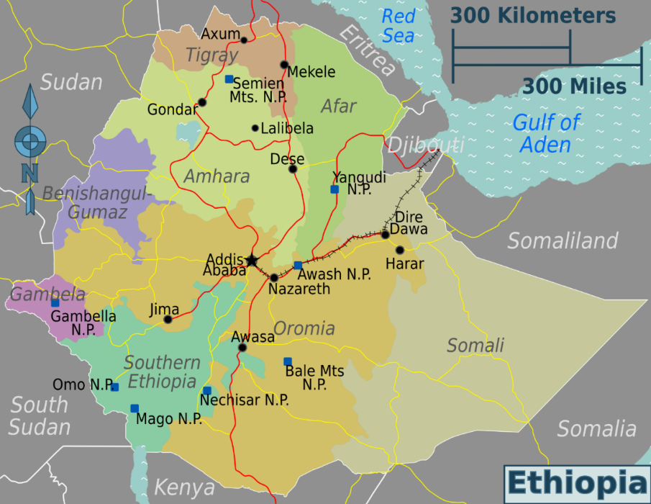

The Ethiopian economy is primarily agriculture-based, with this sector contributing 40% of the country’s GDP and accounting for 80% of employment. The major food crops grown are teff, wheat, maize, barely and sorghum. Coffee is a major export crop, with other important export products including gold, seeds, chat, flowers, live animals, pulses, leather and leather products, meat and meat products, fruits and vegetables.

The nominal GDP is USD 51 billion and GDP per capita of USD 570 in 2014 [2]. However, Ethiopia has experienced rapid economic growth over the last decade, achieving an average growth rate of about 11% between 2005 and 2013 and is one of the top 10 fastest growing economies in the world in 2014. [3] The rural Ethiopian average monthly income is estimated at USD 115 as of 2012, which is less than USD 1 per day per person. The Government of Ethiopia is committed to making Ethiopia a middle-income country with per capita income of at least USD 1,125 per person by the year 2025.

Institutional Setting
The Federal Democratic Republic of Ethiopia is composed of nine national regional states and two administrative states (Addis Ababa City administration and Dire Dawa City Council). The national regional states, as well as the two city administrative councils, are further sub-divided into 68 zones, and the zones are sub-divided into approximately 550 Woredas. A Woreda is managed by a local government and is equivalent to a district. The Woredas are composed of the smallest unit of local government, the 15,000 Kebeles (5,000 urban and 10,000 rural). Kebele is Amharic for neighbourhood, and can be considered as such. Each Kebele consists of at least five hundred families or households.

Development efforts
Rapid economic growth in the last decade has brought many benefits to the country. The share of population living in extreme poverty has fallen from 38.7% in 2004-05 to 29.6% in 2009-10. The Government’s Growth and Transformation Plan (GTP) aims to further reduce extreme poverty rate to 22.2% by 2014-15. [4] The country has also improved many of its human development indicators – it has already achieved its Millennium Development Goal (MDG) target for the child mortality rate and is on course to achieve MDG targets for gender parity in primary education, HIV/AIDS and malaria. Good progress has also been made in achieving universal primary education [4]. Nonetheless, economic growth and socio-economic indicators vary widely from region to region in Ethiopia. Oromia, Amhara and Tigray regions and the city of Addis Ababa have higher socio-economic development levels, whereas the regions of Benishangul-Gumuz, Gambela, Afar and Somali, collectively known as the ‘emerging regions’, lag behind other regions in socio-economic development.

Nevertheless, despite recent progress, Ethiopia’s human development levels remain low by global standards and significant progress still needs to be made. The GTP aims to ensure continued rapid economic growth, increased agricultural output to boost food security and exports, a greater contribution of the industrial sector to the country’s GDP, and development of infrastructure such as power, roads and railway lines to support the economy [4].

Policy and Legislative context
In 1994, a National Energy Policy was adopted in Ethiopia. A recent draft of the updated Energy Policy from February 2013 states that the principal goal is to ensure the availability, accessibility, affordability, safety and reliability of energy services to support accelerated and sustainable social and economic development and transformation of the country. The draft Energy Policy [5] seeks to meet the following broad objectives:

- Improve the security and reliability of energy supply and allow Ethiopia to become a regional hub for renewable energy.
- Increase access to affordable modern energy.
- Promote efficient, cleaner and appropriate energy technologies and conservation measures.
- Strengthen energy sector governance and build strong energy institutions.
- Ensure environmental and social safety and sustainability of energy supply and utilisation.
- Strengthen energy sector financing.

While the principal goal of the updated national Energy Policy is to promote and support expansion of the electricity grid, there is also an emphasis on promoting small-scale renewable energy technologies and improved cook-stoves for rural household use.

The Ethiopia Growth and Transformation Plan (GTP) from November 2010 [6] sets out a strategy for 2010-2015 that aims to increase electricity production for domestic uses and for export; build capacity of the implementing agencies; and promote programmes focused on rural areas, including cooking fuels and small-scale systems. The plan envisages dissemination of 3.15 million solar home systems and 9 million improved cook-stoves. The private sector is given the leading role to achieve these goals. As with the earlier Electricity Proclamation (1997), the GTP is, however, focused principally on large-scale hydropower and wind generation as well as improvements in grid infrastructure.

Since February 2011, the Climate-Resilient Green Economy (CRGE) initiative, under the leadership of the Prime Minister’s Office, the Environmental Protection Authority (now the Ministry of Environment and Forest) and the Ethiopian Development Research Institute, has been developing a strategy to build a green economy. The CRGE initiative aims to protect the country from the adverse effects of climate change and to build a green economy that will help realise Ethiopia’s ambition of reaching middle-income status before 2025. One of the pillars of the CRGE initiative focuses on expanding electricity generation from renewable sources of energy as well as investments in rural energy-efficient cook-stoves.

The CRGE initiative follows a sectoral approach and has so far identified and prioritised more than 60 initiatives that could help the country achieve its development goals while limiting 2030 greenhouse gas (GHG) emissions to around today’s 150 Mt CO₂e – approximately 250 Mt CO₂e less than anticipated under a conventional development path. The green economy plan is based on four pillars:

- Improving crop and livestock production practices for greater food security and farmer income while reducing emissions
- Protecting and re-establishing forests for their economic and ecosystem services, including as carbon stocks
- Expanding electricity generation from renewable sources of energy for domestic and regional markets
- Leapfrogging to modern and energy-efficient technologies in transport, industrial sectors and buildings.

The greenhouse mitigation actions proposed in the CRGE strategy [7] are mostly energy-related and include the scale-up of energy efficient cook-stoves (abatement potential of 34.3 Mt CO₂e annually), increased use of renewable energy sources and displacement of fossil fuels. In this regard, wide-scale dissemination of solar lanterns and solar PV systems in off-grid areas will displace kerosene use for lighting.

Although some progress has been made towards these goals significant challenges remain, particularly in the areas of consumer awareness, private sector engagement and market development.

The Science, Technology and Innovation (STI) policy [8] of the Government accords precedence to local manufacture or assembly of products, including RETs (solar PV assembly and wind power component production, for example, are now underway).

Grid Access
Believing in the importance of electricity as a driver of the rural economy, the Ethiopian Government issued the Rural Electrification Strategy (RES) in 2002 with the overall goal of stimulating rural economic growth and poverty reduction. In line with the RES, a twin-track rural electrification strategy has been developed to increase access to electricity in rural parts of the country. The power utility, Ethiopian Electric Power Corporation (EEPCO), has an ambitious grid extension plan to electrify major towns and villages.

Institutionally, Ethiopia has moved from a vertically-integrated monopoly towards a diversified entity that ensures transmission and distribution and allows for private generation. EEPCO is mandated to encourage private investment in the energy sector and relevant laws were enacted in 2005 and 2007. Private sector power purchase agreements (PPAs) are negotiated with EEPCO. Independent Power Producers (IPPs) are encouraged to supply power through the Electricity Operations Regulations (49/1999) and the Investment proclamation (280/2004) [9].

In recent years of GTP implementation, the total length of power transmission lines was planned to increase from 11,440 km in 2009/10 to 15,120 km in 2012/13 by constructing 3,680 km of additional lines. The actual accomplishment was 1,385 km (37.6%) and, accordingly, the total power transmission line capacity increased to 12,825 km in 2012/13. In spite of these investments, electricity interruptions and fluctuations remain a serious challenge [10].

According to the most recent national statistics, 3.7 million households in Ethiopia were using grid electricity for lighting in 2011 (WMS, CSA, 2012). The electrification level is 23% nationally – 88% in urban areas but only 5% in rural areas. The 3.7 million electricity connections reported in the Welfare Monitoring Survey (WMS) contrasts with the Ethiopian Electric Power Corporation’s domestic customer total of only 1.65 million in 2011. The difference is explained by meter sharing – the WMS indicates that, for every two power utility customers connected through meters, there were 3 additional households sharing meters with them.

In 2010, about 41% of the Kebeles were electrified, with about one-quarter of the households (23%) within the Kebeles having a connection. According to the WMS, 1.86 million households shifted from using kerosene to using electricity or electrical batteries between 2006 and 2011: 1.45 million switched from kerosene to electrical batteries while 0.41 million shifted to electricity. The four largest regions (Oromia, Amhara, SNNP and Tigray) accounted for 95% of this shift away from kerosene.

Power supply reliability for domestic customers already online, in terms of uninterrupted and consistent quality electricity, appears to have worsened in the past five years. According to the WMS survey in 2011, more than 85% of households reported having suffered power interruptions at least once in the previous week and more than 50% reported having suffered power interruptions 3 or more times.

Power blackouts have increased in frequency and depth, not only because of supply constraints (generation and transmission capacity shortfalls) but also due to limited distribution infrastructure capability to meet rapidly increasing connections and demand levels. Electricity sales to domestic consumers actually fell in 2008 and 2010 compared with previous years, despite an increase in the number of customers. Power blackouts were, and still are, common in all the major cities. Power blackouts often occur during peak hours (in the evening for domestic customers) and usually last 4 to 6 hours.

As a consequence of blackouts, customers on the grid have adopted a range of back-up lighting solutions. The more common mitigation strategies include:

- Candles, which cost ETB 3-4 (USD 0.16 – USD 0.21) each, and last 3 to 4 hours;
- Dry cell battery-operated hand torches (flashlights), which cost approximately ETB 25 (USD 1.32) for the torch and ETB 10 (USD 0.53) for the D-type dry cell batteries used; and
- Mains-charged LED lamps, which range in cost from ETB 40 (USD2.11) to ETB 80 (USD 4.21).

Rural Energy Access
Rural residential cooking and baking are a major driver of rural energy demand, accounting for 72% of rural energy use, 88% of which is generated by fuel-wood. Rural energy technologies (RETs) have been promoted in Ethiopia for thirty years by many different national and international stakeholders as well as activities by public, private-sector and non-profit organisations. As one of the leading initiatives of the Government of Ethiopia, the Rural Electrification Fund (REF) is described in Box 1.1.

Starting from the late 1980s, RETs were introduced with pilot projects for both biomass and solar technologies; between 1996 and 2003, improved cook-stoves (ICS) – notably the Lakech charcoal stove and the Mirt Injera stove – became fully commercial in urban areas; from 2003 onwards, when the Rural Electrification Fund was established (see Box 1.1 below), efforts went into promoting both improved cook-stoves (e.g. the promotion of Gunzie stoves) and solar home systems (SHS) in rural areas. The past five years have seen very rapid take-up of ICS and SHS in rural areas, with several hundred thousand units sold annually [10] [11]. Despite the accelerating RET dissemination rate, there is still a significant gap between RET supply and potential RET demand due to the growing number of households and rising incomes. Assuming a distribution rate of ICS and SHS of approximately 0.3 million per annum each and population growth of 2.5% (and thus an increase in the number of rural households of approximately 0.3 million/year), the current dissemination rates are barely able to cover just the population increase.

There is a rural energy policy framework that aims to support the expansion of renewable energy. However, support for private sector engagement and the creation of incentives for small and medium enterprises to thrive are still limited in Ethiopia.

Improvements in socio-economic, institutional, technological and market conditions have contributed to recent successes in the dissemination of rural energy technologies, including:

- A fast-growing economy with rising rural incomes, and an observed willingness and capacity of rural households to pay high prices for RETs;
- Growing access to communication services, which makes it easier to communicate messages to consumers;
- Improving educational levels, which are an important determinant of new technology adoption in rural areas;
- Increasing human resource availability at district and sub-district level for sector offices (energy, environment) and extension workers (agriculture, health);
- Integration of some RETs in sector programmes (e.g. ICS in the health sector);
- Increased availability of financing for consumers, suppliers and promoters through donor support and financing institutions (micro-finance institutions, but also commercial and development banks);
- Worsening access to traditional sources of energy (receding and deteriorating access to biomass fuels, rising prices for cooking and lighting fuels);
- Increasing competitiveness of RETs with traditional alternatives (availability of more appropriate RET designs, cost reductions of RETs);
- Growing capability of RET enterprises, including growing links with large importers/suppliers to rural retailers/installers.

Box 1 - Case Study: The Rural Electrification Fund
The Rural Electrification Strategy (RES) was the basis for the creation of the Rural Electrification Fund (REF). Proclamation 317/2003 established the REF “to provide loan and technical services for Rural Electrification Projects carried out by private operators, cooperatives and local communities and more specifically for those projects operating on renewable energy sources.” [12]

The Rural Electrification Fund (REF) is a permanent financial resource of the Government of Ethiopia and is administered by the Alternative Energy Technology Development and Promotion Directorate (AETDPD) of the Ministry of Water, Irrigation and Energy (MoWIE), with the Development Bank of Ethiopia (DBE) serving as a trust agent.

Although the REF was established mainly as a private sector-led, off-grid rural electrification programme, its support has mostly gone to Energy Service Co-operatives rather than to private businesses. The REF requires rural consumers to be organised in the form of co-operatives, unions or associations to present their requests for lighting services through the Woreda and Regional Energy Bureaus. These co-operatives receive a loan for 95% of the SHS cost they receive, which they pay over 7 years. MoWIE and the regional energy bureaus provide technical support and facilitate the loan process between the loan provider (DBE) and private operators (service providers) and co-operatives (users). Five hundred graduates from technical vocational training schools received special training to serve as micro-technicians in the regions. Procurement of systems is undertaken by MoWIE through international tenders. The REF has issued five international tenders for SHS in the past 10 years, with local PV companies participating in the installation of systems.

By 2011, over 15,000 SHS (mostly 8, 10, 20 Wp, up to 130 Wp) and more than 900 institutional PV systems (400 Wp) for rural health institutions and schools had been installed. In 2012 and 2013, the REF commissioned the procurement and installation of 28,000 SHS from an international supplier. The REF strategic plan for 2015 indicates dissemination of 150,000 SHS, 3,000 institutional solar PV systems and 300 solar pumps. The REF also plans to disseminate 3 million solar lanterns in rural areas of the country. The required investment outlay to achieve the anticipated targets is over USD 50 million [13].

The REF has experienced some significant delivery challenges. The REF’s contribution to overcoming the main challenges and barriers to the wide-scale commercial dissemination of solar lanterns and solar PV systems has been limited by the following factors:

  - The project-based approach that the REF pursued involved single, large-scale tender based procurements as opposed to a continuous supply of solar lighting products;
  - The REF was not able to persuade local banks to lend to RE product and service providers;
  - Sufficient capital and financing were not available for local private companies to respond to the large tenders, with the result that their involvement was limited;
  - The REF did not help to establish market links between the importers (located mainly in Addis Ababa) and distributors/installers located in rural areas;
  - For each project, a different international producer supplied solar lighting products, having no interest in developing the local market for a sustainable business;
  - Maintenance and availability of spare parts became a problem;
  - Public awareness – the REF has made limited efforts to promote the benefits of solar and other off-grid systems. Thus, the dissemination strategy applied by the REF did not help to build a sustainable commercial network for solar lighting products.

Global Significance
Fuel wood consumption, including charcoal, branches, leaves and twigs, is the single largest source of GHG emissions in Ethiopia. In 2010, this source caused nearly 17% of Ethiopia’s GHG emissions. According to the country’s First National Communication to the UNFCCC (2001), the GHG emissions from biomass use were at a level of about 56 Mt CO₂e (reference value for 1995) [14]. Under the more recent BAU scenario of the CRGE Strategy, emissions from forestry will increase from 53 Mt CO₂e in 2010 to 88 Mt CO₂e in 2030 (See Figure 2).

Figure 2: Level of GHG emissions from the forestry sector in a business-as-usual scenario up to 2030. [7]

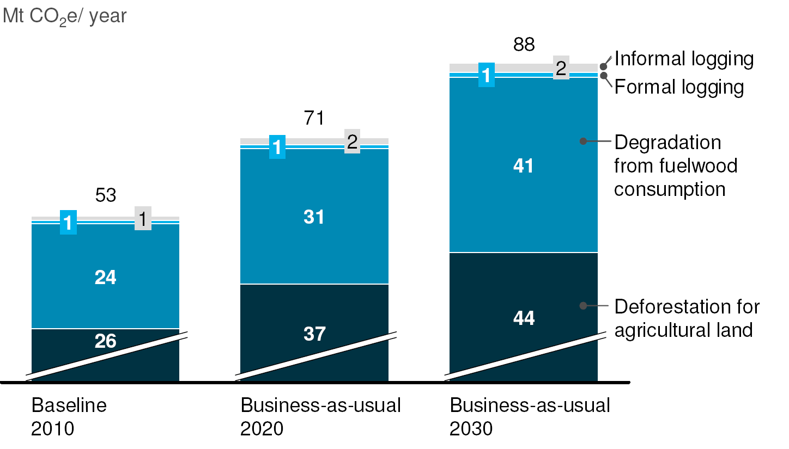

Of the 15 initiatives accorded priority as part of Ethiopia’s CRGE strategy, shifting to fuel wood-efficient or alternative-fuel stoves − Improved Cook-Stoves (ICS) − offers the highest overall potential to reduce GHG emissions: an estimated 34 Mt CO₂e (fuel wood-efficient stoves only) and as much as 51 Mt annually by 2030 when alternative-fuel stoves and fuel wood from regenerated plantations are included, equivalent to about 20% of Ethiopia’s projected total abatement potential. Accordingly, the scale-up of fuel wood-efficient stoves in rural areas is the most important lever to minimise Ethiopia’s GHG emissions and will deliver 65% of the total CO₂e mitigation potential from improved stoves in 2030. Capturing this abatement potential requires the switch of more than 20 million households to more efficient stoves.

Figure 3: Key assumptions taken to project the abatement potential in each sector for the CRGE Strategy [7].
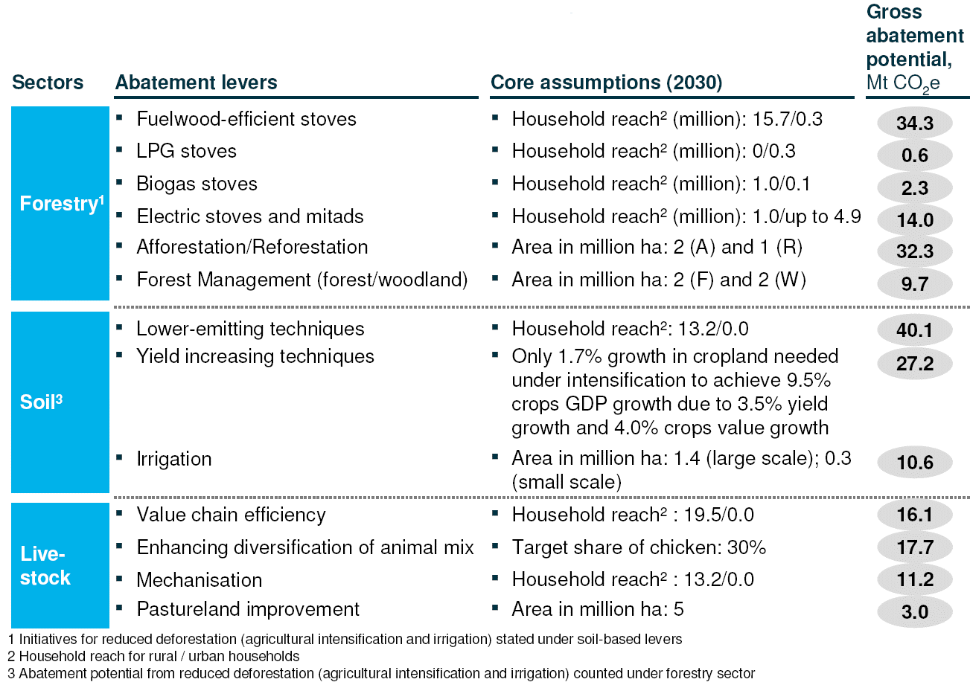

According to a recent market study [15], the off-grid rural household lighting market in Ethiopia is large. Total annual expenditure is estimated at approximately ETB 6,300 million (USD 331 million), of which about three-quarters is spent on kerosene and the remainder on dry cell batteries. Based on the current price of kerosene, it is estimated that over 235 million litres (or 180,000 tonnes) are used each year for lighting by rural households. With an equivalent of 2.5 kg CO₂/litre of kerosene, this equates to emissions of 0.6 Mt of CO₂e per year.

The annual number of dry cell batteries consumed and disposed of by rural households is estimated to be approximately 278 million D-type batteries. This is equivalent to over 25,000 tonnes of batteries, or around 0.1 Mt CO₂e per year from battery production [16].

Threats, Root Causes and Impacts

The Government of the Federal Democratic Republic of Ethiopia has a vision to achieve middle-income status by 2025 and to create a climate-resilient green economy with zero net carbon emissions. In order to meet this challenge, the country needs to reach its economic goals in a sustainable manner, which includes increased levels of access to modern energy.

With this context in mind, the root causes of lack of energy access in Ethiopia lie in the following main areas:

- Energy poverty. Overall electricity consumption in Ethiopia is estimated to be 91 kWh/person – a low level compared with the Sub-Saharan African average of 521 kWh/person. Despite progress over the last 10 years, only 23% of Ethiopians have direct access or “connectivity” to electricity services (with a very large divergence between urban and rural areas, the latter having a rate of only 5% electricity connections).

- Over-exploitation of solid biomass resources. Domestic energy requirements in rural and urban areas are mostly met from wood, charcoal, animal dung and agricultural residues. These domestic energy requirements contribute to increased deforestation and loss of soil nutrients and land degradation. Overall household energy use in 2009 was almost entirely provided by biomass (98.65%), whereas electricity and petroleum products (mainly kerosene) accounted for only 1.35% of total household consumption [17]. In urban areas, access to petroleum fuels and electricity has enabled a significant proportion of the population to employ these sources for cooking and other domestic energy requirements. But, even in these urban areas, half the households still rely on traditional biomass (wood, dung and agricultural residues) for cooking, whereas in rural areas virtually all households depend on biomass including charcoal (except for 1.4% who use kerosene). Hence, the lack of access to modern energy services leads to traditional biomass use, and biomass use in turn leads to unsustainable environmental harm and use of very inefficient traditional cook-stoves (with energy efficiency levels of approximately 10%).

- However, there is an abundance of diversified renewable energy sources, particularly hydroelectric, geothermal, wind and solar primary energy.

- Very limited measures have been implemented to date to improve energy efficiency. Imports of incandescent lamps were banned in 2010 (and some 11.5 million Compact Fluorescent Lamps were distributed), but there remains a large potential to increase the use of efficient equipment (lighting, household appliances in general) and access to improved RETs (such as ICS or SHS).

- Very large financing needs. Energy absorbs a large part of the Government budget. To meet the Government’s economic and sector goals, access to financing would have to increase substantially, and private sector financing would need to be mobilised at a much higher level to develop grid-based (e.g. construction of new hydropower capacities) and off-grid energy access solutions, which would provide a source of demand for RETs to emerge and investments by local manufacturers/suppliers and households to be triggered.

- Very limited role for the private sector so far, limited to the import and distribution of small energy appliances, the distribution of petroleum products and as EPC contractors for EEPCo. Negotiations are, however, underway with private investors for large geothermal plants along the Ethiopian Rift Valley.

- Insufficient institutional and human capacity for planning and implementation in a sector characterised by rapid growth and transformation (transitioning from traditional energies to modern energies), and different and fast-evolving energy technologies.

The following are considered the key threats of, and impacts on, climate change:

- Ethiopia faces rapidly-growing demand for energy and an unsustainable rate of fuel wood consumption. Ethiopia‘s energy consumption is predominantly based on biomass energy sources (94%). This includes fuel wood, charcoal, branches, leaves and twigs. Charcoal is currently made, sold, transported and used as a major source of fuel in rural areas despite a recent Government ban on its use. The prevalence of charcoal sales along roadsides indicates that enforcement of this ban is weak.

- The rate of deforestation and degradation is expected to worsen over the coming decades, as the population grows at 2-3% per year. Firewood consumption is expected to increase in the same proportion, by at least 2-3% per year. Unsustainable fuel wood consumption prevents forests from regenerating and leads to increased vulnerability to climate change. Although the Ethiopian Government has recently started aggressive soil conservation and reforestation efforts, these measures will not stop the problem of widespread clear-cutting of forested land without any controls or restrictions in place. Figure 4 below shows the “hot spots” in terms of wood deficits occurring at Woreda level (marked red) and those areas marked green where there is a positive and sustainable wood supply.

Figure 4: “Hot Spot” Wood Deficit Woredas and Positive Sustainable Wood Supply Woredas [18].
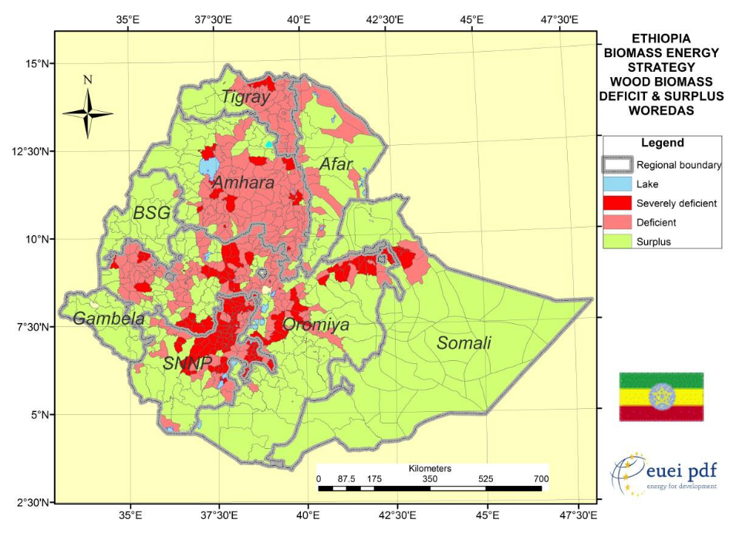

- With regard to electricity generation, renewable energy in Ethiopia has focused on large-scale hydropower. However, much of the small-scale hydropower, solar and wind potential in Ethiopia has yet to be developed. The present energy mix greatly increases vulnerability to climate change and the poorest segment of the population is the most vulnerable. For example, reliance on fuel wood and charcoal brings widespread land degradation, exposing bare soil to erosive rainfall and gulley erosion. The power generation sector accounts for very low GHG emissions (less than 3% of total national GHG emissions) as large hydropower accounts for over 90% of total power generation capacity in Ethiopia. Ethiopia’s hydropower capacity is vulnerable to anticipated climate change, notably fluctuations in rainfall, temperature and evaporation. For example, reduced power production during drought years already takes a significant toll on the economy, since productivity is lost due to power interruptions. A World Bank study estimates that a one-day power outage reduces GDP by 10-15% on that day [19].

- Kerosene as a household fuel contains benzene and other aromatics that are dangerous carcinogens and environmental hazards. Most kerosene stoves in the Ethiopian market are cheaply-made stoves with low efficiencies (<35%) which also result in higher greenhouse gas emissions. The retail price of kerosene has increased by 210% in the past three years, and is likely to continue to increase in price..

- Although affordability remains a big problem, small-scale renewable energy technologies offer the opportunity to reduce greenhouse gas emissions while at the same time providing for the basic energy needs of rural communities. Essential rural energy needs such as hot water, cooking and lighting can all benefit from the introduction and dissemination of renewable energy technologies in a sustainable manner.

- However, due to a lack of awareness, the additional costs involved and the limited ability of local communities to pay, the application of more efficient appliances is severely limited. The numbers of renewable energy technologies currently in use – such as solar lamps, solar hot water systems, solar cookers or improved cook-stoves based on ethanol/biogas – are very small. However, their potential, given that over 70 million people in Ethiopia lack access to modern energy services, is significant.

- In many parts of the country, extending the grid is simply not practical due to the costs involved. Solar lanterns offer a low-cost, fully renewable alternative to the burning of wood or charcoal, as do small-scale, off-grid solar PV systems. Yet the use of solar PV systems remains very low due to lack of appropriate financing mechanisms, which make the technology essentially unaffordable to the majority of the rural population. Solar PV systems are expensive compared to other RETs, costing at least USD 750 for a small unit and rural populations typically cannot afford solar power without proper financing means or donor funding (which brings into question the sustainability of such initiatives). Supporting private sector engagement in the supply and distribution of solar technologies and enabling households to access RETs will reduce the use of low-quality biomass or kerosene applications and thus lessen the environmental harm in the country.

- The vulnerability of Ethiopia’s economy to climate change, combined with its plans to achieve accelerated and green growth, demand significant investment in mitigation and adaptation: 7-8% of Ethiopia’s economy is affected by climate change and maintaining the targeted baseline 11% annual economic growth rate will require an investment of USD 1.2-1.5 billion per annum in mitigation and adaptation [20]. There is a need to enhance Government capabilities in policy and institutional frameworks, and to provide sufficient means to increase access to private-sector financing to navigate the complex task of leveraging emerging opportunities associated with climate change.

- The country registered double-digit annual economic growth rate during the decade up to 2012, and the International Monetary Fund expects Ethiopia to become one of the world’s fastest growing countries over the coming years. However, a number of significant market barriers associated with low (or no) returns on investment, high up-front costs and lack of access to capital, high risks and non-financial barriers (e.g. lack of information and capacity) make it difficult to attract investment that increases access to modern energy while creating new economic opportunities (refer to further details described in the Barrier Analysis – section III). As a result, small-scale renewable energy solutions have not taken off in rural areas in Ethiopia.

Long-Term Solution and Barriers to Achieving the Solution

Currently, a range of initiatives led by the Government seek to increase energy access and enhance climate resilience. Nonetheless, Ethiopia’s energy policy is still in its early stages of preparation (the final draft is out for review and may be finalised in 2015) and implementation.

The country faces four principal barriers that prevent the widespread dissemination of small-scale renewable energy technologies and that will be addressed by the UNDP-implemented, GEF-financed project. They are as follows:

Barrier 1 – Need for Strengthened National Regulatory and Legal Framework for Rural Renewable Energy in Ethiopia
A key issue concerning the National Energy Policy of Ethiopia is that there is no authority or agency responsible for introducing rural energy initiatives other than for expanded grid electricity and petroleum products. In addition, the Climate Resilient Green Economy (CRGE) strategy for Ethiopia is mainly focused on expanding utility-scale electricity generation and extending the grid.

There is no national regulatory and legislative framework for renewable energy for the rural sector and no incentives to specifically promote and encourage renewable energy for rural populations. In addition, there is no legislation or regulations currently enacted which provide up-to-date technical standards for small-scale renewable energy technologies or for improved cook-stoves. Development of standards for RETs is therefore vital and needs stronger emphasis by the Government.

The Rural Electrification Fund (REF) of MoWIE, with a capitalisation of under USD 2 million and limited capacity, does not have the ability to finance a large number of small-scale renewable energy projects. It is important to strengthen the institutional capacity of MoWIE’s Alternative Energy Technology Development and Promotion Directorate (AETDPD) and of the REF to promote small-scale renewable energy solutions to rural communities and to develop and enforce relevant policies and regulations.

Ensuring product quality is a key concern stressed by all relevant stakeholders (Ministries and Government agencies, development partners, RET enterprises). Stakeholders emphasise the central role that the Ethiopian Customs Service, importers, distributors and retailers must collectively play to ensure against poor-quality or inferior products reaching consumers and to strengthen the integrity of the market. Mis-labelling of imported products in particular has led to past product underperformance and failure in the marketplace. In turn, user disappointment has adversely affected consumers’ impressions of the technology and diminished their willingness-to-pay to acquire or replace faulty systems.

To address this challenge, the project will provide within its Component 1 technical assistance to the implementation of technical standards and regulations for rural energy technologies. Training packages for the roll-out and enforcement of product standards and conformity-testing will help to ensure that imports are correctly labelled, renewable energy components are treated consistently, and consumers receive quality products. Quality certification and labelling programmes – such as those being implemented by the World Bank and the International Finance Corporation’s (IFC) Lighting Africa initiative – will provide a best-practice approach for the Ethiopian market. Nevertheless, additional GEF support is required to review the development of technical standards and regulations and prepare a strategy for rolling them out to the market.

Barrier 2 – Lack of Public Awareness of the Benefits of low-cost renewable energy household appliances
There is a lack of awareness among rural populations in Ethiopia of the possibilities for gaining access to energy, including renewable energy. Public awareness campaigns have typically been targeted at urban areas and have neglected important gender-sensitive messages that recognise the important roles of women and female household heads in making purchase decisions; appliance manufacturers have also focused on urban populations, where the ability to pay for renewable energy technologies is higher. The lack of awareness is made more acute by the absence of appliances such as televisions and radios in some rural communities, making these advertising channels unavailable. Public awareness campaigns need to be carefully designed and targeted in order to best overcome these barriers. It is important for the campaigns to solicit feedback and comments from consumers, local governments and NGOs in order to better understand what is effective.

In addition, market actors, most notably solar lantern and solar home system providers, face lack of support in marketing and promotion of rural energy technologies. It is therefore important to involve the private sector in public awareness campaigns and marketing of specific RETs to communicate the benefits of these technologies to promoters and users. The UNDP-implemented, GEF-financed project allocates some USD 2 million of cash co-financing from the private sector under Component 2. These funds represent the marketing budgets of the enterprises and private companies that will be involved in project-supported large-scale public awareness campaigns.

Weekly markets are usually key entry-points to demonstrate technologies directly, gain exposure and help consumers become more acquainted and comfortable with products. A number of suppliers also emphasised during project preparation that farmers who are considered respected leaders in rural areas need to become key partners in helping suppliers and distributors increase awareness and interest in off-grid technologies.

The project’s Component 2 will address the issue of generally low awareness among rural households (equally considering the needs of women, men and children), lack of promotion of specific solar and cook-stove technologies, and their relevant role in providing access to clean and affordable energy at level of household and productive uses. It is thus expected that the uptake of small-scale rural energy technologies will grow significantly and thus market access of technology providers and local enterprises will be leveraged.

Barrier 3 – Lack of Affordability of Small-Scale Renewable Energy Solutions and lack of a Financial Support Mechanism to help accelerate the dissemination of household renewable energy appliances
Lack of affordability of household energy appliances among rural populations, where the majority of people earn less than USD 1 per day, is a significant issue. A financial support mechanism (e.g. performance grants, revolving fund, investment fund, micro-credit scheme, carbon finance, etc.) that would help to subsidise the cost of these appliances or provide households with access to credit is needed to enable them to make purchases that would normally simply not be affordable. The disappointing performance of the Rural Electrification Fund (REF) over the past ten years starkly demonstrates the difficulty of implementing a private sector approach in rural Ethiopia, where inability to pay is such a significant barrier. In addition, the development of business skills and small-scale entrepreneurship will help to ensure that solutions are sustainable.

A number of enterprises seeking to deploy small-scale, off-grid technologies emphasise that the lack of financing options is among the most significant barriers to project deployment. Thus, improving access to financing should be a top priority for enhancing off-grid electrification. The development and commercial banks’ collateral requirements, relatively high interest rates and short payback periods have hitherto rendered these options prohibitive. Further, lenders’ lack of familiarity with rural energy technologies, among both commercial and micro-finance institutions (MFIs), has increased the perceived risk of these projects and limited lending to the nascent sector. MFIs lack the necessary technical knowledge to assess off-grid projects and are, therefore, unwilling to lend to projects. As a result, enterprises have not been able to secure the necessary start-up capital.

Under Component 3 of the UNDP-implemented, GEF-financed project, working with an experienced financial platform, the United Nations Capital Development Fund (UNCDF) CleanStart Programme, which focuses on micro-loans, will increase the chances of the project successfully overcoming the affordability barrier. CleanStart combines assistance with financing arrangements, quality assurance for renewable energy technologies and targeted advisory services to bring energy to the rural poor. The experience and expertise of the CleanStart Programme will be critical in helping to overcome the financial barriers by establishing a credit de-risking facility for the Development Bank of Ethiopia (DBE) and micro-finance institutions (MFIs), as well as capacity-building for these financial service providers to assess, develop, deploy and scale-up micro-finance products to finance sustainable rural energy technologies to low-income households and RET enterprises.

Barrier 4 – Lack of enterprises involved in supplying renewable energy technologies to rural communities in Ethiopia
There are four principal reasons why there is a lack of enterprises and businesses successfully supplying renewable energy technologies to rural communities in Ethiopia. The first reason is that the urban market is more lucrative, with urban customers having higher incomes and higher ability to pay compared to the rural market. Second, the rural setting isolates many rural communities and there is additional time and cost (low economies of scale) involved in travel to these rural areas. Economics does not make it attractive to establish shops or supply centres in remote rural communities. Third, donors have unwittingly undermined the market for enterprises interested in supplying rural communities with energy-related appliances. Donors that give away appliances for free are a much more attractive option for rural communities than enterprises that sell their appliances. The fourth reason is a lack of business skills and start-up capital for enterprises to enter the market. Awareness of innovative technologies is required, as well as institutional support to train business operators and enterprises in improving their skills and readiness to start-up and operate a RET business. Technical and business-development skills – at basic and advanced levels – are required for innovators to develop. In addition, a “one-stop-shop” for enterprises at the level of regions and Woredas would allow micro-enterprises to receive relevant information regarding business registration, training support, financing and funding opportunities and other technical assistance in a nearby location.

Component 4 aims to overcome this barrier and assist local enterprises with developing successful small-scale renewable energy businesses.

Box 2 - Missing capacity for large-scale production
Despite the fact that hundreds of thousands of Mirt stoves have been distributed over the past decade, Mirt stove production and marketing remains in the hands of small family businesses, each employing a handful of people who are often unpaid family members. This has been, and still is, a serious limitation for scaling-up the Mirt and other improved stove businesses in Ethiopia. The majority of stove producers lack the dynamism that the market requires, they respond to consumer demand only reactively, and they lack the ability to manufacture large numbers of stoves meeting minimum quality standards. For instance, despite their long experience and presence in the market, no Ethiopian producer has the organisational capacity to deliver an order for, say, 100,000 stoves over a period of one year.

Therefore, the country needs to look into ways of creating capacity among at least some of the (relatively) larger market players (at the national as well as regional level) to deliver large orders. When creating capacity for large-scale production, it is important to include potential producers best suited (say in terms of machinery, equipment, manpower, range of products on offer, etc.) to engage in large-scale production. The hope for large-scale production capacity is not as bleak as it may currently appear. There are a few producers (one in Addis Ababa and another in Debre Zeit) that demonstrate not only the willingness but also actual efforts to scale-up and commence large-scale production. For instance, when one relatively well-organised producer in Addis Ababa was given an order for 12,000 Tikikil stoves in 2009, the stoves were delivered successfully, despite the challenges in meeting quality standards and delivery deadlines.

Providing institutional support and adequate assistance for enterprises and manufacturers is required to help them scale-up their businesses and strengthen their position in the local market.

Two additional market barriers pertaining to the widespread use of RETs can be summarised as follows and are considered within the implementation of the project:

- Import Barriers: the lack of foreign exchange and clear customs procedures are two primary barriers affecting imports. Given the absence of a domestic manufacturing sector, imports remain a key component of increasing energy access. However, limited access to the foreign exchange needed to import technology and equipment significantly constrains project development and limits RE technology deployment. For those products that are imported, customs irregularities reportedly raise both the costs and risks for importers. Although some energy systems, such as solar lanterns, are duty-free, individual components of energy systems or related equipment do not receive the same treatment and are reportedly assessed arbitrarily and inconsistently. In order to overcome such specific barriers, the Ethiopian Government can provide information and training to customs officials with respect to renewable energy technology, equipment and components, and enforce a systematic procedure for assessing imports.

- Distribution Hurdles: Under-developed infrastructure, coupled with dispersed populations and limitations on private sector engagement in retail, represents a considerable challenge to reaching end-users. Local distribution networks that are able to reach remote communities exist, but the costs are high and financing remains a key hurdle. The result is that manufacturers struggle to reach the end-users. This issue is mainly relevant for solar technology providers in particular, as they often sell their products with high distribution margins in rural areas and therefore are not really competitive.

The activities proposed in the project are designed to remove barriers that hamper the wide-scale use of off-grid renewable energy technologies in households and productive uses in rural areas of Ethiopia, where extending the grid is simply not feasible in the short-run and where the ability to pay for larger-scale solutions is often limited. The barrier removal activities of this project aim to accelerate the provision of small-scale renewable energy technologies to rural communities, which, without the project, would otherwise not have the opportunity to benefit from modern energy services.

Stakeholder Analysis
During the project preparation stage, a comprehensive stakeholder analysis was undertaken in order to identify key stakeholders and assess their roles and responsibilities in the context of the project. The summary below lists the key stakeholder organisations, including their responsibilities and describes the anticipated role of each of the stakeholder organisations in supporting or facilitating the implementation of project activities.

Ministry of Water, Irrigation and Energy (MoWIE)
The Alternative Energy Technology Development and Promotion Directorate (AETDPD) is the focal directorate for the implementation of the project. AETDPD runs a range of programmes and projects. The principal ones that have a direct relationship with the UNDP-implemented, GEF-financed project are:

- National Improved Cook-Stove Programme (NICSP)
- National Domestic Biogas Programme (NDBP)
- Rural Electrification Fund (REF)

Since the UNDP-implemented, GEF-financed project will be based in MoWIE and the Project Office will be integrated in the AETDP Directorate, close coordination and collaboration with the National Improved Cook-Stoves Programme, the National Biogas Programme Ethiopia (Phase II), the Rural Electrification Fund and all other activities and programmes in the pipeline and under discussion is ensured. The mentioned programmes also improve the role of women in rural households with respect to health issues and being able to do more productive work.

At the regional level and below, the Heads of Energy Bureaus (see further below for the section on
Regional Governments) will oversee and coordinate the various programmes with the project to find synergies and synchronise the assistance delivered to end-users, co-operatives and micro- and small enterprises.

National Improved Cook-Stove Programme
The National Improved Cook-Stove Programme (NICSP) is intended to support the adoption of 9.4 million improved cook-stoves through building relevant institutional capacity and developing a sustainable and vibrant market for ICS. The Programme runs from January 2013 to December 2018 and is implemented in all regions of Ethiopia as well as the two City Administrations. The NICSP is hosted by AETDPD/MoWIE and implemented with the Regional Energy Bureaus, MEF and MoFED, as well as FeMSEDA, ECO, World Vision, SNV, HoA-REC/N, WFP and others. [21]

The initial funding parties of the Programme are the Government of Norway/NORAD through the Energy+ Partnership (USD 4.2 million), BARR Foundation (USD 1.8 million) and UNDP (USD 1 million). MoWIE is seeking additional funds and technical assistance from national and international development partners. The anticipated budget is USD 33.56 million.

Between 2016 and 2030, projected additional expenditures of approximately USD 200 million will be required to distribute a total of 125 million stoves (including replacements for old stoves, given that stoves are assumed to have an average service life of 2.5 years (baking stoves) and 4.5 years (cooking stoves)). The distribution of a total of 125 million stoves is necessary in order to have 31 million stoves operating in rural areas by 2030 to achieve the targeted GHG emissions reductions.

The implementation of the Programme has eight major components:

- Establishing management and coordination structures
- Building relevant institutional capacity at all levels
- Communicating to promote, inform, educate and change behaviour
- Developing entrepreneurs to manufacture and distribute cook-stoves
- Enhancing stove performance measurements
- Establishing a carbon financing scheme
- Supporting research and development of cook-stoves
- Establishing a monitoring, reporting and verification database system.

The NICSP is considered a baseline activity; the project will build upon it to leverage increased investment from the private sector (end-consumers and RET enterprises) in a commercial manner.

National Biogas Programme Ethiopia, phase II
In 2008, the National Domestic Biogas Programme (NDBP) – often referred to as the National Biogas Programme Ethiopia or NBPE – was initiated with a project target of constructing 14,000 biogas digesters in 5 years. However, it has managed to construct only 8,000 digesters up to 2014. While the progress made in reaching planned targets is low due to a number of factors, the NBPE has managed to introduce an appropriate set-up for the management of a biogas programme at a national scale.

In phase II of the Programme (2014-2017), the NPBE intends to install a further 20,000 domestic biogas units. Funding has been secured for project design but not for implementation. The Biofuel Development Directorate of MoWIE is responsible for Phase II and funding has been committed from the Africa Biogas Partnership Programme (EUR 4.8 million) and EnDev (USD 0.5 million).

The Programme promotes mainly 6 m³ biogas digesters, which have an average cost of approximately USD 830. Lack of consumer finance was one of the reasons for the low achievement of the NBPE Phase I. In NBPE II the Programme intends to increase consumer financing through the use of micro-finance institutions (MFIs).

SNV will provide technical assistance and capacity development worth about EUR 1.2 million. Including the investments made by households (EUR 7.5 million), the Programme will mobilise approximately EUR 17.6 million.

The NBPE subsidises digester costs by 30-50%. Users pay the remaining 50-70% using 2-year loans taken out from MFIs. The subsidy is used mainly to cover the skilled labour required and to cover the cost of fittings and utensils (about two-thirds and one-third of the total subsidy, respectively).

The fund manager in both phases of NBPE is HIVOS. The funds secured from SNV pass to HIVOS and further to MoWIE. Otherwise, the approach and activities of the Programme are very similar to those of the NICSP.

Biogas/bio-digesters are not selected as priority technologies to be considered for implementation by the UNDP-implemented, GEF-financed project. Nonetheless, the project will target Government stakeholders at regional levels, and thus co-ordination with the NBPE implementation units is expected to take place. Furthermore, with regards to financing of biogas digesters through DBE and MFIs, the initial lessons learned by these stakeholders will be included in the development of the project’s sustainable financing mechanism.

Rural Electrification Fund
The Rural Electrification Fund (REF) was founded by Government proclamation to encourage the utilisation of electricity for productive uses, improving energy availability and quality of rural service sectors. A description of the REF’s past strategy and performance has already been provided in Part I: Situation Analysis, Box 1.1.

According to MoWIE, the REF’s future role will mainly be focused on awareness creation, promotion and technical support provision for consumers, developers, businesses and financial mediators such as banks and micro-finance institutions. The REF, in collaboration with Regional Energy Bureaus, will provide support to identification and organisation of rural consumers, including households and institutions, and will facilitate the means to access off-grid electricity and lighting technologies and services through the private sector. The Development Bank of Ethiopia (DBE) and selected micro-finance institutions are expected to provide financial leverage to the private sector for importation, wholesaling and retailing of off-grid power systems such as solar lanterns and solar home systems.

The UNDP-implemented, GEF-financed project will add substantial momentum to these efforts by further capacitating financial service providers such as DBE, MFIs and the private sector through inclusion in regional awareness creation activities (road shows) and through financial and technical business support.

CRGE Facility and Fast-Track Proposals
The CRGE Facility is the Government of Ethiopia’s national vehicle to help mobilise, blend, combine and sequence domestic and international, public and private finance to support the institutional building and implementation of Ethiopia’s CRGE Strategy. Under the CRGE, several initiatives have been proposed to receive fast-track funding from the CRGE Facility. These are not new activities but, rather, requests for additional funding for the above-described activities. The relevant initiatives can be found in Table 12 in Annex 1: Additional Stakeholder Analysis.

UNCDF CleanStart
The purpose of CleanStart is to improve energy access and contribute to the reduction of carbon emissions. This is achieved by assisting poor households and micro-enterprises to obtain access to sustainable low-cost, clean energy through micro-finance. It is expected that, by the end of the CleanStart Ethiopia programme, there will be increased and sustainable access to RETs: more than 290,000 additional low-income households and micro-enterprises (about 1,500,000 people) will benefit from RETs through the use of micro-finance. It is envisaged that CleanStart, in partnership with UNDP-implemented, GEF-financed project, will create a replicable business model for wider scale-up across other developing countries by adopting an integrated approach to addressing the following demand and supply-side barriers.

UNCDF CleanStart and the UNDP-implemented, GEF-financed project will work closely together, particularly in the context of Component 3, which will be implemented by CleanStart. Under a cooperation agreement that will be signed between the two UN agencies and the Government of Ethiopia, UNCDF will be appointed as the 'Responsible Party' to implement Component 3 of the UNDP-implemented, GEF-financed project. In addition, CleanStart will co-finance the UNDP-implemented, GEF-financed project with USD 980,000 of its global resources.

Further details about the cooperation with CleanStart are provided in Part II, Section II, Component 3.

Ministry of Environment and Forest (MEF)
The political and operational focal point for the GEF is the Director for Strategic Planning and Resource Mobilisation of the Ministry of Environment and Forest (MEF). Thus, MEF will have an oversight and support role. MEF coordinates the multi-sectoral CRGE effort, together with the Ministry of Finance and Economic Development (MoFED).

Regional Governments
Ethiopia is a federation of 9 regional states and 2 city states. The 9 regional states are Afar, Amhara, Benishangul-Gumuz, Gambella, Harari, Oromia, Somalie, Southern Nations, Nationalities and Peoples (SNNP), and Tigray. The city states are Addis Ababa and Dire Dawa. The four regional states of Amhara, Oromiya, SNNP and Tigray account for 86% of the population of Ethiopia and 52% of the land area. The regional (and city) states have a three-tier structure consisting of zones, Woredas and Kebeles (shown in Figure 5).

The project will be implemented in the 9 regional states. The project will be coordinated at the national level by the Alternative Energy Technology Promotion and Dissemination Directorate (AETDPD) of the Ministry of Water, Irrigation and Energy. The project will be executed at the regional level by the Regional Energy Bureaus (Agencies) and their sub-entities down to the Kebele level. Regional Energy Bureaus will manage/coordinate (plan, direct, monitor/review, report). Woreda-level government institutions will have a key implementation role because implementation including RET marketing, RET enterprise organization and capacity building, RET enterprise and consumer financing, and quality control will be at the Woreda level.

Regional support institutions include Regional Bureaus of Environment, Regional MSE Development Agencies, Regional Bureaus of Children, Youth and Women, and Regional MFIs. These will support the project in public awareness-raising and communication, RET enterprise organisation and capacity building, and RET supplier and consumer financing.

Figure 5: Exemplary institutional set-up of the National Improved Cook-Stove Programme [22]
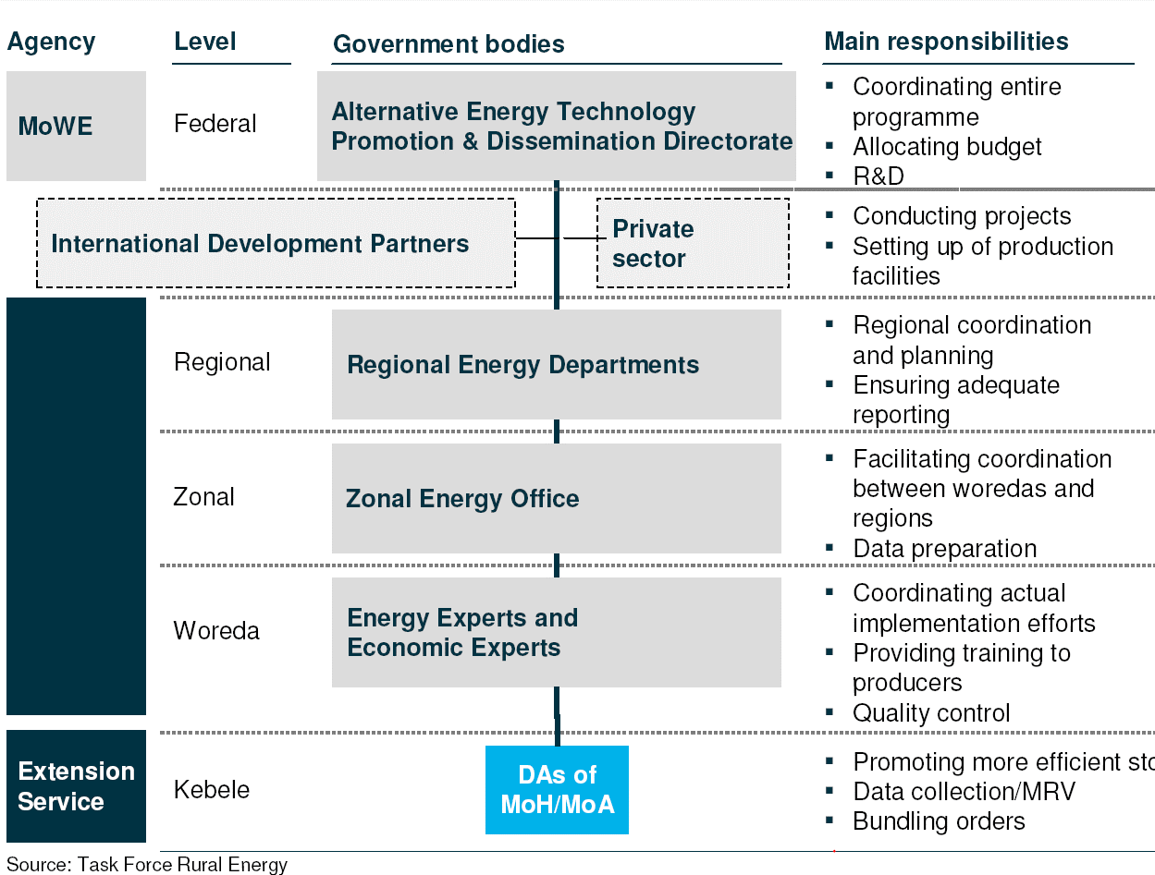

World Bank Credit Line for Renewable Energy Technologies
A World Bank/IDA credit line to the Government of Ethiopia called the Electricity Network Reinforcement and Expansion Project (ENREP) of USD 200 million was approved in 2012, and is expected to be closed in 2017. Of this USD 200 million, USD 40 million has been allocated to ENREP’s component 3, Market Development for Renewable Energy and Energy Efficient Products. The Development Bank of Ethiopia (DBE) is the financial intermediary for ENREP’s Component 3. As of November 2014, only about USD 0.6 million had been disbursed to DBE by the World Bank. The major challenges encountered have included:

  - Inadequate collateral provided by the private sector
  - Inability to raise the required 30% equity contribution from the private sector
  - The performance of the Micro-Finance Institutions involved has fallen short of the planned target (due to lack of coordination between the National Biogas Programme, Oromia Energy Bureau and Oromia Credit and Saving Share Company (OCSSCO) as the MFI.
  - Lack of advertising and awareness campaigns
  - Difficulty in obtaining end-user information for the distributed products

Micro-Finance Institutions
The micro-finance sector in Ethiopia is well developed, with 31 licenced micro-finance institutions (MFIs) operating in the country as of 2014. MFI operations in Ethiopia are typically regional, with the largest MFI in each region typically owned or backed by respective regional governments, together with Non-Governmental Organisations (NGOs). However, some of the largest MFIs in the country, such as Oromia’s largest MFI, have also begun operating outside their core regions. Several private sector MFIs operate too, although they are smaller in size than the regional Government-backed MFIs. The sector is regulated by the National Bank of Ethiopia (NBE) and foreign equity investments in MFIs are not allowed.

According to data from the Association of Ethiopian Micro-Finance Institutions (AEMFI), as of June 2014, the 31 licenced MFIs in the country served nearly 3.27 million active borrowers and their combined outstanding loan portfolio was ETB 14.3 billion (nearly USD 715 million). These MFIs had also mobilised savings worth ETB 9.3 billion (nearly USD 465 million). The micro-finance industry in Ethiopia has grown steadily since 2003, growing from serving just 746,000 customers and a gross loan portfolio of ETB 330 million (USD 16.4 million) to 3.27 million active borrowers and a gross loan portfolio of ETB 14.3 billion in 2014, as shown in Figure 6 below. The average loan per borrower has also increased, from ETB 441 (USD 22) in 2003 to ETB 4,372 (USD 219) in 2014 [23].

Figure 6: Micro-finance Market Growth in Ethiopia – 2003-2014
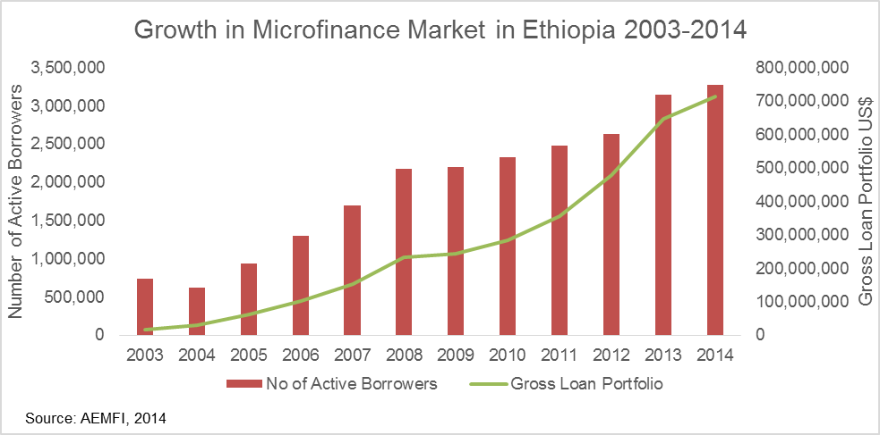

The MFIs currently functioning in Ethiopia exhibit a number of strengths in their operation. To mention a few: service provision is centred on both urban and rural poor, particularly in alleviating the chronic problem of poverty; the number of clients served is growing; and the regional distribution of services is appreciable as micro-finance institutions are operating in all regional states of the country.

Though the strengths of the MFI industry outweigh its weaknesses, there are still considerable challenges facing MFIs. The first challenge is the inaccessibility of foreign capital that could support their loan portfolios. As a result, many MFIs are limited to certain categories of services, such as agricultural businesses, livestock and other micro-businesses. Lack of skilled personnel is a common problem in Ethiopian MFIs. This situation is exacerbated by high turnover of experienced personnel, driven both by switching to better jobs and also a dislike of working in rural areas with minimal facilities provided. There is also a problem of using modern core finance technologies by many MFIs, especially those micro-finance institutions operating in remote rural areas with poor infrastructure. As a result, there are problems of non-standardised reporting and performance monitoring systems. In addition, MFIs face challenges in obtaining loans in the existing finance market, particularly from banks. [24]

Association of Ethiopian Micro-finance Institutions (AEMFI)
The Association of Ethiopian Micro-Finance Institutions (AEMFI) is a micro-finance industry association; it counts all the licenced MFIs in the country as its members. AEMFI, established in 1999, is structured as a not-for-profit organisation and acts as the industry’s nodal agency to promote the growth of micro-finance in the country. The objectives of AEMFI are:

- To provide a forum through which MFIs can exchange information
- To enhance capacity through the provision of training, capacity building and funding negotiations, and
- To strengthen the sector by providing research, advocacy, promotion and engagement to positively influence policies and practices.

AEMFI has close links with the Government and is playing a key role in the development of the industry and in shaping the policy environment. AEMFI develops and delivers training programmes to its members to improve their efficiency, identify and expand into new business segments and incorporate micro-finance industry best practices from other countries into its members’ operations. In addition, AEMFI also collects reports from its members on their operations, outreach and portfolio size, while also conducting in-depth market research and data collection activities, which are then published as strategic reports, conference papers and knowledge products. AEMFI is regarded as the most reliable source of data, information and analysis on the micro-finance sector in Ethiopia, while also being recognised as a reliable provider of training and capacity building services in Ethiopia and the rest of the East African region. Consistent with this position, AEMFI has now established an Ethiopian Micro-Finance Training Centre in Addis Ababa, which aims to institutionalise AEMFI’s leading position as a training and capacity building provider.

RET enterprises
RET enterprises are micro-, small- and medium-enterprises that produce, assemble, distribute, import, install, service or conduct business with RETs. Individual entrepreneurs are covered by the definition of micro-enterprises having fewer than 5 employees.

There are about 40 solar companies listed by the Energy Coordination Office (ECO) (see below table 2) for import, distribution, sales, installation and production of solar lanterns, solar home systems, larger solar PV systems and solar water heaters.

Over 1,000 women’s groups and co-operatives at village level have been trained to produce ICS. Their production capacity is typically 20-200 ICS per months. Further, there are an estimated 20 SMEs producing ICS in higher quantities (e.g. 1,000 units per month) throughout the country.

The following are a sub-set of Ethiopian companies interviewed by the Ethiopian Climate Innovation Centres (ECICs) (see below) seeking various kinds of support and financing. The companies provided detailed information on the constraints they are facing and their required needs to overcome these challenges.

Table 2: Needs of RET enterprises [25]
Sector | Product | Date Founded | Needs
Solar Energy | Planning, sales and installation of turn-key renewable energy systems | 2000 | Capacity building  Market  Private/public sector network  Information on polices  Finance
Solar Energy | Import, installation and maintenance of solar equipment | N/A | Information/advisory services  Private/public sector network
Solar Energy | Import and distribution of solar equipment | 2009 | Technical support  Capacity building
Biofuels | Biogas | N/A | Public awareness  Policy intervention/ lobbying  Capacity building
Solar Energy | Solar distribution and installation | 2006 | Finance
(Names have been removed for confidentiality reasons.)

Women-led business in Ethiopia
On average, 35% of firms in Ethiopia had female participation in ownership of the company in 2011/12, and only 34% had permanent female full-time workers [26]. In many cases, women work in areas that utilise gender-based skills such as food processing, clothing and hairdressing or, in the agricultural sector, selling milk, yogurt or vegetables, often on street stalls. [27] Many women in the informal sector turn to micro-finance to expand their businesses. However, micro-finance loans are usually limited to far less than USD 1,000, constraining women from being able to grow their business beyond the micro-enterprise level. An African Development Bank report describes the difficulties faced by Ethiopian women entrepreneurs of different sized companies, and is summarised in the table below. [27]

Table 3: Difficulties faced by Ethiopian women entrepreneurs of different sized companies.
Size of company | Barriers
Micro-enterprises | Low level of education and knowledge of business-related skills  Limited access to training and business services  Problems associated with operating in informal sector (e.g. licensing and tax issues)
Small-enterprises | Micro-finance ceiling is too low for growth  Collateral constraints limit commercial sources of funding
Medium/large enterprises | Micro-finance ceiling is too low for growth  Need growth management and leadership training  Need more flexible loans to meet working capital needs  Need networks and access to information and markets to export products/practices

End-Consumers
The household sector is the largest energy consumer in Ethiopia. According to the Ethiopian National Energy Policy (2013), the sector accounts for 89% of the total energy consumed in Ethiopia. Cooking is responsible for the largest share of the energy used by households (most of the biomass and a substantial proportion of the non-biomass).

This UNDP-implemented, GEF-financed project is piloting a purely commercial approach, with no subsidies to end-consumers, and concessional financing backed by credit risk guarantees to leverage credit from financial service providers to sustainable RET enterprises and service providers. Thus, it is the end-consumers who finally have to address the full investment cost for rural energy technologies. The technologies have been selected using the criteria of affordability and market readiness. Solar lanterns and ICS are generally affordable for all income-group rural households; solar home systems are generally affordable for middle- and high-income rural households.

Ethiopian Energy Authority
The Electricity Proclamation, Number 86/1997 [28], established the former Ethiopian Electricity Agency to regulate the technical aspects and tariffs of the electricity sector. In 2013, the Ethiopian Energy Authority (EEA) replaced the Ethiopian Electricity Agency, and is now an autonomous federal agency engaged mainly in the determination and enforcement of the quality and standard of electricity services, issuance of operation and investment licences and competency certificates (supervising implementation), conducting tariff studies and providing indirect efficiency regulation. Dealing with energy efficiency standards is the mandate of the EEA, while general product standards that mainly focus on durability are the mandate of the Ethiopian Standards Agency (ESA).

EEA is familiar with standardisation processes, and thus EEA will be involved as a major Government stakeholder in the process of development of RET standards and regulations. In order to promote energy efficient products in the country, EEA has plans to establish energy efficient product demonstration centres in six regions (4 large regions and two others). Once they are established, RETs will be displayed and promoted in these centres. EEA has also obtained funds from DFID to support business incubators engaged in the promotion of energy efficient products.

Lighting Africa: Ethiopia
Lighting Africa: Ethiopia (LA-E, also known as Lighting Ethiopia), in partnership with MoWIE, has provided training to local distributors interested in distributing modern off-grid lighting products with international manufacturers in the context of the Lighting Africa Quality Assurance Programme and Lighting Africa Quality Standards and Product Verification.

Based on the World Bank’s recommendations, the Government of Ethiopia has removed the import customs and duties for Lighting Africa-approved products. However, the market for these products has not flourished as expected, as importers are unable to secure working capital loans and are sometimes unable to secure the foreign currency needed to place orders for these products. Banks generally have high collateral requirements (120% of the loan amount) that limits the amount importers can borrow.

A report published by Lighting Africa in June 2013 summarises its findings on stakeholder roles as follows:

There is strong political will and commitment for the wide-scale dissemination of solar lighting products to off-grid consumers. However, strategies adopted in the past were not effective enough in continuously engaging the private sector as a key driver for marketing off-grid lighting products. The dissemination strategy for solar lighting products was tender-based (REF) and not continuous. Even though it helped to create awareness about solar lighting products in project areas, it was location-specific and did not help to build a sustainable market chain. Federal and regional government energy sector organisations and non-governmental organisations active in the energy sector should work more on awareness creation and technical capacity building, and help link market channels to end-consumers. Promoters of solar lighting products should recognise that the private sector is the ultimate market driver. [15]

The USD 20 million loan to DBE under ENREP is considered a response to the financial aspect of this problem statement. With the new funds from the SREP through IFC, the new Lighting Ethiopia project complements the World Bank’s ENREP to increase access to electricity services in Ethiopia. In addition, it is envisaged that IFC, the World Bank and MoWIE will be developing a joint country strategy for off-grid lighting products targeted at the bottom-of-the-pyramid. Moreover, Lighting Ethiopia will be complemented by the World Bank FOREX Facility Project, which aims to ensure a steady supply of clean energy products in the Ethiopian market by mitigating foreign exchange scarcity and its impact for SMEs importers. This Facility also enables uninterrupted supply chains and provides a platform which will be used by the Lighting Ethiopia project to help scale-up the market for clean lighting products.

The next planned actions by Lighting Africa are to roll-out support to the ENREP credit facility, capacity building for MFIs and consumer education activities (awareness campaign), as well as to work with the Government to address key market entry barriers encountered by the private sector (e.g. quality assurance). Since this activity is just starting, with an expected project closure date in December 2016, the UNDP-implemented, GEF-financed project will take stock of its achievements in awareness creation, quality assurance and market transformation at inception and will complement these efforts in a coordinated manner.

Entrepreneurship Development Centre (EDC)
The Entrepreneurship Development Centre (EDC) is a quasi-governmental entity established in February 2013, under the framework of the Entrepreneurship Development Programme (EDP), which is implemented by the Federal Medium and Small Scale Enterprises Development Agency (FeMSEDA) of the Ministry of Urban Development, Housing and Construction (MoUDHCo) with the support of UNDP, in order to help the Government accomplish visions and goals envisaged in the Growth and Transformation Plan (GTP) by developing best practices and piloting promising initiatives of entrepreneurship development.

The Centre offers potential entrepreneurs and Micro and Small Enterprises (MSEs) 6-day intensive Entrepreneurship Training Workshops and other customised entrepreneurship training. Business Development Services (BDS) are also provided to business owners to improve their business management and operations and to potential entrepreneurs to support their business start-ups.

Ethiopian Climate Innovation Centre (ECIC)
The Ethiopia Climate Innovation Centre (ECIC) is an initiative supported by the World Bank’s infoDev initiative, and is part of a global network of Climate Innovation Centres being launched by InfoDev’s Climate Technology Programme (CTP). The Ethiopia Climate Innovation Centre is funded by UK-Aid and the Norwegian Ministry of Foreign Affairs. It is a component of DFID’s Strategic Climate Institutions Programme (SCIP) in Ethiopia and the Government of Ethiopia’s Climate Resilient Green Economy (CRGE) vision.

With a grant of USD 5 million from the World Bank to Addis Ababa University, ECIC became operational in December 2013. The Horn of Africa Regional Environment Centre and Network (HoA-REC/N) is involved in ECIC’s management.
ECIC supports enterprises that are developing innovative solutions that address climate change challenges. ECIC aims to accelerate the development, deployment and transfer of climate technologies by providing MSMEs with a set of holistic, country-driven support services, including early-stage financing, business support and capacity building.

Support is given to those MSMEs that win a periodic 'proof of concept' competition. In the first round, out of 186 applications 28 SMEs and enterprises were selected to receive ECIC support services and, of these, 8 candidates were the winners of proof-of-concept grants of up to ETB 1 million each. The concepts were evaluated based on criteria of innovation, business viability and impact on the environment and society. Individual awards ranged from USD 25-37,500.

It is planned to establish further regional centres in other regions (one most probably in Haramaya / Harar, and at least two more, whose locations are not yet decided). Each centre will provide early-stage financing and other services to enable local enterprises to pro-actively and profitably develop innovative climate technology solutions that meet local needs. The centres will collaborate with local universities.

For Component 4 of the UNDP-implemented, GEF-financed project, the ECIC is considered among potential institutions to provide Intensive Business Training Courses for selected RET MSMEs.

Energy Coordination Office of GIZ
The Energy Coordination Office (ECO), often referred to as GIZ-ECO, is a programme coordinated by GIZ and funded by Energising Development (EnDev). ECO has a budget of EUR 12.69 million from EnDev for the period 2010 to 2017. It receives additional earmarked funding from Irish Aid, SNV and others.

ECO supports MoWIE in a range of programmes and also partners with MoFED, MEF, the Ethiopian Energy Agency, the Ministry of Agriculture, the Ministry of Health, Regional Governments/Agencies/Bureaus of Energy, Education, Health, Agriculture; universities/institutes of technology/technical vocational educational and training units; chambers of commerce; the Solar Energy Development Association - Ethiopia (SEDA-E); the Ethiopian Hydro Power Society (EHPS); regional (development) associations; private solar energy installation and maintenance companies; and others.

ECO’s activities relating to ICS and solar PV can be summarised as:

- Training of local stove producers
- Support to marketing campaigns for ICS
- Promotion of ICS for enterprises
- Support for firewood planting and marketing for communities and the private sector
- Capacity building in technical and business management of energy experts working at different structural levels (Government, NGOs, private sector)
- Training solar technicians in cooperation with partner organisations
- Installing and maintaining PV systems (local companies)
- Training users in proper use and maintenance of systems
- Training technicians from the regional health bureaus on simple repairs
- Electrification of health centres and other social institutions with solar technology

In addition, Ethiopia's first solar technology training centre has been set up at Selam Vocational Training Centre, in Addis Ababa.

Since ECO is a technical resource and training provider for RETs in Ethiopia, with a well-recognised approach and an established partner to many Ministries, development partners and initiatives, ECO is considered a potential service provider for specific technical assistance. Further, at the regional level the Project Implementation Unit of the UNDP-implemented, GEF-financed project will coordinate with the activities of ECO for training, awareness creation and selection of RET enterprises.

Development assistance programmes
During the project preparation stage, a stakeholder analysis was undertaken in order to identify key stakeholders and assess their roles and responsibilities in the context of the project. Table 11 in Annex 1: Additional Stakeholder Analysis lists the key stakeholder organisations; provides a brief summary of the responsibilities of each of these stakeholder organisations (specifically as it applies to RET); and describes the anticipated role of each of the stakeholder organisations in supporting or facilitating the implementation of project activities.

Baseline Analysis

The activities in the field of rural energy technologies are wide-ranging with respect to the types of technologies promoted, the different financing and promotion methodologies used, and levels of capacity building efforts. The focus and activities of the stakeholders described above, and thus the baseline developments in the field of RETs, can be summarised as follows:

- Supporting the Government in improving access to a modern energy supply and scaling-up the dissemination of rural energy technologies
- Promoting professional and managerial capacity building, including provision of training courses on rural energy technology development, rural energy market development, strategy and communications
- Providing finance to low-income households and micro-enterprises that promote rural energy technologies
- Advocacy work and partnerships to create an enabling policy and business environment to expand micro-finance for clean energy

Development of National Rural Energy, Regulatory and Legal Framework
Ethiopia already has a Rural Renewable Energy Policy Framework and an updated Energy Policy. Under this framework, Ethiopia has a vision of becoming a renewable energy hub by 2015 and for the energy sector to play a significant role in socio-economic development and transformation of the country through provision of a sustainable, reliable, affordable and quality energy service for all sectors in an environmentally benign manner.

While the principal goal of the updated national Energy Policy is to promote and support expansion of the grid, there is also consideration of promoting small-scale renewable energy technologies and improved cook-stoves for rural household use. This includes the strengthening of the legislative and regulatory basis for supporting the widespread dissemination of small-scale renewable energy technologies by focusing on amendments to legislation and the introduction of new regulations in a manner that is consistent with the new Energy Policy. In particular, this requires the development of technical standards to promote the further development of the market for small-scale solar technologies and for improved cook-stoves.

In the Project Identification Form (PIF), two major outputs were:

1.1 Development of technical standards to support the development of small-scale solar technologies
1.2 Development of technical standards to support the development of the improved cook-stove market

The current situation concerning standards is that they are already under development, supported by GIZ. The draft standards have been completed by the Technical Committees and are ready for submission to the National Council of Standards. However, in Ethiopia the staple food Injera requires baking and thus very special baking stoves, for which no standards exist internationally. Further, the standards that have been developed relate only to solid biomass fuels, while MoWIE wants to include stoves using alternative fuels such as biogas and plant oil in the new regulations. Thus, special refinements and additional elaborations to the draft standards are required.

So far, there is no concrete plan on how to roll-out and implement the standards, and what rules and regulations need to be in place to ensure country-wide adherence of products to these standards. The closest related baseline activities are a recent Energy Authority tender for a study on "Efficiency Standards and Labelling for electric Injera Mitads”, and the fact that the Ethiopian Conformity Assessment Enterprise (ECAE) has acquired equipment to evaluate the performance of PV components (PV panels, batteries), which it intends to use to assess conformity with the standards when they are published.

Development of RET Enterprises
To grow opportunities for new technology applications and investment in the small-to-medium enterprise sector, the Government of Ethiopia is looking to provide incentive schemes including tax relief, lowered investment capital requirements, access to land, provision of accessible finance and technical assistance to green ventures.

The GTP envisions a significant role for Ethiopia’s micro- and small-scale enterprise sector in all areas of the economy. Accordingly, the Government of Ethiopia has devised a micro- and small-scale enterprise (MSE) development strategy, which is implemented by the Federal Micro and Small Enterprise Development Agency (FeMSEDA), under the Ministry of Construction and Urban Development. The strategy envisions a large expansion in the number and quality of MSEs across the country via the provision of industrial extension services, micro-finance and business development services. FeMSEDA is creating one-stop-shop structures to provide services to enterprises in each region. The UNDP-implemented, GEF-financed project will work with FeMSEDA to ensure that business development services can be targeted to the project’s beneficiaries and other climate technology businesses.

Supporting private sector development and co-operatives is also the goal of many donor-funded activities and initiatives. The Ethiopian Climate Innovation Centre offers enhanced services (selection of promising enterprises, provision of comprehensive training, and start-up financing) to small and medium enterprises that are very much in line with the goals of the project. The Entrepreneurship Development Centre, supported by UNDP and the Horn of Africa Regional Environment Centre & Network, is an additional important partner for supporting local RET enterprises.

A number of specific training centres for solar technologies have been developed by, for example, the Solar Energy Foundation and specific courses are offered in Technical Vocational Education and Training institutes.

Dissemination of Rural Energy Technologies
The density of interventions varies considerably between regions: most of the activities are ongoing in the four major regions of Amhara, Oromia, SNNP and Tigray. Specific RET programmes, such as the NICSP, REF and Lighting Africa Ethiopia, are considered key baseline activities upon which the UNDP-implemented, GEF-financed project will build to leverage further investments from the private sector (end-consumers and RET enterprises) in a commercial manner. The ENREP loan to DBE provides the core source of financing for the sector but suffers from the lack of capacity and awareness evident amongst financial service providers and end-consumers.

According to MoWIE, the REF’s future role will be mainly in awareness creation, promotion and technical support provision for consumers (and especially also women’s groups playing an important role at household level), developers, businesses and financial mediators such as banks and micro-finance institutions. The REF, in collaboration with Regional Energy Bureaus, will provide support to identification and organisation of rural consumers, including households and institutions, and will facilitate the means to access off-grid electricity and lighting technologies and services through the private sector.

The Development Bank of Ethiopia and selected micro-finance institutions are expected to provide financial leverage to the private sector for import and wholesaling, retailing and acquisition of alternative energy technologies, including off-grid lighting products such as solar lanterns and solar home systems. The lending so far of USD 20 million by the World Bank to the Development Bank of Ethiopia under component 3 of the Electricity Network Reinforcement and Expansion Project is seen by all stakeholders as the key source of capital for financing the loans required by consumers, co-operatives and enterprises to buy, manufacture, distribute and sell rural energy technologies. The UNDP-implemented, GEF-financed project will add substantial momentum to these baseline activities through further capacitating the financial service providers, such as DBE, MFIs and the private sector, through inclusion in regional awareness creation activities (road shows) and through financial and technical business support.

In the field of rural energy technologies, the Energy Coordination Office (established by GIZ) has proven itself as a widely-accepted resource institution for technology development, promotion and capacity building. ECO’s efforts are focused on technical training and product development and it operates only in the major regions.

Market Development Data Analysis - Business As Usual - Baseline
There are many different stakeholders involved in the dissemination of RETs, which are, to varying degrees, complementary and interlinked. A central coordination body that can keep track of sector achievements is missing, and the establishment of a quantitative baseline is currently a matter of guess-work based on the different estimates (using different methodologies) of reports, forecasts, project plans and strategies.

As discussed above, GIZ-ECO has been active in the dissemination of ICS in several regions of Ethiopia using a market-based (or commercial) approach. According to ECO [29], there are now more than 600 producers of energy-efficient cook-stoves, across 310 districts and seven regions. The total sales of Mirt and Tikikil stoves for the period 2006 to end of January 2012 were 418,248 and 70,612 units, respectively [21]. By the end of November 2013, they had sold more than 735,000 stoves [29]. Hence, about 250,000 units were produced by ECO-affiliated producers between January 2012 and November 2013.

According to data from a Global Alliance for Clean Cook-stoves report [30], production capacity and sales information on improved cook-stoves is as shown in the table below.

Table 4: Ethiopia Improved Cook-stove Market Information - 2011
Ethiopia Improved Cook-Stove Market Information | In 2011
Production capacity | 1.9 million stoves per annum
Number of people trained in producing cook-stoves | 25,000
Sales of improved cook-stoves | 30-300 stoves per month per producer
Number of Mirt stove producers | 600
Number of Tikikil stove producers | 45
Injera stoves distributed until 2011 | 3.8 million

According to MoWIE, about 7 million ICS had been disseminated by end-2012, mostly to households; actual use is estimated to be 5 million [31]. A 2011 assessment of programmes underway at the time revealed that, in addition to the already-existing capacity for distributing 2 million high-efficiency stoves by 2015, nearly 7 million additional stoves will have to be produced and distributed between 2012 and 2015. For this period, the Fuel Wood Efficient Stoves Investment Plan [22] identified a need for additional funding of USD 29.2 million, excluding USD 7.3 million for subsidies.

Overall expenditures to conduct the NICS scale-up programme add up to USD 56 million between 2012 and 2015, of which nearly USD 40 million is additional to funding to continue existing public and private programmes in a BAU scenario. Between 2016 and 2030, projected additional expenditures of approximately USD 200 million will be required to distribute a total of 125 million stoves (including replacements for old stoves, given that stoves are assumed to have an average service life of 2.5 years (baking stoves) and 4.5 years (cooking stoves)). The distribution of a total of 125 million stoves is necessary in order to have 31 million stoves operating in rural areas by 2030 to achieve the targeted GHG emission reductions.

All of these numbers differ in important respects, but it can be concluded that about 1 million ICS were sold between 2012 and 2014, and there exists considerably higher market potential for growth.

The draft Ethiopia SE4All National Action Plan [31] states a baseline of 12,500 SHS and institutional PV systems for 2011/2012 and a target of 165,500 for 2015 to achieve the GTP goals; it further mentions that currently (May 2014) fewer than 50,000 SHS have been installed by the private sector, and about 1 million solar lanterns were sold by private businesses in total (timeframe not specified).

The Market Study for Solar Lighting [15] states that the largest and fastest growing distribution model for solar lighting products in Ethiopia is the private importer-distributor-retailer model. The volume and value of sales through this channel (excluding sales to NGOs, which give out systems for free to, for example, refugees) is estimated to have reached 120-150,000 units of solar lanterns and sales of ETB 75 million (USD 3.9 million) in 2012. Sales volume at the consumer level is estimated as twice as much, or ETB 150 million (USD 7.9 million).

Thus, it can be concluded that at least 500,000 small-scale solar lighting products (lanterns, micro-SHS and larger SHS with an average system capacity of 7 W) were sold between 2012 and 2014, and there is higher market potential for growth.

Since most of economy of Ethiopia is based on agriculture (46% of GDP, 80% of total employment), rural households are the key target group, and demand for, and market-readiness of, RETs is high, it is estimated that, with all these facilitating activities described above, there will be additional 5-10 percentage points of growth for the RET market on top of the general economic growth rate forecast by IMF [32]. On average, therefore, the solar products market can be expected to grow at a compound annual growth rate (CAGR) of 23% and the ICS market at 17% CAGR, in the period 2014-2019. Please refer to Table 6 and Table 7 for a full analysis of market data and growth of the baseline.

Part II: Strategy

Project Rationale and Policy Conformity

Ethiopia signed the United Nations Framework Convention on Climate Change in 1992 and ratified the Kyoto Protocol in 2005.

Fit with the GEF Focal Area Strategy and Strategic Programme
This UNDP-implemented, GEF-financed project has been designed to be consistent with the GEF-5 climate change strategy Objective 2 and Objective 3. GEF Climate Change Strategy Objective 2 is focused on promoting market transformation for energy efficiency in the building and transport sectors and explicitly includes promotion of improved cook-stoves. Objective 3 is focused on the promotion of investment in renewable energy technologies.

The project complements the Ethiopian Energy Strategy, the Ethiopian Climate Resilient Green Economy Strategy, and the Initial National Communication of Ethiopia to the UNFCCC, and is aligned with the technology options derived from the Technology Needs Assessment (TNA) prepared by UNDP with GEF support in 2007 [33]. It is also fully consistent with the goals of the Sustainable Energy for All (SE4All) initiative of the United Nations Secretary General, which are: (i) to ensure universal access to modern energy services, (ii) to double the rate of improvement in energy efficiency by 2030, and (iii) to double the share of renewable energy in the global energy mix by 2030. Ethiopia has joined the SE4All initiative and is committed to undertaking activities to meet these goals. Furthermore, Ethiopia is one of 20 African countries in the UN-REDD collaborative initiative on Reducing Emissions from Deforestation and forest Degradation. The project is supportive of REDD objectives and will contribute to lower emissions from deforestation by promoting efficient biomass use (through ICS) and switching from traditional biomass to renewable energy sources (mainly solar).

Rationale and summary of GEF Alternative
The UNDP-implemented, GEF-financed project is set within the strategic framework of the country’s ambition to reduce GHG emissions and is framed around three strategic priorities of the UNDP Country Programme: enhanced economic growth and poverty reduction; democratic governance and capacity development; and development of a low-carbon and climate-resilient economy. Gender aspects, knowledge management and South-South cooperation will be utilised to facilitate innovation and scale-up good practices.

The GEF funds will be used for incremental activities designed to remove the identified barriers to adoption of RETs in Ethiopia. In particular, the GEF funds will be used for those incremental activities that expand the scope of, or supplement, the baseline activities in leading to or enhancing global environmental benefits. A component-by-component assessment of the incremental activities and expected global environmental benefits is provided below.

Table 5: Summary of baseline, GEF alternative and global environment benefit per component.
Baseline practices | Alternative to be put in place by the project | Global Benefit
Component 1: Strengthened regulatory and legal framework based on national standards
Energy policy of the Government of Ethiopia (GoE) does not currently contain any regulatory basis to improve and control the quality of rural energy technologies in Ethiopia. | Based on the new product quality standards currently under development for RETs, new regulations put in place in Ethiopia to support small-scale renewable energy technologies with a focus on high-quality product design, development production and assurance. | Reduction in greenhouse gas emissions from accelerated uptake and wider use of RETs, since trust and recognition in the products are enhanced. Less primary resource wastage since products are used longer.
Component 2: Rural Public Awareness Campaign on Renewable Energy Technologies
Lack of public awareness in rural communities about the benefits of improved energy technologies for lighting and cooking.  Lack of public awareness about the availability of financial products to purchase rural energy technologies.  The use of over 15 million inefficient cook-stoves and over 15 million kerosene lamps leads to 34 Mt CO₂e emissions annually. | Successful national and regional public awareness campaign with specific focus on target groups at rural household level (e.g. women’s roles), which leads to increased private investments in small-scale renewable energy technologies. Beyond the Sustainable Financial Mechanism (SFM) to be implemented, it is expected that the awareness campaign will lead to an additional 100,000 units of small-scale solar technologies and the dissemination of an additional 400,000 improved cook-stoves. | Reduction¹² in greenhouse gas emissions from accelerated uptake and broader use of RETs.
Component 3: Sustainable Financial Mechanism (SFM) for RETs for rural households – UNCDF CleanStart
No lending for RETs by MFIs; slow disbursement of an available World Bank loan for the sector of USD 40 million (15% disbursement between August 2012 and April 2014).  The use of over 15 million inefficient cook-stoves and over 15 million kerosene lamps leads to 34 Mt CO₂e emissions annually. | With support from a project-implemented financial mechanism, 1,000 additional enterprises and small businesses will be involved in the production, sale and distribution of RETs in Ethiopia, leading to investment and deployment by the end of the project of an additional 100,000 units of small-scale solar technologies and the dissemination of an additional 190,000 improved cook-stoves. | Reduction¹² in greenhouse gas emissions from more investments in (and thus use of) RETs due to sustainable financial mechanism successfully operating.
Component 4: Business Incubator to Promote Greater Entrepreneurship for Investment in RETs
At least 120 enterprises in Ethiopia are unable to launch improved businesses due to lack of capital and business expertise. | 120 enterprises launch micro-businesses to sell either small-scale solar technologies or improved cook-stoves (or both) with at least a 25% success rate (i.e. – still in business and profitable after 12 months). 12 enterprises further develop their businesses based on innovative RETs due to investment grants and training. | Reduced¹² greenhouse gas emissions due to enhanced products and availability, after-sale services and investments in RETs as a result of supporting > 120 additional RET enterprises.

Summarising the effects of these activities, it is expected that an additional 5-10 percentage points of annual growth can be contributed to the baseline development (see above) of RET dissemination in Ethiopia.

The analysis presented in Table 6 and Table 7 below is based on market data from Solar Lighting Ethiopia, ECO and NICSP. An incremental ~225,000 units of small-scale solar technologies (2.5 MWp capacity) worth USD 8.8 million and 600,000 ICS units worth USD 6 million is the calculated direct impact of the project.

As part of this impact assessment, the effects of the support to the financial sector (Component 3 - UNDCF CleanStart) alone are estimated to leverage at least USD 7 million in private/end-user RET investments. It is estimated that 60% these investments will be used for small-scale solar technologies and 40% for ICS. With average costs of USD 40 for small-scale solar technologies and USD 15 for ICS, this will lead to an incremental ~100,000 solar units and ~190,000 ICS units. This will result into 0.63 Mt of CO2e as part of the direct GHG emission reductions.

Thus, on average it is estimated that, with project support, the small-scale solar technologies market will grow by 28.4% compound annual growth rate (CAGR) and the ICS market by 24.8% CAGR between 2014 and 2019.

The impact on the reduction of greenhouse gas emissions for ICS is calculated using values from the World Vision CDM Programme of Activities (PoA) for ICS, which includes the effects of deforestation. Over their lifetimes of 3 years, the 600,000 additional ICS will avoid 1.98 Mt of CO₂e emissions.

For small-scale solar technologies, the total direct incremental GHG emission reductions are calculated to be 37,000 tonnes of CO₂e over their lifetime of 3 years.

As the lifetime of small-scale RETs is assumed to be 3 years on average the total lifetime direct GHG emission reductions are 2 Mt of CO₂e.

Assuming that the credit-risk guarantees put in place in component 3 will stay effective after the project period and thus will lead to at least three times more investments, the total lifetime direct post-project GHG emissions avoided are calculated to be 3.16 Mt of CO₂e.

The indirect post-project emission reductions are calculated based on the accelerated growth rates for the RET products, incorporating the impacts of project-supported awareness creation, capacitated financial service providers and capacitated RET enterprises. Further, due to implementation of new product standards and regulations, it is estimated that the quality, and thus durability, of 50% of all the RET products on the market will be extended (conservatively) to at least 5 years. Thus, for the 5 years following the end of the project, the indirect GHG emission reductions will be 29 Mt of CO₂e.

A detailed elaboration of the GHG emission reductions calculations is provide in .

Table 6: Baseline and incremental market developments for small-scale solar technologies
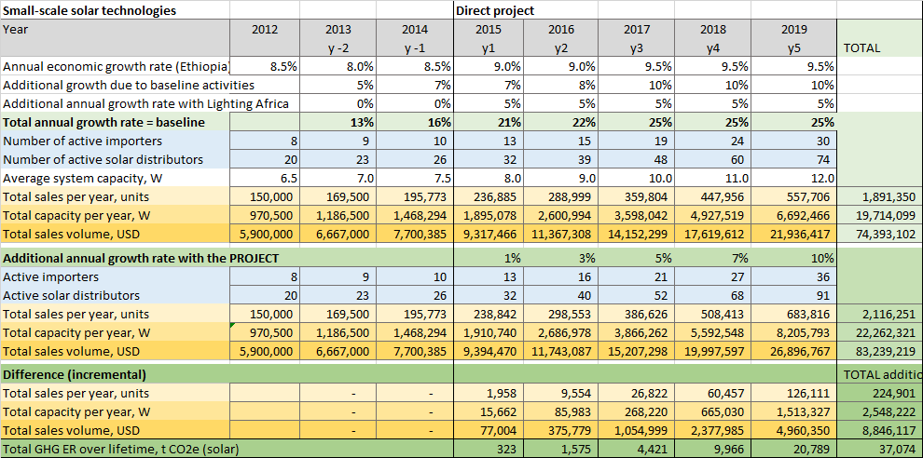

Table 7: Baseline and incremental market developments for improved cook-stoves
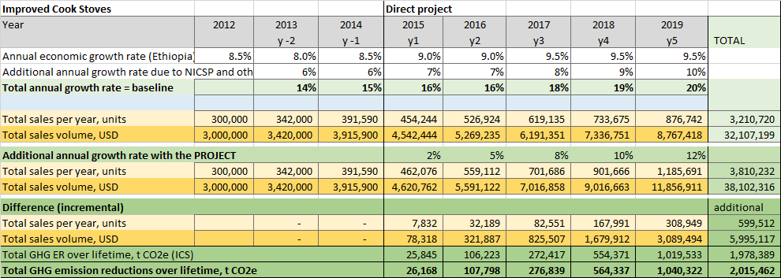

Environmental co-benefits will include reduced deforestation, protection of habitats, conservation of biodiversity, protection of soil quality, maintaining ecosystem services related to watershed management, and prevention of desertification.

There are also significant climate change adaptation benefits associated with this project through the delivery of enhanced, reliable energy supply, which promotes energy access among the poor. The current dependence on biomass products for energy greatly increases vulnerability to climate change. For example, reliance on fuel wood and charcoal brings widespread land degradation, exposing bare soil to erosive rainfall and gulley erosion. Energy generated by hydropower is also vulnerable to fluctuations in rainfall, temperature and evaporation. For example, reduced power production during drought years already takes a significant toll on the economy, since productivity is lost due to power interruptions. A World Bank study estimates that a one-day power outage reduces daily GDP by 10-15% [19].

The social benefits of the project will have a very strong gender-differentiated aspect in favour of women and girls under the age of 15 years. Reduced time will be spent by women and girls on fuel wood collection because less wood will be required for thermal energy compared with the baseline. For instance, ICS, having energy efficiencies between 13-20%, are expected to reduce fuel wood use per stove significantly, by between 39-57%. Since it is reasonable to assume that the time spent on collecting fuel wood is directly proportional to the volume of fuel wood collected, expected reductions in fuel wood collection times are 39-57%.

Inefficient cooking fuels and technologies produce high levels of household air pollution with a range of health-damaging pollutants, including small soot particles that penetrate deep into the lungs. In poorly-ventilated dwellings, indoor smoke can be 100 times higher than acceptable levels. Exposure is particularly high among women and young children, who spend time near the domestic hearth. Household air pollution is responsible for nearly 5% of the global disease burden (expressed as disability-adjusted life-years), making it globally the single most important environmental risk factor [34]. Consequently, a reduction in deaths due to reduced household air pollution can be expected to differentially favour women and children.

Project Goal, Objective, Outcomes and Outputs/Activities

The overall objective of the project is to promote and encourage significantly greater use of renewable energy technologies for household and productive uses in rural communities in Ethiopia.

In order to achieve the project objective, and address the identified barriers, the project’s intervention has been organised into four components:

Component 1: Strengthened regulatory and legal framework based on national standards
Component 2: Rural Public Awareness Campaign on Renewable Energy Technologies
Component 3: Sustainable Financial Mechanism (SFM) for RETs for rural households – UNCDF CleanStart.
Component 4: Business Incubator to Promote Greater Entrepreneurship for Investment in RETs

Technology Selection
The RET systems selection criteria for this project include: (a) market potential, (b) proven performance, (c) consumer acceptance, (d) readiness for scale-up, and (e) potential for local production or assembly.

The first criterion has been used to identify and select a broad group of technologies within RETs. Improved cook-stoves and solar electricity are found to be the most widely marketable RETs in the Ethiopian context. Selection of specific technologies within these groups has been performed using the remaining four criteria. Thus, among the ICS technologies, stoves with proven fuel-saving and indoor air pollution (IAP) reduction benefits, as well as suitability for local production, were selected (Mirt, Gonzie, Tikikil). Among the solar electricity technologies, solar home systems (including solar lanterns) were selected because these is a growing market for these in rural areas of Ethiopia and they are well-positioned for scale-up.

The selected technologies have to fulfil country-specific improved cook-stove and solar lighting product standards and regulations that are now in place (for example, the Lighting Africa standards for solar lanterns) or that will be put in place during the project implementation period.

Systems promoted by the project also have to be affordable, which means that they should not cost more than five times the current monthly household expenditure on fuel and power of the target population (i.e. 5 x USD 13.7 = USD 68.6). Table 8 indicates the cost and the average number of months it will take for a lowest-income household, which earns USD 55 per month, to pay back the cost of the technology.

For the purposes of this project, Improved Cook-Stoves (ICS) are fuel-efficient stoves using solid biomass. Small-scale solar technologies are mainly solar lanterns with or without mobile phone charger (typically 4-8 Wp), micro-solar home systems with 1 or more detached LED lamps and mobile phone charger operating at low voltage (e.g. 5 or 12 V, typically 5 to 20 Wp), and solar home systems with voltage inverter to run common appliances (e.g. 240 V, up to 200 Wp).

The principal activities (standards, promotion, and support to RET-enterprises) of the UNDP implemented, GEF financed project will be focused on improved cook-stoves and small-scale solar technologies. However, financing in Component 3 under CleanStart will also be open to biogas and other sustainable rural energy technologies, if they meet the criteria of the financial products to be defined by the MFIs.

Table 8: Payback analysis of selected technologies
Technology | Cost range per unit, USD | Payback period in months for household spending an average 13.72 USD per month for fuel and power
Improved cook-stoves | 5 -100 | 0.4 - 7.3
Solar cookers | 6 - 120 | 0.4 - 8.7
Solar lanterns | 15 - 30 | 1.1 - 2.2
Micro solar home systems | 20 - 50 | 1.5 - 3.6
Solar home systems | 50 - 1,200 | 3.6 - 87.5

Detailed analysis of technologies, and selection of focus technologies for the project activities, can be found in the Technology Selection Reports in Annexes II and III.

Electronic waste (e-waste) is a global concern as e-waste contains heavy metals such as mercury and lead. At their end of life, solar lanterns and solar home systems can be considered e-waste, sometimes with a significant weight content of lead, depending on the type of batteries used. Thus, the following measures are included in project activities to mitigate the environmental harm posed by this e-waste:

- The new standards and regulations (Component 1) will include rules and criteria that lead to a reduction of the dangerous inputs (mainly lead, lead acid and other heavy metals).
- In the awareness-raising campaigns under Component 2, collection of used materials will be a topic. These campaigns will be conducted in partnership with other advertisers facing similar challenges to share costs while maximising outreach by leveraging different brands’ awareness (e.g. Samsung, GE).
- Loans to RET enterprises in the solar sector (Component 3) will only be given if enterprises commit themselves to take back used systems and components, collect and hand them over to already existing e-waste and battery collectors and recyclers in the country (e.g. http://www.pagrik.com).
- Financial support to RET enterprises (Component 4) will only be given if enterprises provide a concept for after-sales services, including waste collection and safe disposal or recycling.

Despite these measures, it is likely that the market itself will help, since it is expected that the cost of more environment-friendly lithium ion batteries, currently costing up to four times more per kWh than lead acid cells, will progressively fall, thus replacing the demand for lead acid batteries.

A key assumption of the project is that Government, MFIs and RET enterprises will coordinate activities, sequentially and/or in geographical locations, to realise essential project synergies. This may involve the processes of selecting partner institutions or locations to pilot and roll-out activities. Without financing of RET enterprises and individual consumers, RET enterprises will achieve minimal market penetration; likewise, finance alone cannot achieve results without the enabling infrastructure (from the national to the local) for the RET supply chain.

To facilitate strong coordination, the Project Steering Committee will include members from the financial service provider community and from the private sector. Further, the project will provide Resident Capacity Builders/Coordinators to act as focal points and technical support in the regions. These are experienced technical experts in the regional energy bureaus. They will also be responsible for coordination and communication between the Project Office in Addis Ababa and the regional offices and between the many regional stakeholders, including the regional bureaus of other line ministries (such as Youth, Children and Women's Affairs, Health, Industry and Environment), regional MFIs and local agencies (e.g. ReMSEDA), and organisations including NGOs (e.g. ECO) and bilateral projects. Thus, they will also act as the regional focal point for the project’s activities. Specific tasks of the Resident Capacity Builders/Coordinators are described in the respective context and in Part III: Management Arrangements.

Component 1: Strengthened Regulatory and Legal Framework based on National Standards

Outcome 1: Favourable legal and regulatory environment created for small-scale off-grid renewable energy investments in rural areas are in place and stakeholders are trained to comply and implement the new standards and regulations.

As described in the baseline analysis (Part I.-V.), the development of two separate product standards is currently ongoing. These standards are designed to reduce energy demand, lower emissions of greenhouse gases and other pollutants, and save consumers the expense of repair or replacement every year.

The expected outcome of this Component is that a strengthened regulatory and legislative basis is in place that, by leveraging the new quality standards, will support rural energy by de-risking the opportunities to invest in and adopt renewable energy. End-users, RET enterprises and financial service providers will benefit as follows:

- End-users will have access to more information about the quality of RET products from independent authorities and will thus be enabled to make more informed purchase choices.
- RET enterprises: product standards set certain minimum requirements for quality, safety and performance of products. By ensuring that their products meet those requirements, RET enterprises will have a marketing advantage, fewer product returns/recalls and more satisfied customers.
- Financial Service Providers: for the risk assessment of loans to RET enterprises, FSPs will have independent product quality assurance and thus the lending process will be faster, risks will be reduced and the cost of loans will ultimately be reduced.

Output 1.1 Improved and new standards are in place for domestic cook-stoves and solar lighting products
The standards currently under development require further refinement and diversification. For example, the current draft standards are national adoptions of other international and national standards, but such standards exist only for cooking stoves. However, in Ethiopia the staple food Injera requires baking and thus very special baking stoves, for which no standards exist internationally. Further, the draft standards apply only to solid biomass fuels, while MoWIE wants to include stoves using alternative fuels such as biogas and plant oil. Hence, the project will provide technical assistance to:

- Refine the existing draft standards to, among other things, include criteria that lead to a reduction of the dangerous inputs (such as lead, lead acid and other heavy metals)
- Develop new standards for Injera baking stoves
- Develop new standards for liquid fuels and electricity
- Provide standard development training for Standardisation Committee member institutions

Output 1.2: New regulations for enforcement of standards in place
There is currently no fixed strategy or concrete plan for what kind of new regulations should be in place for enforcement of the standards. Options for new rules and regulations for enforcement of standards are:

- Enforcement of product standards need rules for independent testing and product certification schemes
- Independent quality and performance labelling of products on the market
- Tax breaks for producers of small-scale solar technologies and improved cook-stoves in adherence with the standards
- Duty waivers for importers of tested products and materials
- Regulations to provide subsidies to certified products and services

MoWIE, together with the Ethiopian Energy Authority, MoFED, MEF, the Ethiopian Conformity Assessment Enterprise and other stakeholders such as, for example, Lighting Africa - Ethiopia will develop the new rules and regulations based on the standards currently under development. International and national consultants will assist the process with their knowledge and experience of international best practice and will support MoWIE in the definition of the new regulations.

Finally, the Government of Ethiopia will endorse the new regulations so as to make them mandatory.

Output 1.3: Stakeholders have been trained in implementation and adherence to the new standards and regulations
Once the new regulations are developed and endorsed, the project will support the roll-out of the new standards and regulations by training different stakeholders. With the GEF funding, customised training packages for the individual interest groups will be developed and made available. Training will be organised and held in Addis Ababa and all regions to inform and educate stakeholders about the new standards and regulations.

Table 9: Exemplary stakeholders to receive training.
Stakeholders with a national focus, thus trained in Addis | Stakeholders with a regional focus, thus trained in the regions
- Ethiopian Energy Authority  - MoFED  - MEF  - Customs Authority  - Association of Ethiopian Micro-Finance Institutions  - DBE  - Ethiopian Conformity Assessment Enterprise  - Solar Energy Development Association - Ethiopia  - Technical Service Providers | - RET enterprises (importers, manufacturers, distributors)  - MFIs  - ReMSEDA  - Regional Energy Bureaus  - Technical Service Providers  - TVET, special training centres, academics

It is the specific role of the Resident Capacity Builder/Co-ordinator to identify and invite all the regional stakeholders to the trainings and to ensure that all relevant stakeholders receive customised information about the new standards and regulations.

Awareness creation on the new standards and regulations and detailed information to end-users will be channelled through the public awareness campaigns in Component 2.

Results: New standards and regulations for quality assurance of RET are in place, and stakeholders have been trained on how to comply with them.

Component 2: Rural Public Awareness Campaign on Renewable Energy Technologies

Outcome 2.1: Greater awareness among rural populations about the benefits and qualities of renewable energy for household and productive uses
Outcome 2.2: Greater awareness among RET enterprises about the availability of SFM and business support

Under this Component, a public awareness campaign (supported with funding from the GEF for general awareness and cash co-finance from private sector partners for specific product-based marketing) focused on the benefits of improved cook-stoves and small-scale solar technologies will be launched. The public awareness campaign will specifically be aimed at rural populations, including, as a special focus, women’s groups. GEF support will focus on designing the awareness-raising activities, and on involving the private sector in directly running roadshows. The roadshows will have a specific focus on the rural areas furthest away from the large towns and markets. While the project will be national in its scope, the roadshows will focus on areas not so easily reached from the major towns and markets – for example, the highland areas of Ethiopia, given that the highlands have a higher density of human population and there is the potential to achieve greater impact. Road shows address the challenge that many inhabitants of the rural areas lack televisions, radios and internet (which limits the role of mass-media campaigns).

Through the use of GEF funds, the project will mobilise RET enterprises to extend their awareness-raising activities to the remote areas and reach out to end-users.

Output 2.1: Public awareness campaign to end-users for small-scale RETs designed and implemented through national and regional media
Based on guidance from AETDPD, marketing experts will develop a comprehensive media package of key messages, concepts for features on radio and TV, leaflets, brochures, newspaper articles and presentations. The design of this media package will be based on the achievements and lessons learned from previous activities, and will be closely coordinated with Lighting Africa - Ethiopia, since it is running a special awareness creation campaign for solar products that started in 2014.

Collection and recycling of used materials will be a special topic in this campaign, which will be conducted in partnership with other advertisers facing similar challenges to share costs while maximising outreach by leveraging different brands’ awareness (e.g. Samsung, GE, etc.).

The key messages and media channels also need to be well coordinated with other national RET programmes, such as NICSP, NDBP and REF, as well as with awareness-creation campaigns of other line ministries, especially concerning health, women, youth, education and agriculture. Special attention will be given to development of promotion packages for schools that can be used by teachers and local Development Agents.

Based on the developed media package, MoWIE will run a national awareness campaign on the benefits of high-quality RETs to reach out to end-users and especially households (e.g. considering the role of female household heads). After translation into local languages, the regional energy bureaus will be responsible for campaigning at the regional level.

Results: Households are aware of the benefits, correct use and quality aspects of RETs, and where and how to access finance for purchasing them.

Output 2.2: Showcasing of specific RETs introduced through technology roadshows by hired RET enterprises
The purpose of the technology roadshows is to raise awareness of the benefits of small-scale RETs and to facilitate sales in conjunction with the promotion of the improved quality of these products. This ‘technology roadshow’ approach will help demonstrate the advantages of small-scale RETs for basic energy needs.

A technology roadshow in this context is a trip of several days, which will involve various private sector companies involved in the manufacture, distribution and/or sale of small-scale renewable energy technologies. The Resident Capacity Builder/Co-ordinator will accompany the technology roadshow to ensure consistency of the messages delivered with the messages developed at the national scale; to include information on the financial services available; to monitor the effectiveness of the roadshows; and to provide feedback to be included in further tendering of roadshows and the regional and national awareness campaigns. The local Development Agents will be invited to participate in the roadshows as well.

Based on tenders, RET enterprises will be enabled to show and sell their own products, supported by centrally-designed awareness creation packages. This could include larger established companies as well as the new or innovative RET enterprises targeted under Component 4 of the project.

GEF funds will be used to cover the additional expenditures of the RET enterprises for the extra efforts to reach out to the rural communities in the regions: this will be in the range of USD 500 (ETB 10,000) for a one-month roadshow, including fuel, subsistence allowance and advertising materials. To qualify for financial support, the RET enterprise will have to provide staff, products, appropriate transport and other promotion materials. Thus, private sector funding (totalling USD 500,000 of co-financing) will focus on marketing and awareness-raising activities for specific products and technologies, while delivering the key messages of a centrally-designed awareness campaign. In this manner, the GEF funds and the private sector funds will complement each other.

The cost-effectiveness of awareness methodologies needs to be tested, hence a phased approach will be adopted:

Phase 1: Pilot in Oromia
Phase 2: Roll-out in major regions
Phase 3: Roll-out in emerging regions

During the pilot phase, the roadshows will include the schools in the selected area and the reaction will be closely monitored to improve the promotion package for different age-groups.

Box 3 - Preliminary selection criteria for tendering the road shows to enterprises

Priority will be given to:
- Consortia of technology providers (solar and ICS)
- Local enterprises with local culture and language
- Enterprises with an established relationship or partnership with an MFI (co-ordination in timing, products and campaigns)

Further criteria for qualification of enterprises are:
- Adherence with standards and regulations
- After-sales service arrangements (how can the producer be contacted in terms of questions/failure?)
- Waste collection and recycling concept
- Cost of offer
- Cost of products
- Staff experience and gender balance (women will be preferred)
- Market experience (duration on the market, units sold)
- Enterprise capacity (staff, vehicles, etc.)
- Roadshow and marketing concept

Results: The private sector has been supported to address the market and a market link among private sector actors (importers, manufacturers, retailers and service providers) has been developed. New marketing approaches have been tested and employed for RET dissemination. A greater number of rural households are aware of the benefits of RETs and have purchased small-scale RET products directly at the roadshows.

Output 2.3: Awareness campaign to RET-enterprises for SFM and business incubation services designed and implemented
Aligned with the approach described above for the development of a public awareness campaign to end-users, there will be a separate campaign with a focus on RET enterprises. Together with stakeholders such as AEMFI, DBE, MFIs and FeMSEDA, marketing experts will develop an awareness campaign specifically for the private sector as the target group, making private sector actors aware of the financial services and the business incubation support provided by the project. Leaflets, brochures, posters and presentations will be distributed in specific training and service centres and through existing training programmes by a range of stakeholders. Special articles and advertisements will be featured in targeted newsletters, websites and social media channels of the stakeholders, such as FeMSEDA, universities, TVET, ECO-GIZ, HoA-REC/N, LED, REF, NICSP and SEDA-E. MoWIE, together with FeMSEDA, will be responsible for inserting these campaign materials in the selected communication channels.

To facilitate programming and accounting of the partnership with CleanStart, particularly within this Output, the activities that specifically involve FSPs as facilitators are further described and budgeted under Component 3 as Technical Assistance on awareness-raising to FSPs.

Result: New entrepreneurs and existing RET enterprises are aware of the services offered by the project and will apply for business incubation support and/or lending from MFIs.

Component 3: Sustainable Financial Mechanism (SFM) for RETs for rural households - UNCDF CleanStart

Outcome 3: By the end of project, more than 290,000 low-income households and micro-enterprises (1,500,000 beneficiaries) will have sustainable access to clean energy through micro-finance. It is envisaged that CleanStart, in partnership with the UNDP-implemented, GEF-financed project, will create a replicable business model for wider scale-up across other developing countries by adopting an integrated approach to addressing demand and supply-side barriers.

Outputs:

  - Risk Capital for Financial Service Providers established: provision of risk capital to at least five financial service providers (FSPs) to assess, develop, deploy and scale-up micro-finance products to finance sustainable RETs for low-income households and micro-enterprises.

  - Credit Risk Guarantees to the Development Bank of Ethiopia (DBE) and FSPs to leverage credit from DBE and FSPs to sustainable RET enterprises and service providers.

  - Technical Assistance to FSPs, DBE, RET enterprises, MoWIE and other Government institutions to eliminate knowledge and capacity barriers for micro-finance for RETs; support for advocacy and developing partnerships.

  - Knowledge Management and Dissemination to promote awareness and understanding of the potential for micro-finance to stimulate adoption of clean energy and generate investor interest through demonstration effects.

Output 3.1: Risk capital for Financial Service Providers established.
Performance-based risk capital grants for market entry have been a key financial instrument offered by UNCDF under its several micro-finance-focused programmes in developing countries. Risk capital grants provided by UNCDF, not just under its CleanStart programme but also under its other micro-finance programmes such as YouthStart and Microlead, have been structured through Performance-Based Agreements (PBAs) with FSPs.

The risk capital grants are intended to under-write the costs (income statement items) associated with designing, developing, launching and scaling-up (start-up or pilot phase activities) a new loan programme so that FSPs can diversify their loan portfolios while also creating a specific socio-economic and/or environmental benefit to borrowers, and to the country as a whole. UNCDF’s PBA-based risk capital grant model is based on the premise that FSPs have access to liquidity (balance sheet items), either from credit lines or refinancing facilities of central banks or international development institutions (such as the World Bank), for on-lending to these new loan programmes but require risk mitigation instruments and technical assistance for successfully structuring and scaling-up such programmes. CleanStart is of the view that risk mitigation, rather than credit lines, is its core value proposition for market development for clean energy lending and, as such, no credit line or refinancing facility from CleanStart is envisaged in Ethiopia.

Given the market and regulatory conditions in Ethiopia, limited availability of liquidity has always been a major concern for MFIs. MFIs do, however, have access to a World Bank credit line through DBE (under its ENREP programme, as described earlier) to on-lend to finance clean energy in Ethiopia. Nonetheless, the existing loan products to finance RETs developed by a handful of financial service providers (FSPs) have been offered only on a very limited scale, as is evidenced by the small number of biogas loans made by OCSSCo and Wasasa, and the inability of these two FSPs to disburse more than 5% of the funds allocated to them under the World Bank-DBE credit line. These loan products do not have the required risk mitigation strategies to enable FSPs to be sufficiently confident to provide them at scale rapidly; therefore FSPs have adopted a cautious approach to providing these loans.

The risk capital grants, which are estimated to be approximately USD 150,000 per FSP and to be provided to a maximum of 5 FSPs in Ethiopia (for a total budget of USD 750,000), will be provided in tranches to selected FSPs based on their performance at scaling-up their clean energy lending portfolios, as agreed through PBAs signed with FSPs after the Request for Proposal (RFP) and selection process. The funds for this output will be made available from CleanStart’s global programme budget. Additional risk capital grants might be made available, either to the same five FSPs or to a new set of FSPs which might be selected through another RFP process at a later stage of the programme, if CleanStart manages to raise additional funding from its own donors and funding agencies.

In addition to risk capital grants to FSPs, subject to additional funding being made available from its global programme, CleanStart will consider providing risk capital as strategic impact investments to sustainable RET enterprises and energy service providers in Ethiopia. Component 4 of the UNDP-implemented, GEF-financed project, which will establish a business incubation centre for enterprises to launch their businesses focused on providing RETs, already includes a start-up/risk capital portion for these entrepreneurs and MSEs. However, at a later stage in the programme, if CleanStart observes a demand from RET enterprises and service providers for additional start-up capital, then it might consider this option. Some of these risk capital grants to RET enterprises and service providers might be provided to innovative business models such as pay-as-you-go solar or asset finance models, to mitigate some of the risks associated with introducing such models to the market.

Under this project Output, the following two activities are planned:

- Pre-investment technical assistance to support FSPs to strategise and articulate their proposed business models and risk assessments of clean energy lending programmes, through provision of access to international and national expertise and experience. The aim of this activity is to support FSPs to develop their business plans for their proposed clean energy lending programmes to be structured and scaled-up with risk capital grants that will be provided to them if selected.
- Risk capital grants provided to a select number of high-performing FSPs (at least 5) to cover the up-front costs and mitigate some of the risks associated with introducing a range of specific new energy loan product lines.

Output 3.1.1: Pre-Investment Technical Assistance

A. Request for Proposal
An Expression of Interest (EOI) and Request for Proposal (RFP) process will invite interested and eligible (eligibility criteria are outlined below in Box 3.1) FSPs to submit business proposals outlining their strategy for introducing clean energy financing. Selected FSPs, as outlined by the selection criteria in Box 3.2, will initially be invited to participate in a structured course of awareness-raising and confidence building on a no-commitment basis and will be assisted to develop outline business plans. The EOI and RFP will be open to all 31 licenced MFIs in Ethiopia and a nation-wide call for EOIs will be announced with support from AEMFI. The FSP eligibility and selection criteria (as defined in Boxes 3.1 and 3.2) will be aligned with those of the World Bank-DBE MFI selection criteria for their ENREP credit line. At least five FSPs will be selected for risk-capital grants based on pre-defined performance-based selection criteria and a due diligence process.

Box 4 - FSP Eligibility Criteria

Minimum eligibility criteria for financial service providers will include, but will not be limited to:

- Licenced by the National Bank of Ethiopia (NBE) and compliant with all prudential regulations
- Sufficient, capable and qualified management team, institutional capacity and corporate governance structure
- At least two years of operational experience in providing financial services for the poor
- Profitable for the last two years and a low risk profile
- Capital adequacy ratio (ratio of total capital to total risk-weighted assets) of at least 12% as per prudential regulations
- Sufficient liquidity, by maintaining liquid assets at 20% of total deposits
- Good lending portfolio quality (Portfolio at risk >30 days of less than 5% in the last 12 months or Non-Performing Loans as a ratio of total assets of less than 8 %)
- Sufficient provisions and risk management policies for managing credit risks, liquidity risks, interest rate risks, currency risks, market risks and operational risks
- Client base of at least 20,000 borrowers (women and men) at the time of application, reached directly or through partner institutions
- Demonstrated management commitment and capacity to manage financial support and to achieve desired objective of the project
- Willingness to institutionalise a range of clean energy products, systems and practices as a result of technical assistance, particularly in rural areas of Ethiopia
- Willingness to lend to individuals and MSEs (non-group lending)
- Sufficient IT and Management Information Systems (MIS)
- Adequate financial information systems in place to provide accurate financial statements in a timely manner

Box 5 - Selection Criteria

The selection criteria for all applications will include, but will not be limited to:

- Soundness and sustainability of the institution, as demonstrated by good key performance indicators
- Willingness and ability of the institution to introduce energy lending and scale-up in the target market segment within 2-3 years
- Proven or likely market demand and growth potential
- Feasibility of business plan and likelihood of success
- Willingness to enter into strategic partnerships with RET enterprises
- Willingness to undergo intensive technical assistance, training and capacity building
- Ability to raise credit line/refinancing (liquidity) for lending portfolio
- Commitment to understand the impact of energy lending on clients over time and adjust operations accordingly
- Demonstration of commitment to knowledge management and sharing
- Demonstration of commitment to client protection and transparent pricing

Preferences will be given to applicants that have previous experience in energy lending, including individual and MSE lending in the energy sector.

In addition to the selection criteria listed in Box 3.2, desirable criteria for selection of FSPs will include prior experience in clean energy lending for both households and MSEs for both group and individual lending models, willingness to designate special loan officers as exclusive clean energy loan officers, and a willingness (preferably through existing relationships) to work with reliable RET enterprises, distributors or even last-mile delivery partners such as Savings and Credit Co-Operatives (SACCOs), community-based organisations and cooperatives to increase their outreach. FSPs that do not meet the eligibility and selection criteria will still be involved in CleanStart’s training and capacity building programmes that will be open to all MFIs in the country but they will not be selected for receiving risk capital grants. Nonetheless, if CleanStart is able to bring additional funds to the programme in Ethiopia at a later stage, a second EOI/RFP process might be conducted to select additional FSPs for participation.

Partnership with selected FSPs will be governed by a Performance-Based Agreement (PBA), which will include initial process milestones and key performance targets. A thorough due diligence process, including reference and data checks and on-site visits to the FSPs under consideration, will be undertaken to verify management and operational abilities to perform according to the anticipated agreement.

B. Training and Technical Assistance to Develop Business Plans
Staff members of all MFIs in Ethiopia, including those that do not meet the criteria listed above, will be invited to participate in an introductory course on sustainable finance mechanisms or micro-finance for sustainable RETs. Staff members of those FSPs that meet the eligibility criteria and submit Expressions of Interest (EOIs) for participating in the programme, will be provided with technical assistance for developing detailed business plans that will be submitted to CleanStart for further evaluation and selection. This technical assistance will be to help FSPs strategise and articulate their activities in a detailed manner, while also sufficiently assessing the associated costs and risks, which will be reflected in the final business plans submitted to CleanStart. The business plans will also include a target number of households for energy lending and the timeline for achieving it, which will also form the basis of the milestones for release of tranches of risk capital grants from CleanStart if selected, which will be agreed in PBAs.

As mentioned earlier, one of the criteria for selection of FSPs from among the shortlisted list will be their partnerships with RET enterprises. This would mean that the FSPs need to discuss, structure and articulate their partnership and implementation model with RET enterprises in the business plan that they submit to CleanStart for further evaluation. Hence, this activity will also include technical assistance for match-making between FSPs and RET enterprises, and structuring legally-binding Service-Level Agreements (SLAs) between FSPs and RET enterprises before a business plan is submitted to CleanStart. Specific activities will include:
- Match-making between FSPs and RET enterprises, ensuring two or more RET enterprises partner with each FSP.
- Technical assistance will be provided to FSPs to develop customer outreach, marketing and promotion strategy and deployment of solar, ICS and biogas loan products in partnership with RET enterprises.
- Technical assistance will be provided to FSPs to setup after-sales service and client feedback mechanisms in partnership with RET enterprises.
- Technical assistance will be provided to FSPs and RET enterprises to form legally-binding service level agreements (SLAs) for provision of RETs and the associated credit; SLAs will include, but will not be limited to, technical quality standards and specifications of RETs to be installed, after-sales service and loan product structure. UNCDF/UNDP national and international consultants will work with FSPs and RET enterprises to establish these SLAs.
- The technical assistance provided by the project will then help the FSPs to define this strategy in their business plans.

Output 3.1.2: Risk Capital Grants
Risk capital grants will be provided by CleanStart to FSPs for energy loan product development, deployment, customer outreach and technical capacity building. These risk capital grants are intended to under-write costs and the risks of designing, developing and launching new loan products for end-user financing of sustainable RETs. Typical uses of these funds will include:

  - Analytical/assessment work on financing needs in energy value chains
  - Matching grants for diagnostic studies
  - Market surveys and product development research
  - Staff training
  - System development for monitoring and evaluation
  - Promotion and marketing of new clean energy loans
  - Salaries of designated clean energy loan officers for the first few months

If, at a later stage of the project, CleanStart is able to bring in additional funding to the programme in Ethiopia and if it is decided to offer this additional funding as risk capital grants to FSPs (either selected initially or newly selected at that time based on a second EOI/RFP process), then FSPs might be allowed to use a portion of these risk capital grants as loan loss provisions for their clean energy loan portfolios. However, in the initial stage of the project, FSPs will not be able to use risk capital grants as loan loss provisions.

While the CleanStart model is focused largely on providing risk capital and TA to FSPs, it is also recognised that innovative financing models, such as asset finance and pay-as-you-go, have been implemented with reasonable success by RET enterprises and service providers (Energy Service Providers/ESPs) in neighbouring East African countries such as Kenya, Tanzania and Uganda. Hence, if the right opportunities arise for CleanStart to support such innovative models in Ethiopia during the course of the project, they might be provided with some risk capital and TA support too, either from the existing CleanStart budget or from the additional unfunded budget which might be made available at that time.

Output 3.2: Credit Risk Guarantees Fund established
A loan (credit risk) guarantee fund that will provide partial credit risk guarantees will be established by CleanStart under the Development Bank of Ethiopia (DBE):

- To provide partial credit risk guarantees (up to 50%) to loans from commercial banks to larger RET enterprises with regional/national outreach; the risk guarantees are intended to make credit from commercial banks more easily accessible to RET enterprises and service providers. The GEF budget for this portion of the guarantee fund is proposed to be just over USD 1.2 million.

- To provide partial credit risk guarantees (up to 50%) to MFI loans to small, local RET enterprises with district/sub-regional outreach; the risk guarantees are meant to make MFI credit more easily available to local RET enterprises and service providers. The GEF budget for this portion of the guarantee fund is proposed to be USD 238,000.

At an average guarantee of 50% of loan size, the proposed credit risk guarantee fund can achieve financial additionality (additional capital leveraged from financial institutions) of USD 2.8 million for financing RET enterprises. The proposed fund size is not very large, but this is the first guarantee fund focused on sustainable small-scale RET enterprises in Ethiopia and, hence, it is important to structure it initially as a relatively small, pilot fund to test the viability of this financial instrument for catalysing capital for the clean energy sector. If successful, CleanStart and the UNDP-implemented, GEF-financed project will work to attract additional funds from other international development institutions and investors to scale-up the guarantee fund’s size and scope.

The purpose of the credit risk guarantees is to increase the availability of capital for investments (capex) or working capital requirements (opex) of RET enterprises. Commercial banks and MFIs are expected to provide credit to RET enterprises from their own capital sources but to do so with increased confidence due to the availability of risk guarantees. Most RET enterprises, large and small, tend to have existing banking relationships, either for letter of credit (LC) funding for importing solar panels or for general banking purposes. In the case of small, local RET enterprises (Micro and Small Enterprises, MSEs), MSE-owners tend to be clients of MFIs who have sufficient credit history with the MFI through several borrowing and repayment cycles (either under group lending or individual lending modalities) and, hence, will be eligible for individual lending from MFIs. Nonetheless, despite these existing banking relationships, RET enterprises find it difficult to obtain credit from commercial banks and MFIs, primarily due to their stringent collateral requirements. Risk guarantees are planned to be partial, ideally providing guarantees for 50% of the collateral requirements of the lending institutions. The residual 50% collateral requirement will be provided by the borrowers.

Providing collateral is one of the biggest barriers faced by RET enterprises and service providers when borrowing from commercial banks, MFIs and DBE in Ethiopia, since they need to pledge fixed assets or deposits of value up to 100% of the loan amount to the lending financial institution. Even if they manage to offer this collateral, it is locked-in for the term of the loan, making these assets inaccessible until the loan is repaid. The proposed credit risk guarantee instrument will help facilitate loans from FSPs/DBE to RET enterprises that do not have sufficient collateral. Guarantees that are proposed to be provided will be linked to technical assistance and capacity development activities for RET enterprises to de-risk the loan guarantee by strengthening the capacity of RET enterprises.

The proposed credit risk guarantee mechanism will be based on USAID’s Development Credit Authority (DCA) model. The DCA has provided partial credit risk guarantees (typically 50%) to leverage credit from local financial institutions to entrepreneurs/SMEs as well as to specific development sectors such as energy, health and agriculture. Since its inception in 1999, USAID DCA has mobilised more than USD 3 billion in credit in developing countries across Asia, Africa and Latin America. In 2013, USAID DCA approved 26 new partial credit risk guarantees in 19 countries, including Ethiopia. In Ethiopia, the DCA guarantee facility was provided through the Bank of Abyssinia, a private sector bank, for agricultural supply chain and other small-scale manufacturing businesses.

Guarantee Fund Mechanism
The credit risk guarantees will be backed by a clean energy guarantee fund, which will be managed by the Development Bank of Ethiopia (DBE), which will be the guarantor. The guarantee fund is proposed to be a pilot public guarantee fund provided by the Government through DBE, with funding support from the UNDP-implemented, GEF-financed project and technical support from CleanStart, to provide an incentive to Ethiopian commercial banks and MFIs to lend to clean energy/RET enterprises, thereby improving the availability of capital to the supply-side of the clean energy market in Ethiopia. The fund is proposed to cover only partial credit guarantees (up to 50% of the outstanding principal loan amount) and it will be offered on an individual loan basis (and not for any particular commercial bank/MFI’s entire loan portfolio) and will operate on a claims-based system.

Consultations with clean energy/RET enterprises and commercial banks (CBE, CBB, Dashen Bank) indicate that lack of sufficient collateral is the most important issue that prevents access to credit by RET enterprises. Based on the experience of other credit risk guarantee programmes such as USAID DCA and a global review of credit risk guarantees by OECD, credit risk guarantees of up to 50% have been typically found to work well, with sufficient incentives for both borrowers to repay and lenders/guarantors to conduct thorough customer due diligence. Other guarantee programmes in Ethiopia, implemented by DBE (Export Credit – 80% guarantee) and FeMSEDA (MSE Credit – 100% guarantee) have seen significant loan defaults, which has been one of the reasons for commercial banks to reduce their lending exposure to MSEs. Hence, the guarantee facility is designed to initially provide 100% collateral (50% guarantee from DBE fund, the remaining 50% from the borrower). However, as energy enterprises build credit histories with commercial banks based on these initial loans, DBE will negotiate with commercial banks on relaxing their equity and collateral requirements. DBE has sufficient incentive to push commercial banks to lend to energy enterprises at easier equity/collateral terms since DBE receives fees (2%) from these commercial banks for providing this guarantee, which it will receive only on credit disbursement from commercial banks. From the third year of project implementation, commercial banks are expected to reduce their equity contribution requirements to about 10-15% and collateral requirement to 75-80% of the loan amount. At this stage, the project may consider a slow reduction in the guarantee percentage over time and can reflect this as part of its exit strategy.

CleanStart proposes that the guarantee fund amount (USD 1,445,150 from the GEF grant) be deposited in a special guarantee fund account opened by DBE in the National Bank of Ethiopia (NBE, the Central Bank). The NBE already has a similar account operational for an export credit risk guarantee fund that is administered by DBE.

- Large RET enterprises, which require loans for either working capital or medium-term loans of USD 200,000 average size (indicative only, can be between USD 2,500 to USD 300,000), secure these loans from local commercial banks; DBE as the guarantor provides a credit risk guarantee of up to 50% of the loan amount to the lending commercial bank and the RET enterprises (borrowers) provide the remaining 50% of the collateral required for the loan from their own fixed assets/capital sources.

- It is estimated that at least 10 large RET enterprises with regional/national outreach in Ethiopia will require credit of at least USD 240,000 each from DBE, so that the total credit requirement is USD 2.4 million; 50% of the total loan amount, i.e. USD 1.2 million, will be guaranteed by DBE through this fund.

- It is estimated that at least 200 SME/individual loans to small, local RET enterprises with district/sub-regional outreach in Ethiopia will be made by FSPs (MFIs), with an average loan size of at least USD 2,000, so that the total credit requirement is USD 400,000; 50% of the total loan amount, i.e. USD 200,000, will be guaranteed by DBE through this fund.

- Small local RET enterprises (MSEs that are solar distributors, cook-stove manufacturers or biogas contractors), which require loans for either working capital or medium-term loans of USD 2,500 or less average size, secure these loans from local MFIs; DBE as the guarantor provides a credit risk guarantee of up to 50% of the loan amount to the lending MFI and the RET enterprises (borrowers) provide the remaining 50% of the collateral required for the loan from their own fixed assets/capital sources.

- The guarantee fund account in NBE will be administered by DBE but UNCDF CleanStart, UNDP Ethiopia and MoWIE will be designated as guarantee fund management committee members.

- The guarantee fund amount needs to be accessed by DBE only in case of default by a borrower: i.e. when the lending commercial bank or MFI decide to classify a loan as a ‘non-performing asset’ (NPA) and DBE, after it is convinced that the lender has exhausted all options for loan recovery, can withdraw the guaranteed amount from the fund and pay the lender.

- Any guarantees above USD 2,500 and all withdrawals from the guarantee fund account need to be reviewed and approved by the fund’s management committee. The $2,500 threshold level was determined on DBE’s and MoWIE’s advice and reflects an expectation that energy enterprise loans of size $2,500 and above will be made by commercial banks and any loans of size below $2,500 will be made by MFIs. It is estimated that about 10 energy/RET enterprise loans of size $2,500 and above (average loan size of $240,000 – based on responses from energy enterprises) will be guaranteed by DBE. Even if the average loan size is lower, the expectation is that the number of loans of this size will not be more than 15-20. For energy/RET enterprise loans of size $2,500 and below, which will be made by MFIs, it is estimated that approximately 200 such loans will be made by MFIs and guaranteed by DBE. This structure is explained in Figure 7 below.

Figure 7: Operating scheme of the Guarantee Fund Mechanism
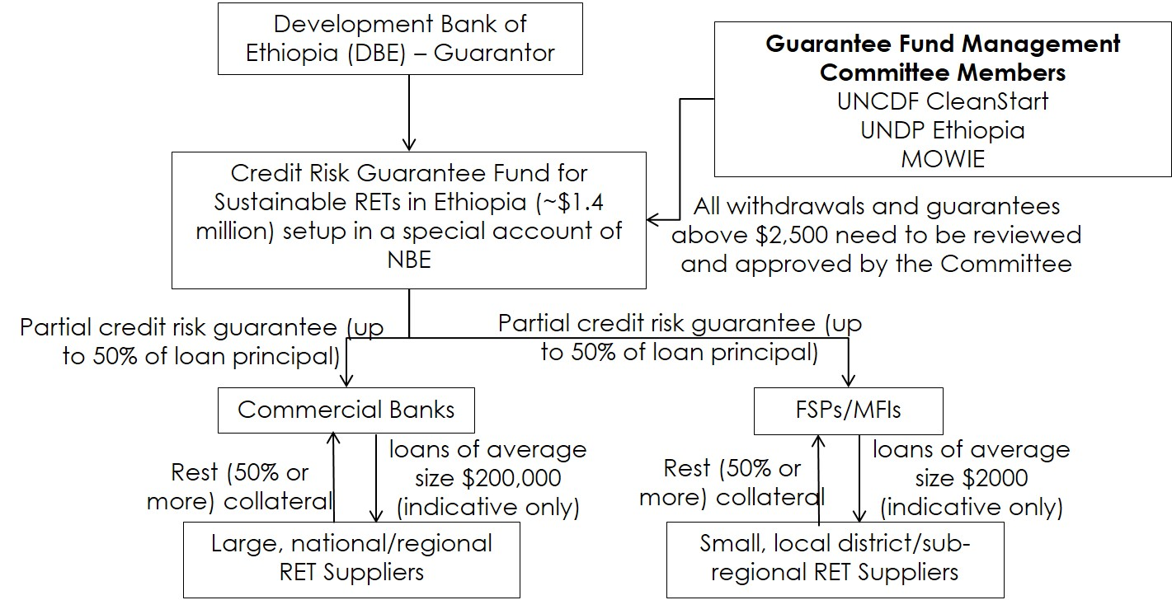

Output 3.3: Technical assistance provided for FSPs to deploy SFM for RETs
Output 3.3 on Technical Assistance (TA) will focus on removing the barriers to the sustainable deployment of a number of relevant low-carbon energy technologies and services for which the selected FSPs will provide micro-finance. It will move away from a technology-driven approach to become more technology-neutral and focused on end-users’ needs. In practice, this will mean rigorous assessments to more clearly identify the specific demand for energy technologies and deployment of technical assistance to remove supply chain barriers that in effect fail to match supply with this latent demand. This Output is expected to lead to the development of:

- Customised energy loan solutions targeted at specific technologies which meet the energy service demands of low-income households and small companies
- Increased collaboration and risk-sharing arrangements between FSPs and energy suppliers
- Increased knowledge of clean energy technologies by relevant FSP staff
- Increased marketing of specific energy loans for specific technologies
- More cost-effective systems for delivering, maintaining and financing clean energy systems and services at scale

A. Needs Assessments and Market Research
Activities under this TA sub-output will include:

- A baseline survey of households, focused mainly on core regions (Oromia, Amhara, Tigray and SNNP), on demand for RETs and credit.

- A market scoping and needs assessment exercise to assess the financial needs of FSPs and RET enterprises and interest among FSPs to on-lend to households and RET enterprises and service providers.

The goal of this exercise is identification of potential FSPs and RET enterprises for investments (pipeline building), identification of suitable financial instruments, and partnerships for FSPs and RET enterprises.

B. Training and Capacity Building
Activities under this TA sub-output will include:

- Design, development and delivery of a national-level training programme on energy lending to staff members of FSPs. This will be a national technical training programme for FSPs to provide an introduction to energy lending (open to all interested MFIs from all regions of the country). The training module development and delivery will be undertaken by UNCDF/UNDP national and international consultants together with AEMFI and SEF.

- Design, development and delivery of a loan officer training programme on energy lending, which includes a detailed methodology to assess energy (solar, ICS, biogas) loan applications from households and RET enterprises, estimate risks and manage repayments. The training module development and delivery will be undertaken by UNCDF/UNDP national and international consultants together with AEMFI and SEF. This training programme will be primarily for the five FSPs selected to participate in the project (those receiving risk capital grants), with at least five loan officers from each of these five FSPs being trained.

C. Brokering Partnerships between FSPs and Energy Suppliers
This activity will be a follow-up activity to the similar TA provided to FSPs during the pre-investment phase. FSPs will be encouraged to form further partnerships with RET enterprises, and activities will include technical assistance for additional match-making between FSPs and RET enterprises, organising technology and finance expos, structuring legally-binding Service-Level Agreements (SLAs) between FSPs and RET enterprises.

- Training on needs assessment methodologies and tools, market research and baseline surveys will be conducted for FSPs. The training module development and delivery will be undertaken by UNCDF/UNDP national and international consultants together with AEMFI and SEF.

- RET Technology and Finance Expos – one in Addis Ababa and another in Bahir Dar (Amhara) or Awasa (SNNP) – will be conducted for match-making between FSPs and RET enterprises.

- Technical assistance will be provided to FSPs to develop customer outreach, marketing and promotion strategies, and deployment of solar, ICS and biogas loan products in partnership with RET enterprises.

- Technical assistance will be provided to FSPs to establish after-sales services and client feedback mechanisms in partnership with RET enterprises.

- Technical assistance will be provided to FSPs and RET enterprises to form legally-binding SLAs for provision of RETs and the associated credit; SLAs will include, but will not be limited to, technical quality standards and specifications of RETs to be installed, after-sales service and loan product structure. UNCDF/UNDP national and international consultants will work with FSPs and RET enterprises to establish these SLAs.

D. Financial Product Development and Roll-Out
Activities under this TA sub-output will include:

- In-depth technical assistance provided by UNCDF international and national consultants to the five selected FSPs for loan product design, development, risk management and piloting; these loan products will finance households to acquire solar, ICS, biogas and other rural energy technologies for their energy needs. Based on pilot results, reworking/fine-tuning these products will also be supported as TA to these FSPs.

- In-depth technical assistance provided by UNCDF international and national consultants to the five selected FSPs on need, tools, methodologies and systems for monitoring and evaluation of energy lending programmes; support will also be provided to FSPs not selected in this project, in addition to support for selected FSPs, on establishing and implementing necessary M&E systems. This support might include support for identification and deployment of MIS system upgrades if necessary. The training module development and delivery will be undertaken by UNCDF/UNDP national and international consultants together with AEMFI.

E. Awareness-Raising
This TA activity includes design and execution of a nation-wide awareness-raising campaign by FSPs, in partnership with RET enterprises, in rural areas on the availability of FSP credit for RETs and the benefits for RETs. Synchronisation of this campaign with the awareness-raising/marketing campaigns planned under other components of the UNDP-implemented, GEF-financed project will be ensured. In addition, coordination and synchronisation of these awareness-raising activities with those of the Lighting Africa programme and other information and dissemination activities to rural households and women groups (see also Component 2) will also be ensured.

The proposed targeting of districts (Woredas) in different regions for awareness-raising campaigns is as follows - Oromia: at least 40 Woredas; Amhara: at least 20, Tigray: at least 20; SNNP: at least 20; emerging regions: at least 20. These regional targets are only tentative and actual target Woredas will depend on final selection of FSPs and their regions of operation.

F. Technical Assistance to DBE
Activities under this TA sub-output will include:

- In-depth technical assistance provided by a UNCDF international consultant to DBE on setting up the risk guarantee fund mechanism, the fund's own risk management, managing coverage and leverage ratios, selection of lenders, fund operational terms and conditions, and fund management set-up. DBE staff will also be trained to operate the guarantee fund facility.

- TA to DBE staff will also include support for managing credit lines and refinancing facilities for wholesale lending to RETs. It is estimated that at least five DBE staff will be trained by UNCDF international and national consultants.

G. Technical Assistance to MoWIE and Regulators
This activity includes in-depth technical assistance provided by an international consultant to MoWIE and other regulatory/policy-making agencies on the sustainable finance mechanism (SFM) and on devising a favourable policy and regulatory environment.

H. Technical Assistance on Innovative Business Models
This activity includes introductory technical assistance provided by an international consultant to the five selected FSPs and at least three large RET enterprises on innovative business and financing models, such as asset finance, pay-as-you-go, leasing and carbon finance. Innovation funding can also play a role, such as in the development of a challenge-fund or Results-Based Financing (RBF) mechanism, assuming a further influx of project resources (either at the national or international level).

Output 3.4: Knowledge management and dissemination provided
This Output will focus on capturing lessons-learned, and on developing and publishing knowledge products such as market intelligence reports and replication guides that can be used by other FSPs and RET enterprises, DBE, Government institutions and donors in Ethiopia and other developing countries. This Output will also promote awareness and understanding of the potential of SFM to stimulate adoption of RETs. Additional Knowledge Management activities could be envisaged at a later stage of project development.

A. Capture and research knowledge on the SFM for RETs
Activities under this sub-output include:

- Conducting research, capture lessons-learned and best practices in terms of SFM loan products, customer outreach and delivery models, business models and processes and FSP-ESP partnerships.

- Conducting research and capture learnings in terms of end-user and value chain impact assessment, resolved and unresolved bottlenecks, and barriers and improvements in the policy/regulatory environment.

B. Knowledge product development, publications and communication
Activities under this sub-output include:

- Developing and publishing research outcomes as strategic reports, case studies, databases, brochures and audio-video material.

- Organising knowledge management, communication and dissemination workshops to promote further dialogue on the SFM for RETs.

The overall implementation of the CleanStart programme in Ethiopia is shown in Figure 8 below, with CleanStart activities under the governance structure of the UNDP-implemented, GEF-financed project Steering Committee, as well as the UNCDF CleanStart Global Investment Committee which is responsible for approving activities funded under the globally-financed elements of CleanStart, amounting to USD 980,000.

Figure 8: Implementation arrangements for Component 3
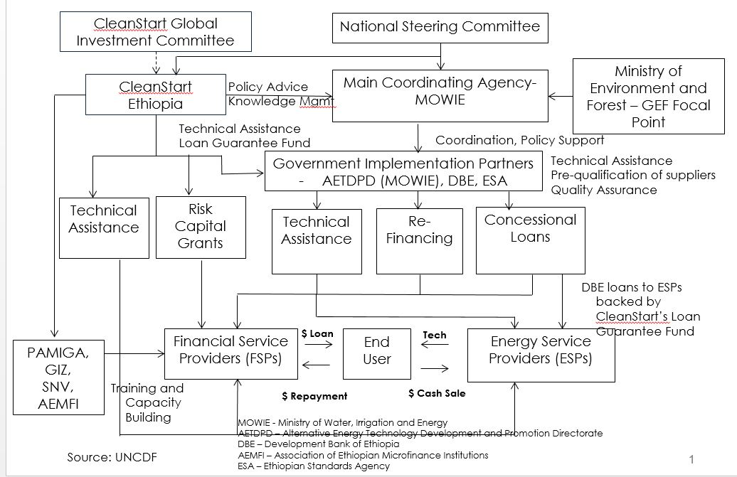

Component 4: Business Incubator to Promote Greater Entrepreneurship for Investment in RETs

Outcome 4: At least 120 small-scale enterprises and manufacturers are successfully producing and profitably selling RETs both for household consumption and for productive uses.
This Component recognises the fact that market-based approaches offer the best possibilities for scaling-up investment in small-scale renewable energy solutions and offer the greatest sustainability. Promoting entrepreneurship, commercialisation and mass production is a key for RET development in Ethiopia, and yet appropriate market conditions and incentives need to be established to support business development across the country.

For example, cook-stove production is still a small-family business employing a handful of people who are often unpaid family members. This has been, and still is, a serious limitation throughout the Mirt and other improved stoves sector. The majority of stove producers lack the dynamism that the market requires, and they respond to consumer demand only reactively. In general, many producers of Mirt as well as other improved stoves lack a proactive stance towards marketing and the ability to manufacture large quantities of stoves meeting certain minimum quality standards.

The project will allow domestic RET producers to evolve, build their capacities to start-up and run their businesses, and benefit from economies of scale that will result in lower prices of improved appliances. In addition, the Component will consider the provision of better networking capacities and a “holistic service approach” at local/regional levels between relevant stakeholders (e.g. Regional Energy Bureaus as “technical capacitators”, MFIs as “financial capacitators”, and ReMSEDA as a provider of business development services), especially with respect to early-stage financing, business support and capacity building services to the Ethiopian private sector, including rurally-based entrepreneurs and business owners.

In general, enterprises are in the need of the following services and support programmes:

- Access to finance (risk capital provision through flexible funds and reduced collateral).
- Mentoring support (training on business planning, financial management and marketing; business skills, technical support).
- Policy support (relevant legislation, policies and standards provided and how it affects RET enterprises).
- Market information (opportunities at local and regional level, with a focus on RET enterprises).
- Marketing and promotion services (business opportunities and outreach on climate innovation for enterprises (and women in particular), partnering with universities and facility providers to offer start-ups; office space, testing, equipment, machinery and access to student talent).

Therefore, Component 4 is designed to select and award potential RET innovators, offer them access to basic business development services for creating capacity among the RET enterprises, and thus advance them in their innovativeness and technical and business operations to access local, regional and supra-regional markets with their energy technologies. Within a first basic business incubation initiative, at least 120 enterprises (to be selected via tender) will be provided with basic development skills and grant support. Those innovators that are more capable, and thus provide more potential and willingness to increase their RET business idea to the regional or supra-regional level, will be invited to apply for an advanced-level advisory and mentoring support programme (grant support to be provided to a minimum of 12 innovative RET enterprises). At a further progressed stage, businesses will have the chance to enrol in additional programmes (particularly supported by other donor programmes), such as the Ethiopian Climate Innovation Centres (ECICs) with their extensive training and mentoring programme for entrepreneurs, or the Entrepreneurship Development Centre (EDC), implemented by MoUDHCo together with UNDP and offering basic business development support.

Output 4.1: Business incubation support programme initiated at MoWIE
In order to accelerate the provision of small-scale RETs to rural communities, business development support is expected to realise the opportunities and benefits of innovation in the clean energy market. Under the current framework of basic business development and incubation support offered through the Entrepreneurship Development Programme (EDCs) and the Incubation Centre at AETDPD, the project will demonstrate a results-oriented model to foster clean technology innovation and new product development at the rural level through providing valuable assistance to business start-ups to increase their chances of success. For the purpose of promotion in the context of the UNDP-implemented, GEF-financed project, the business incubation support will call for innovators to provide appropriate rural energy technologies and products that can be properly diffused, adopted and adapted to fit local needs and requirements.

Output 4.1.1: Linking activities with the Entrepreneurship Development Programme
In order to adopt and distribute innovative RETs on a broad scale, there is a need for the emergence of new enterprises and technology innovators who are concerned about rural energy needs within the current socio-economic setting and, in addition, are able to make profits in their business ventures. Creation of an enabling environment in which such enterprises can emerge will be supported in collaboration with the Entrepreneurship Development Programme to increase capacity.

A. Training
To accelerate the Programme and scale-up product distribution, a specific set of training modules will be developed and offered to help participants understand: the conceptual framework for RETs, the basics of production and distribution, business operations (covering management, technical, commercial and legal aspects), and improved customer service. EDC is partly already offering training support and training modules on: Technical Business, Management, Socio-Economic and Environmental, Marketing and Financing, Risk Management, etc. Under this activity, a training needs assessment will be undertaken to identify synergies with existing business support programmes (particularly EDC) and demand for capacity-building and additional training support identified and adapted to the specific needs of the RET enterprises.

B. Business Development Services (BDS)
Business Development Services encompasses the wide range of services used by enterprises to help them operate efficiently and grow their businesses with the broader purpose of contributing to economic growth, employment generation and poverty reduction. Business Development Services can enhance the development of RETs, reaching higher-income target markets, and designing and selling new products. Entrepreneurs located in rural areas tend to operate within their communities, selling their services and goods to low-income local customers. As they have very few or no contacts with businesses belonging to the formal economy, they are often unaware of potential market opportunities outside of their villages and continue to perpetuate their low turnover and profits.

A business advisory programme can break RET enterprises’ isolation and dependence solely on low-income communities by linking them to high-income markets and by helping them succeed in selling their services and products to new customers. Cost reductions for RET enterprises come from assistance in finding new suppliers, improving inventory management (e.g. by minimising the costs of under-stocking and over-stocking), introducing managerial systems to track costs and identify product profitability, and introducing accounting systems (i.e. income statements, balance sheets and cash flow statements), allowing RET enterprises to monitor and improve their financial performance.

Result: MoWIE to enhance the business development support offered through a programmatic approach that links existing activities of initiatives such as EDC, FeMSEDA/ReMSEDA and CleanStart.

Output 4.2: Basic business advisory support granted to RET enterprises
The project will assist RET enterprises/MSMEs in developing basic skills to establish their businesses and receiving targeted assistance in registering, business planning and marketing their business idea or micro-/small enterprise start-up. In comparison with other entrepreneurship training or business development services offered through programmes such as EDC, the UNDP-implemented, GEF-financed project will provide, as a first step, small grants to eligible RET enterprises.

- RET producers or technology providers (with a focus on solar technologies or improved cook-stoves, but eventually also other technologies such as biogas and micro-hydro) from all regions in Ethiopia will have the chance to apply for a “Business Development Grant” through annual tenders issued by MoWIE.

- Applications will be organised and selection criteria defined accordingly. MoWIE’s MSE Directorate, the AETDPD or the Regional Energy Bureaus will be represented in the jury and will undertake final selection of RET enterprises.

- RET enterprises will specify their business needs and support required during the application stage, with respect to:

  - Basic business skills and training:
    - How to set-up a business, where to receive market information, support with business registration, access to finance and funds, training of entrepreneurs and staff, etc.
  - Basic technical support to innovators:
    - Verification of technical innovations, support in prototype assessment and conformity testing (compliance with the newly-developed technical standards), specialised manufacturing equipment, etc.

- Small-scale grant support (kick-off funding) will be made available through individual technical assistance packages (from one or more local/regional service providers) for approximately 120 enterprises based on their specified needs, considering a maximum grant of USD 5,000 per entity to be approved. Expenditures using grant funds will need to be corroborated by invoices from TA service providers.

- Business skills enhancement services, as well as basic technical innovator support, will be offered by regional/local government entities (such as FeMSEDA/ReMSEDA, EDC, Regional Energy Bureaus) or private TA providers (e.g. for market research, feasibility studies, marketing and public relations support, rent of handicraft tools, access to testing facilities, etc.).

Result: approximately 120 RET enterprises/micro-enterprises/individual businesses are supported with targeted grants to allow rural innovators to emerge.

Output 4.3: Capable innovators enrolled for advanced business mentoring and advisory service
Building upon the 120 RET enterprises that have received basic business development support in the first phase, in a second phase the project will enhance their capabilities by offering additional qualifications and mentoring services for those enterprises/individuals that are considered as “capable RET innovators”.

- A Call for Proposals will be initiated to invite up to 12 additional innovative RET enterprises to qualify under an advanced business support and mentoring programme:

  - Second round, with call for proposals issued by MoWIE.
  - Application criteria to be developed and provided through the project – including innovative business ideas to be supported through mentoring for business plan development.
  - Criteria for enrolment will consider RET innovation potential, strategies for upscaling and diffusion to regional level, as well as compliance to technical standards and market readiness.

- Provide up to 12 innovative RET enterprises with additional business/technology development services:

  - Pre- and post-investment technical assistance will be provided through mentor support and targeted advisory services.
  - Access to international expertise for climate technology entrepreneurs and businesses.
  - Provision of flexible financing to accelerate the development of RETs and catalyse investment in new climate technology businesses.
  - Identification and unlocking of market opportunities through access to key market information while actively promoting sector opportunities and technology benefits.
  - Facilitating linkages with rural and regional partners to: (a) support a targeted outreach and education campaign for innovation (e.g. with a specific target for women) and (b) enforce linkages with universities and facility providers to support cost-effective access to equipment, office space and talent.

- Additional large-scale support grants will be made available for capable innovative businesses (up to USD 40,000, and on average USD 25,000). Again, grant support will be available through individual technical assistance packages based on business needs and development. Expenditures using grant funds will need to be corroborated by invoices from TA service providers and business plans.

- Innovative RET enterprises that have received the basic innovation support through the UNDP-implemented, GEF-financed project will also have the option, in addition, to apply to other donor-funded business mentoring programmes through open calls and business awards to develop their innovative solutions to climate change challenges.

Result: Additional targeted training and business mentoring provided to approximately 5 enterprises, thus supporting capable RET innovators to further develop their business ideas.

Output 4.4. Monitoring of RET enterprises development established
The project will actively pursue, monitor and evaluate a number of impact and result targets, including:

- RET-related impacts: volume of local production of ICS or solar equipment/installations imported.

- Impacts on the development of businesses: such as numbers of RET enterprises receiving targeted support; outreach: number of RET enterprises receiving support in different regions and level of outreach achieved by these companies (how much did they spread into other woredas or regions).

- Number of additional rural energy technologies (ICS, solar, others) sold to rural households or productive users as a result of local entrepreneurs and business start-ups supported.

- Capacity building and enabling environment-related impacts: number of training courses offered and participants (disaggregated by gender) involved.

- Leverage and impacts of financial provisions.

Monitoring requirements will be guided and approved through the Project Steering Committee; implementation and supervision will be organised by MoWIE and MEF as the GEF Focal Point. A database will be developed to review the success of RET enterprises developing on the market and impact/results achieved concerning the above mentioned criteria.

Results: The Component is designed to accelerate the start-up and growth of clean energy technologies in Ethiopia and monitor its main social, economic and environmental impacts throughout the project lifetime.

Indicators and Risks
Identified Risks and Category | Impact | Likelihood | Risk Assessment | Mitigation Measures
 | High / Moderate / Low | Likely / Moderately likely/ Unlikely | Low / Moderate / High
Limited Government capacity and resources impede effective project implementation | High | Moderately likely | Moderate | Project Management will be established to help make sure the risk of underperformance is mitigated. If underperformance occurs, the following project structures will be involved in proactively seeking solutions to overcome implementation challenges.  A Project Steering Committee will be established to co-ordinate the main governmental stakeholders and international partners, such as MoWIE, MoFED, MEF, DBE, UNDP and UNCDF, and ensure that the project remains on course to deliver the desired outcomes of the required quality.  At the (sub-national) regional level, the project will enhance the technical and managerial capacities of Regional Energy Bureaus through Resident Capacity Builders/Coordinators. Their role will be also to inter-link the technical staff of the Energy Bureaus with the financial capacity of FSPs in order to properly raise awareness of RET enterprises.
Weak coordination between different energy programmes causes duplication of efforts and systems | Moderate | Unlikely | Low | The UNDP-implemented, GEF-financed project will work with MoWIE and UNCDF CleanStart to ensure sufficient coordination is achieved among all MoWIE and donor programmes. In case of any overlaps identified and duplication of efforts, the Project Steering Committee will be tasked with reconciling competing efforts.  There is value added to the project in linking the MoWIE-executed GEF project with contributions provided by CleanStart. One benefit to the project is the performance-based selection of FSPs based on their level of partnering with RET suppliers. FSPs will be required to discuss, structure and articulate their partnership and implementation model with RET suppliers in the business plan that they will submit to CleanStart for further evaluation. Component 3 will also include technical assistance for match-making between FSPs and RET suppliers, and thus mitigate the potential overlap of activities and programmes.  On a regional level, Resident Capacity Builder/Coordinators will be put in place specifically to coordinate and strengthen the link between FSPs, RET suppliers and rural households benefiting from improved and affordable energy technologies.
Lack of awareness of the benefits of clean and renewable energy technologies prevents their widespread dissemination | Moderate | Moderately likely | Low | The project will develop large public awareness campaigns targeted at rural households in order to overcome the awareness barrier. For example, road shows will address the challenge that many inhabitants in the rural areas lack televisions, radios and internet (which limits the role of mass-media campaigns).  Through the use of GEF funds, the project will mobilise RET enterprises to extend their awareness-raising activities to the remote areas and reach out to end-users.  If a lack of information and awareness prevails, especially at the level of (sub-national) regions, the project may redistribute funds allocated to dissemination activities or leverage further co-financing during project implementation to mitigate the risk as much as possible.
Limited affordability of RETs by rural populations | High | Moderately likely | Moderate | 30 million people in Ethiopia live on less than 1 USD per day. However, four factors will help to reduce this risk: 1. Consumer spending power in Ethiopia is increasing as the economy grows; 2. Efforts are being strengthened to bring down the cost of production through local business development support; 3. Only the most affordable and commercially-viable technologies have been selected for promotion; 4. The financial support mechanism will help to reduce the cost to consumers.
Entrepreneurs are not interested in entering the renewable energy technology market in Ethiopia. | High | Unlikely | Moderate | Lack of start-up capital is the key barrier facing most small-scale enterprises wanting to start their own businesses. Component 3 will provide suitable financing mechanisms to strengthen the capacity of MFIs and their willingness/ability to offer targeted financing to enterprises and end-users. If the sector is shown to be profitable, there will be a clear interest from other firms to enter the market. Component 4 will facilitate market entry by providing start-up capital and additional capacity building.
Macroeconomic risk:  Financial sector stability and sustainability risks due to controlled, low interest rates and high inflation, resulting in negative real interest rates | High | Moderately likely | Moderate | The project cannot mitigate the economic risks that are influenced by macroeconomic and financial market developments. However, through the introduction of the Sustainable Financial Mechanism, the economic risks for end-users and RET enterprises will be minimised, since a continuous policy dialogue with NBE to maintain prudent macroeconomic policies and interest rate-setting policies will be achieved. In addition, the project will ensure that key financial indicators, such as development of interest rates, cost recovery, financial returns and the financial health of participating FSPs, will be regularly monitored, and, in case of adverse developments emerging, countermeasures planned within the Project Steering Committee.
Environmental risk:  The UNDP-implemented, GEF-financed project does not lead to anticipated results and therefore GHG mitigation potential is not realised | High | Low | Moderate | The UNDP-implemented, GEF-financed project will lead to significant climate change mitigation benefits through the delivery of enhanced, reliable energy supply, which will promote energy access among the poor. Without proper hardware standards/labels, awareness and financing mechanisms, which the project is specifically promoting to support RET enterprises and individual consumers to use these technologies, RET enterprises will achieve only minimal market penetration; likewise, the project would not be able to achieve its anticipated significant lifetime indirect GHG emission reductions.  Climate-related risks are considered low. As Ethiopia’s Initial National Communication to the UNFCCC notes, biomass resources may experience stress as temperature and precipitation regimes evolve, and hydro-power resources may be at risk of reduced rainfall and higher evaporation rates. The project will serve to reduce both stresses by reducing demands on biomass (through the use of more efficient cook-stoves) and promoting the use of solar energy.

Cost-Effectiveness
In the alternative scenario proposed by this project, a more private sector-driven and market-based approach is adopted towards promoting renewable energy technologies in rural communities in Ethiopia. This approach would clearly not take place without the UNDP-implemented, GEF-financed project. The four components consist of a combination of de-risking instruments (Component 1) and market-enabling activities (Component 2 and Component 4) that will combine with a financial support mechanism (Component 3) in order to help transform the market for off-grid renewable energy technologies in rural communities. The renewable energy technologies that have been selected by this project have been chosen because they are market-ready, relevant to all regions of the country, and are the most suitable (and affordable) for rural communities in Ethiopia. The list of technologies covered by the project includes improved cook-stoves of different kinds and makes, solar cookers, solar lanterns and (micro) solar home systems.

To realise this alternative scenario, the project will seek to complement and build upon existing baseline activities already underway through MoWIE and many other stakeholders. Wherever possible, the project will use the competencies and technical skills within the institutions of the executing partner and co-financiers to implement the project activities. Where applicable, project resources will also be deployed to strengthen and expand existing initiatives and programmes and ultimately lay the groundwork for a wide-ranging and comprehensive outcome. Resident Capacity Builder/Coordinators will be engaged with the specific task of coordinating the different stakeholders in the regions to make their activities more effective as well as to achieve the project’s goals in the most effective manner.

The project is considered cost-effective for the following principal reasons:

- The activities are considered very much incremental to an already broad and comprehensive set of baseline activities.
- The project focuses on improved cook-stoves, which offer one of the largest single areas of potential for GHG emission reductions in Ethiopia (34.3 Mt CO₂e per year) and, further, one of the lowest abatement costs (-20 USD/t CO₂e) according to an assessment for the CRGE Strategy. [7]
- The project will support and engage the private sector as a central actor, thus leveraging significant investments in business, market and technology development, as well as production and distribution capacities that further lead to high sales of rural energy technologies.
- GEF resources will be used to develop financial instruments that catalyse much larger, yet mostly dormant, financial resources already available. The co-financing to be leveraged by the project exceeds USD 50 million, from both public and private funding.
- The alternative scenario provides an incremental global environmental benefit of 2.0 Mt CO₂e direct GHG emission reductions. In relation to the GEF project grant of USD 4,091,781, this represents an attractive abatement cost of 2 GEF USD/tonne CO₂e.

Country Ownership: Country Eligibility and Country Drivenness
Ethiopia signed the United Nations Framework Convention on Climate Change in 1992 and ratified the Kyoto Protocol in 2005.

The strategic directions for the energy sector during the five-year period include the development of renewable energy, the expansion of energy infrastructure, and the creation of institutional capacity that can effectively and efficiently manage energy sector development.

One of the four initiatives for fast-tracking under the CRGE is “large-scale promotion of advanced rural cooking technologies”. The Improved Cook-Stove (ICS) Programme of MoWIE is directly linked to this initiative and will establish the foundation for CRGE’s goal of reducing emissions by 54 MtCO2e by 2030 through the deployment of a combination of fuel wood-efficient, LPG, biogas and electric stoves. [21]

The goal of the ICS Programme is to contribute to the realisation of the CRGE vision of reducing emissions from deforestation and forest degradation and ensuring access to clean energy. The Programme will directly support two pillars of the CRGE:

- Protecting and re-establishing forests for their economic and ecosystem services, including as carbon stocks; and
- Expanding electricity generation from renewable sources of energy for domestic and regional markets

The objective of the Programme is to support the dissemination of 9 million improved cook-stoves in Ethiopia up to January 2018 through building sustainable and vibrant market for improved cook-stoves and institutional capacity. [21]

In January 2010, the Government of Ethiopia reaffirmed its commitment to the Copenhagen Accord by submitting a list of voluntary Nationally Appropriate Mitigation Actions (NAMAs) to be implemented by 2020. Under the category “Electricity Generation from Renewable Energy for Off-grid Use and Direct Use of Renewable Energy”, a project to distribute nine million improved biomass household stoves starting from 2010 up to 2015 is mentioned, a reference to the ICS Programme. Further, a NAMA to install 150,000 solar home systems and 3 million solar lanterns starting from 2010 up to 2015, which links to the REF and other initiatives, is identified.

Project Consistency with National Priorities and Plans
In line with the Rural Electrification Strategy (RES) [35], a twin-track rural electrification strategy has been adopted to increase access to electricity in rural parts of the country. The power utility, the Ethiopian Electric Power Corporation (EEPCO), is running a programme of near-continuous extension of the national electricity grid to major towns and villages, while the private sector provides access to electricity in off-grid areas through stand-alone and mini-grid systems.

The Government of Ethiopia’s green economy target for all of its efficient stove initiatives detailed in the Fuel Wood-Efficient Stoves Investment Plan 2012-2015 [22] has two horizons: (i) in the long-term (2030), deploying 31 million fuel wood-efficient stoves in rural and urban areas, and (ii) in the short-term (2015), deploying 9 million stoves in rural areas.

The goals and activities of the UNDP-implemented, GEF-financed project are also fully aligned with the Ethiopia SE4All National Action Plan [31], which features programmes for:

- Solar lanterns and Solar Home Systems (SHS) involving DBE and MFIs for financing (EUR 2.15 million).
- Dissemination of ICS to households and institutions, involving the NICSP under AETDPD as well as DBE, MFIs and others for financing and other support (EUR 2.15 million).
- Minimum energy efficiency standards, testing and labelling, and information and communication through the Ethiopian Energy Authority (EUR 12.85 million).
- Institutional development and capacity building and EE awareness, involving the Ethiopian Energy Authority, federal and regional administrations, and the private sector (EUR 8.05 million).

Innovativeness, Sustainability and Replicability

Innovativeness
This project is innovative in that it combines strengthening the national legislative and regulatory framework to support rural renewable energy with an original financing mechanism.

Innovative energy access models, supported by innovative financing mechanisms, are essential in Ethiopia. Currently, lack of access to finance, awareness, technical know-how and quality of equipment are some of the principal barriers that inhibit the accessibility and affordability of off-grid, small-scale, sustainable rural energy technologies (RETs). Component 3 of the UNDP-implemented, GEF-financed project will, with the support of UNCDF’s CleanStart Programme, stimulate the creation of a wider market base for sustainable RETs among households and micro- and small-scale enterprises by increasing the public awareness of RETs, developing an enabling policy and regulatory framework for RETs, providing access to an affordable and sustainable financing mechanism, and technical assistance support.

The project will also support and engage the private sector through leveraging significant investments in business, market and technology development and strengthening the capacities of micro- and small enterprises (MSEs) involved in the manufacturing, supply and distribution of RETs.

The innovative approach sought by the project intervention is to enhance commercial activities at the rural level and strengthen the technology innovators and catalysts through appropriate financial support mechanisms and business incubation support. Supply (through RET manufacturers, suppliers and distributers) and demand (mainly from rural households and productive users) will be better matched by increasing the awareness of end-consumers of the benefits of renewable energy technologies and by providing opportunities to technology providers to better market and promote themselves (e.g. through technology road shows in the regions).

In addition, the potential for scaling-up will be greatly enhanced by the new legislation to promote renewable energy in the rural environment, which includes regulations to put in place new technical standards (as well as their enforcement) that will support the development of more entrenched markets for small-scale renewable energy technologies (focusing on solar) and improved cook-stoves in Ethiopia.

Sustainability
Ethiopia has been one of the best economic performers in Africa in the last decade and has experienced rapid economic growth, with a consistent double-digit GDP growth rate of about 11%, approximately double the average economic growth of Sub-Saharan Africa. According to the International Monetary Fund’s (IMF’s) 2014 World Economic Outlook report, Ethiopia is one of the top-ten fastest growing economies in the world in 2014, recording a GDP growth rate of 8.5%. To support rapid economic growth in future, Ethiopia’s energy infrastructure needs significant capacity additions and upgrading to become more efficient and economically and environmentally sustainable. Building an inclusive and sustainable energy infrastructure will be one of the key success factors for Ethiopia to maintain its current pace of economic development.

Even though grid electrification rates continue to increase, given the large size of the country’s off-grid population and remoteness of many of the regions, grid electrification is unlikely to reach millions of households in the next decade. Hence, off-grid sustainable rural energy technologies (RETs), such as solar lanterns and solar home systems, as well as improved cook-stoves and other technologies (such as biogas digesters), have high potential for deployment in Ethiopia and thus need to be supported from the perspective of business development and incubation support.

Market opportunities for both private sector and public sector investments are very positive, since Ethiopia’s renewable energy potential is high and is largely untapped. The Government’s demonstrated intent to reduce consumption of fossil fuels and traditional biomass by households and to address climate change are encouraging developments that strengthen the case for tapping into these market opportunities to address energy challenges, through the country’s relatively large and well-developed micro-finance industry.

The purpose of the UNDP-implemented, GEF-financed project is to improve energy access and contribute to the reduction of carbon emissions. This will be achieved by assisting poor households and micro-enterprises to obtain access to sustainable, low-cost, clean energy supplies that contribute to the overall development goals of Ethiopia’s GTP and CRGE initiatives – aiming to protect the country from the adverse effects of climate change and building a green economy that will help realise the ambition of reaching middle-income status before 2025. The project is expected to contribute to an increase in sustainable access to RETs by more than 800,000 low-income households and micro-enterprises (about 4 million people) through the use of innovative financing mechanisms.

Replicability
The project is focused on developing market-based approaches to offer the best possibilities for scaling-up investment in small-scale renewable energy solutions. An enabling environment in which enterprises can emerge and grow will be created. Business development services will support the development of RETs, reaching higher-income target markets and designing and selling new products.

It is important to promote entrepreneurship and commercialisation and mass production, but Ethiopia first needs to look into ways of creating capacity among at least some of the (relatively) larger market players (at the national as well as regional level) to deliver large orders. When creating capacity for large-scale production, potential producers need to be attracted and those best-suited identified and specifically promoted (in terms of technical capacity, equipment, manpower, range of products on offer, marketing, etc.) to engage in large-scale production. There are already a few producers that show significant potential to scale-up and commence large-scale production.

Through the scaling-up activities of the project, particularly within Components 3 and 4, domestic producers of small-scale RETs will benefit from economies of scale by lowering the prices of improved technologies and equipment. For example, improved cook-stoves represent a technology that has high development potential for an enlarged manufacturing base in Ethiopia, if the stoves are able to meet minimum technical standards, as developed under Component 1 of the project. Component 4 will therefore set out to support enterprises entering the market with business development assistance and kick-start financing to launch technology and service innovations.

Financing support for enterprises will be provided through the working relationship with UNCDF CleanStart (under Component 3). Financial support will be provided only to enterprises that sell products that meet the minimum technical standards, as established under Component 1 of the project. Technical assistance will focus on removing the barriers to the sustainable deployment of a number of relevant low-carbon energy technologies and services for which selected FSPs will provide micro-finance.

In addition, the involvement of CleanStart will help to ensure the sustainability of the business development support beyond the lifetime of the project as funding from CleanStart can be used to enhance and expand the business incubation mechanism if it proves to have developed a successful model for supporting the development of the market.

Gender Issues
In most regional states, substantial time must be devoted to the collection of firewood for cooking. For instance, a study has shown that households collecting firewood in SNNPR perceive progressively increasing time and effort needed to collect firewood [36]. The reasons for this include: (1) increasing scarcity of wood due to land clearing for agriculture, and (2) higher demand for fuel wood due to increased household energy consumption. It is clear that the burden (higher in rural households) of firewood collection falls heavily on adult women and female children under 15 years of age. Recent results of a survey revealed that: “the supply of traditional fuels in SNNPR is highly gendered, as it is elsewhere in Ethiopia. Irrespective of woody biomass endowment and whether fuels are purchased or freely collected, results of the survey revealed that the traditional fuels supply scene is dominated by women followed distantly by girls” [36].

Inefficient cooking fuels and technologies produce high levels of household air pollution with a range of health-damaging pollutants, including small soot particles that penetrate deep into the lungs. In poorly-ventilated dwellings, indoor smoke can be 100 times higher than acceptable levels. Exposure is particularly high among women and young children, who spend time near the domestic hearth. Introducing ICS on a large scale will have direct gender-differentiated impacts in favour of adult women and girls.

Part III: Management Arrangements

Project Implementation Arrangements

The project will be nationally implemented (NIM) by the Alternative Energy Technology Development and Promotion Directorate (AETDPD) of the Ministry of Water, Irrigation and Energy (MoWIE). The Director of AETCPD will also be the National Project Director. The main national stakeholders for the project are the Development Bank of Ethiopia, Regional Energy Bureaus of the nine Regional States (Afar, Amhara, Benishangul-Gumuz, Gambela, Harari, Oromia, Somali, SNNP, and Tigray), selected Agencies and Directorates under MOWIE (e.g. EEA), the Ministry of Environment and Forest (MEF), selected federal government institutions (e.g. FeMSEDA), and the Association of Ethiopian MFIs (AEMFI).

The project consists of four components and will be implemented over a period of five years.

Component 1: Strengthened National Rural Energy, Regulatory and Legal Framework
Component 2: Rural Public Awareness Campaign on Renewable Energy Technologies
Component 3: Sustainable Financial Mechanism (SFM) for RETs for rural households - CleanStart
Component 4: Business Incubator to Promote Greater Entrepreneurship for Investment in RETs

Components have both national- and regional-level outputs. For example, standards and regulations will be set at the national level but enforcement will be at the regional and local levels; and a national public awareness campaign will be launched but the messages will be calibrated and made relevant for the local level.

Figure 9: Overview of implementation arrangements

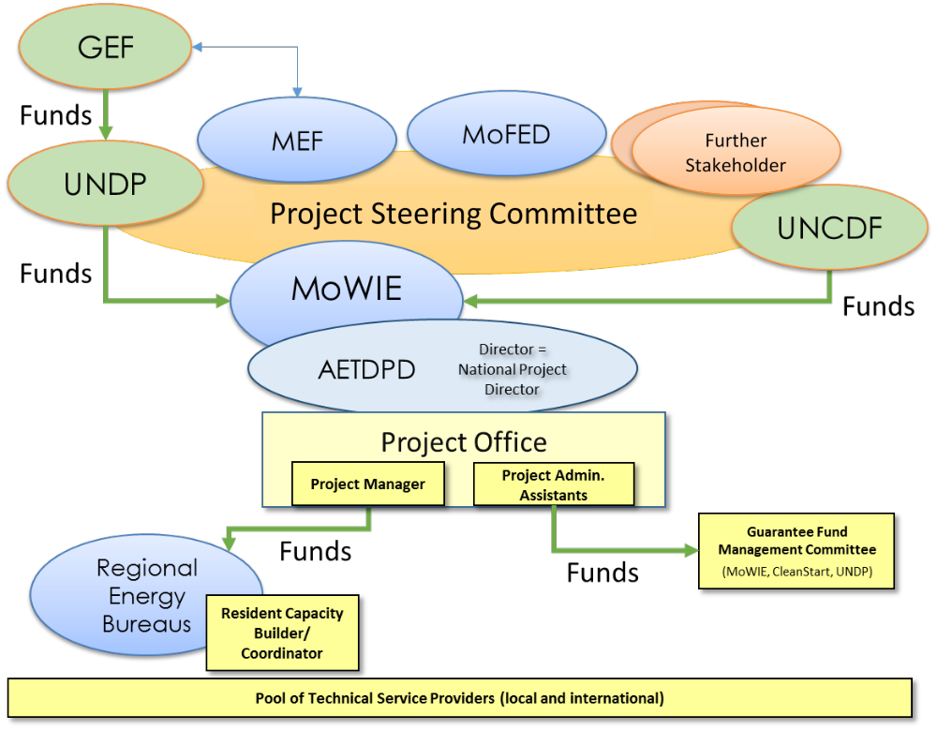

AETDPD - MoWIE
AETDPD will create a Project Office with a dedicated Project Manager (PM), with the support of Project Assistants for administration and finance. Project activities will be executed by AETDPD staff with support from the Project Office. A Project Steering Committee composed of the main stakeholders will provide guidelines for overall project implementation and review (further details below).

The day-to-day administration of the project will be carried out by the Project Office. The PM and the Project Assistants will be based in Addis Ababa. The project staff will be recruited using standard UNDP recruitment procedures. The PM has the authority to administer the project on a day-to-day basis on behalf of MoWIE, within the constraints laid down by the Project Steering Committee (PSC).

The PM’s prime responsibility is to ensure that the project is implemented in an efficient and effective manner and produces the results specified in the Project Document, to the required standard of quality and within the specified constraints of time and cost. The PM will prepare Annual Work Plans (AWPs) in advance of each successive year and submit them to the Project Steering Committee for approval. The Project Manager is also the focal point for day-to-day operations of the UNCDF CleanStart programme. The PM will liaise and work closely with all partner institutions to link the project with other complementary national programmes and initiatives. The PM is accountable to the National Project Director for the quality, timeliness and effectiveness of the activities carried out, as well as for the use of funds. The Project Assistants will provide project administration support to the PM, as required. The terms of reference for the PM and Project Assistants are detailed in .

UNDP
UNDP will monitor the implementation of the project, review progress in the realisation of the project outputs, and ensure the proper use of UNDP/GEF funds. Working in close cooperation with MoWIE, the UNDP Country Office (CO) will provide support services to the project - including procurement, contracting of service providers, human resources management and financial services - in accordance with the relevant UNDP Rules and Regulations, Policies and Procedures and Results-Based Management (RBM) guidelines. A Letter of Agreement between the IP and UNDP (Annex VIII) describing all additional services required from UNDP beyond its role in oversight between the IP and UNDP will be signed. The direct project costs (DPCs) requested of UNDP are also detailed in the Total Budget Work Plan (TBWP).

CleanStart
UNCDF, through its CleanStart programme, will be the ‘Responsible Party’ for implementing Component 3 of the project (relating to the sustainable finance mechanism) and GEF funds will be disbursed directly to UNCDF from UNDP. The proposed partnership model is as shown in below.

Figure 10: Partnership model for CleanStart Ethiopia and the UNDP-implemented, GEF-financed project
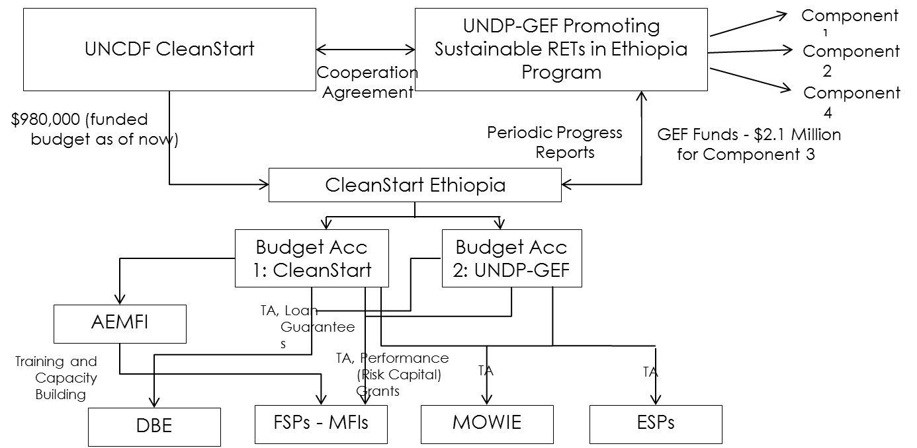

The CleanStart programme will be coordinated by the Ministry of Water, Irrigation and Energy (MoWIE), under the overall guidance of the Project Steering Committee (and the CleanStart Global Investment Committee for globally-funded activities)—as referred to at the end of the Component 3 section. However, the Development Bank of Ethiopia (DBE) will be a partner with UNCDF in providing wholesale funds, credit risk guarantees and assisting in selection of participating Financial Service Providers (FSPs) and technical assistance for clean energy lending. Additionally, other Government institutions, such as the Ethiopia Standards Agency (ESA), will also be involved in defining technical standards. MoWIE will coordinate activities among these different Government agencies.

UNCDF will be responsible for:
- Initial capital contribution and raising additional funding to cover the costs of implementing the CleanStart Ethiopia business plan
- Risk capital grants to FSPs to cover upfront costs of product development
- Catalysing liquidity support for FSPs
- Technical assistance for financing activities
- And in Component 3 for:
  - Fund management
  - Oversight and quality assurance
  - Technical oversight and quality assurance
  - Programme implementation and management
  - Monitoring and evaluation

Project Steering Committee
The Project Steering Committee (PSC) will be constituted to serve as the executive decision-making body for the project. The Project Steering Committee will ensure that the project remains on course to deliver the desired outcomes of the required quality. The PSC will meet formally at least once per annum (more often if required).

The Project Steering Committee (PSC) is responsible for approving the plan proposed by the Project Office and will provide general guidance. Among others, the activities include:

  - Review and approve annual plans and reports
  - Review project progress every six (6) months
  - Advice on coordination of actions among the stakeholders
  - Review and advice on public awareness campaign (messages, communication media)
  - Approve large-scale support grants for business incubation
  - Monitor and evaluate progress
  - Review and revise implementation strategies where necessary
  - Review and decide on other issues related to the project (but were not considered initially)
  - Mobilise Government and development partner support to scale-up proven business models

The following agencies will be members of the national PSC:

  - MoWIE, through the Alternative Energy Technology Development and Promotion Directorate (AETDPD) (National Project Director and chair)
  - Ministry of Environment and Forestry, MEF (GEF National Focal Point)
  - National Project Manager (secretary)
  - UNDP’s Climate Resilient Green Growth Unit representatives
  - UNCDF CleanStart in Ethiopia representatives
  - Ministry of Finance and Economic Development (MoFED)
  - Development Bank of Ethiopia (DBE)
  - Ethiopian Energy Authority (EEA)
  - Federal Micro and Small Enterprise Development Agency (FeMSEDA)
  - Association of Ethiopian MFIs (AEMFI)
  - Private sector representative for ICS and solar technologies (e.g. SEDA-E)

The PM will produce an Annual Work Plan (AWP) to be approved by the PSC at the beginning of each fiscal year. These plans will provide the basis for allocating resources to planned project activities. Once the PSC approves the AWP, this will be sent to the UNDP Regional Technical Advisor at the GEF Regional Service Centre (RSC – located in Addis Ababa) for clearance. Once the AWP is cleared by the RSC, it will be sent to the UNDP/GEF Unit in New York for final approval and release of the funding. The PM will further produce quarterly operational reports, Annual Progress Reports (APRs) and Project Implementation Reviews (PIRs), and any other reports at the request of the PSC. These reports will summarise the progress made by the project versus the expected results, explain any significant variances, detail the necessary adjustments and be the main reporting mechanism for monitoring project activities.

Regional Implementation
At the regional level, the project will be executed by Regional Energy Bureaus and their staffs. Focal points and technical support for the PM and the Project Office will be the key technical experts in the regions, termed Resident Capacity Builders/Coordinators. These are experienced technical experts in the regional Energy Bureaus. Further, they are responsible for coordination and communication between the Project Office in Addis Ababa and the regional offices, and between the many regional stakeholders including the regional bureaus of other line ministries such as Youth, Children and Women’s Affairs, Health, Industry and Environment, regional MFIs and local agencies (e.g. ReMSEDA), and institutions including NGOs and bilateral projects (e.g. ECO). Thus, the Resident Capacity Builders/Coordinators will act as the regional focal points for the activities of the project.

To support the coordination of the regional stakeholders, the Regional Energy Bureaus and the Regional Environmental Bureaus may create Regional Steering Committees if they deem these useful. Regional Steering Committees (RSCs) coordinate and guide activities at the regional level. Regional agencies may decide to set up RSCs or not, depending upon their situation. RSCs will have two meetings annually and other unplanned meetings as necessary. RSCs will carry out the following activities:

- Ensure coordination of actions among the regional stakeholders
- Monitor and evaluate project progress at regional level
- Review and decide on other issues related to the project (but were not considered initially)

The following agencies are proposed for membership of Regional Steering Committees:

- Regional Energy Agency (chair)
- Resident Capacity Builders/Coordinators (secretary)
- Regional Bureaus of Environment
- Regional Micro and Small Enterprise Development Agency
- Regional MFIs
- Regional Bureau for Children, Youth and Women
- Private sector representative

Guarantee Fund Management Committee
The guarantee fund account, which will be a special account of DBE housed in NBE, will have a fund management committee comprising of CleanStart, DBE, MOWIE and UNDP.
- The committee will be responsible for approval of lenders (commercial banks and MFIs) that will be eligible to receive guarantees from the facility.
- The committee will also conduct periodic audits and review of the fund’s guarantee liabilities and review selected credit risk assessments conducted by the lender and DBE.
- Any guarantee of value USD 2,500 and above need to be reviewed and approved by the committee.
- In case of a call on a guarantee due to defaults, all claim payments to the lenders have to be reviewed and approved by the committee.

Technical Service Providers
There are also a number of other technical service providers (TSPs) that will provide a range of services to MoWIE as well as the FSPs, RET enterprises, MSME and DBE. These TSPs will consist of national and international experts. Among such national TSPs envisaged are the Association of Ethiopian Micro-Finance Institutions (AEMFI), the Ethiopian Climate Innovation Centres (ECICs), the Energy Coordination Office (ECO), and other stakeholders or donor-funded programmes.

Financial and Other Procedures
The financial arrangements and procedures for the project are governed by the UNDP rules and regulations for National Implementation Modality (NIM). All procurement and financial transactions will be governed by applicable UNDP regulations under NIM.

Audit Clause
The project audits will be conducted according to UNDP Financial Regulations and Rules and applicable Audit policies.

Part IV: Monitoring Framework and Evaluation

Monitoring and Reporting

The project will be monitored through the following M&E activities. The M&E budget is provided in the table below.

Project start:
A Project Inception Workshop will be held within the first 2 months of project start, involving those with assigned roles in the project organisation structure, UNDP Country Office and, where appropriate/feasible, regional technical policy and programme advisors as well as other stakeholders. The Inception Workshop is crucial to building ownership for the project results and to plan the first year annual work plan.

The Inception Workshop will address a number of key issues including:

- Assisting all partners to fully understand and take ownership of the project. Detailing the roles, support services and complementary responsibilities of UNDP Country Office and Regional Coordination Unit staff vis-à-vis the project team. Discussing the roles, functions, and responsibilities within the project's decision-making structures, including reporting and communication lines, and conflict resolution mechanisms. The Terms of Reference for project staff will be discussed again as needed.
- Based on the project results framework and the relevant GEF Tracking Tool, finalisation of the first annual work plan. Reviewing and agreeing on the indicators, targets and their means of verification, and rechecking assumptions and risks.
- Providing a detailed overview of reporting, monitoring and evaluation (M&E) requirements. The Monitoring and Evaluation work plan and budget will be agreed and scheduled.
- Discussing financial reporting procedures and obligations, and arrangements for annual audits.
- Planning and scheduling Project Steering Committees meetings. The roles and responsibilities of all project organisation structures will be clarified and meetings planned. The first Project Steering Committee meeting will be held within the first 12 months following the inception workshop.

An Inception Workshop Report is a key reference document and must be prepared and shared with participants to formalise various agreements and plans decided during the meeting.

Quarterly:
Progress made shall be monitored in the UNDP Enhanced Results-Based Management Platform. Based on the initial risk analysis submitted, the risk log shall be regularly updated in ATLAS. Risks become critical when the impact and probability are high. Note that for UNDP-implemented, GEF-financed projects, all financial risks associated with financial instruments such as revolving funds, micro-finance schemes or capitalisation of ESCOs are automatically classified as critical on the basis of their innovative nature. Based on the information recorded in Atlas, a Project Progress Report (PPR) can be generated in the Executive Snapshot. Other ATLAS logs can be used to monitor issues, lessons learned, etc. The use of these functions is a key indicator in the UNDP Executive Balanced Scorecard.

Annually:
Annual Project Review/Project Implementation Reports (APR/PIR): This key report is prepared to monitor progress made since project start and, in particular, for the previous reporting period (30 June to 1 July). The APR/PIR combines both UNDP and GEF reporting requirements. The APR/PIR includes, but is not limited to, reporting on the following:

- Progress made towards the project objective and project outcomes - each with indicators, baseline data and end-of-project targets (cumulative).
- Project outputs delivered per project outcome (annual).
- Lessons-learned/good practice.
- AWP and other expenditure reports.
- Risks and adaptive management.
- ATLAS QPR.
- Portfolio-level indicators

Periodic Monitoring through site visits:
The UNDP Country Office and the UNDP Regional Coordination Unit will conduct visits to project sites based on the agreed schedule in the project's Inception Report/Annual Work Plan to assess first-hand project progress. Other members of the Project Steering Committee may also join these visits. A Field Visit Report/Back to Office Report will be prepared by the UNDP Country Office and UNDP Regional Coordination Unit and will be circulated no less than one month after the visit to the project team and Project Steering Committee members.

Mid-term of project cycle:
The project will undergo an independent Mid-Term Review at the mid-point of project implementation (February 2018). The Mid-Term Review will determine progress being made toward the achievement of outcomes and will identify course correction if needed. It will focus on the effectiveness, efficiency and timeliness of project implementation; will highlight issues requiring decisions and actions; and will present initial lessons-learned about project design, implementation and management. Findings of this review will be incorporated as recommendations for enhanced implementation during the final half of the project’s term. The organisation, terms of reference and timing of the Mid-Term Review will be decided after consultation between the parties to the Project Document. The Terms of Reference for the Mid-Term Review will be prepared by the UNDP CO, based on guidance from UNDP-GEF. The management response and the evaluation will be uploaded to UNDP corporate systems, in particular the UNDP Evaluation Office Evaluation Resource Centre (ERC).

The GEF Climate Change Mitigation Focal Area Tracking Tool will also be completed during the Mid-Term Review cycle.

End of project:
An independent Final Evaluation will take place three months prior to the final Project Steering Committee meeting and will be undertaken in accordance with UNDP and GEF guidance. The Final Evaluation will focus on the delivery of the project’s results as initially planned (and as corrected after the Mid-Term Review, if any such correction took place). The Final Evaluation will look at impact and sustainability of results, including the contribution to capacity development and the achievement of global environmental benefits/goals. The Terms of Reference for this evaluation will be prepared by the UNDP CO based on guidance from UNDP-GEF.

The Terminal Evaluation will also provide recommendations for follow-up activities and requires a management response which will be uploaded to PIMS and to the UNDP Evaluation Office Evaluation Resource Center (ERC).

The GEF Climate Change Mitigation Focal Area Tracking Tool will also be completed during the final evaluation cycle.

During the last three months, the project team will prepare the Project Terminal Report. This comprehensive report will summarise the results achieved (objectives, outcomes, outputs), lessons-learned, problems encountered and areas where results may not have been achieved. It will also lay out recommendations for any further steps that may need to be taken to ensure sustainability and replicability of the project’s results.

Learning and knowledge-sharing:
Results from the project will be disseminated within and beyond the project intervention zone through existing information-sharing networks and forums. The project will identify and participate, as relevant and appropriate, in scientific, policy-based and/or any other networks, which may be of benefit to project implementation though lessons-learned. The project will identify, analyse and share lessons-learned that might be beneficial in the design and implementation of similar future projects. Finally, there will be a two-way flow of information between this project and other projects of a similar focus.

Communications and visibility requirements:
Full compliance is required with UNDP’s Branding Guidelines. These can be accessed at http://intra.undp.org/coa/branding.shtml, and specific guidelines on UNDP logo use can be accessed at: http://intra.undp.org/branding/useOfLogo.html. Amongst other things, these guidelines describe when and how the UNDP logo needs to be used, as well as how the logos of donors to UNDP projects needs to be used. For the avoidance of any doubt, when logo use is required, the UNDP logo needs to be used alongside the GEF logo. The GEF logo can be accessed at: http://www.thegef.org/gef/GEF_logo. The UNDP logo can be accessed at http://intra.undp.org/coa/branding.shtml.

Full compliance is also required with the GEF’s Communication and Visibility Guidelines (the “GEF Guidelines”). The GEF Guidelines can be accessed at:
http://www.thegef.org/gef/sites/thegef.org/files/documents/C.40.08_Branding_the_GEF final_0.pdf.

Amongst other things, the GEF Guidelines describe when and how the GEF logo needs to be used in project publications, vehicles, supplies and other project equipment. The GEF Guidelines also describe other GEF promotional requirements regarding press releases, press conferences, press visits, visits by Government officials, productions and other promotional items.

Where other agencies and project partners have provided support through co-financing, their branding policies and requirements will be similarly applied.

M&E work plan and budget
Type of M&E activity | Responsible Parties | Budget  Excluding project team staff time | Timeframe
Inception Workshop and Report | - Project Manager  - UNDP CO, UNDP GEF | Indicative cost: USD 10,000 | Within first two months of project start-up
Measurement of Means of Verification of project results. | - Project Manager will oversee the hiring of specific studies and institutions, and delegate responsibilities to relevant team members. | To be finalised in Inception Phase and Workshop. | Start, mid and end of project (during evaluation cycle) and annually when required.
Measurement of Means of Verification for Project Progress on output and implementation | - Oversight by Project Manager  - Project team | To be determined as part of the Annual Work Plan's preparation. | Annually prior to ARR/PIR and the definition of annual work plans
ARR/PIR | - Project manager and team  - UNDP CO  - UNDP RTA | None | Annually
Periodic status/ progress reports | - Project manager and team | None | Quarterly
Mid-term Review | - Project manager and team  - UNDP CO  - UNDP RTA  - External consultants (i.e. evaluation team) | Indicative cost: USD 50,000 | At the mid-point of project implementation
Final Evaluation | - Project manager and team  - UNDP CO  - UNDP RTA  - External consultants (i.e. evaluation team) | Indicative cost: USD 50,000 | At least three months before the end of project implementation
Project Terminal Report | - Project manager and team  - UNDP CO  - Local consultant | 0 | At least three months before the end of the project
Audit | - UNDP CO  - Project manager and team | Indicative cost per year: USD 6,000 | Yearly
Visits to field sites | - UNDP CO  - UNDP RTA (as appropriate)  - Government representatives | For GEF-supported projects, paid from Implementing Agency (IA) fees and operational budget | Yearly
TOTAL indicative COST  Excluding project team staff time and UNDP staff and travel expenses |  | USD 140,000  (+/- 5 % of total budget)

Part V: Legal Context

This document, together with the UNDAF signed by the Government and UN Country Team which is incorporated by reference, constitute a constitute together a Project Document as referred to in the Standard Basic Assistance Agreement (SBAA).

Consistent with the Article III of the SBAA, the responsibility for the safety and security of the implementing partner and its personnel and property, and of UNDP’s property in the implementing partner’s custody, rests with the implementing partner.

The implementing partner shall:

- Put in place an appropriate security plan and maintain the security plan, taking into account the security situation in the country where the project is being carried;
- Assume all risks and liabilities related to the implementing partner’s security, and the full implementation of the security plan.

UNDP reserves the right to verify whether such a plan is in place, and to suggest modifications to the plan when necessary. Failure to maintain and implement an appropriate security plan as required hereunder shall be deemed a breach of this agreement.

The implementing partner agrees to undertake all reasonable efforts to ensure that none of the UNDP funds received pursuant to the Project Document are used to provide support to individuals or entities associated with terrorism and that the recipients of any amounts provided by UNDP hereunder do not appear on the list maintained by the Security Council Committee established pursuant to resolution 1267 (1999). The list can be accessed via http://www.un.org/Docs/sc/committees/1267/1267ListEng.htm. This provision must be included in all sub-contracts or sub-agreements entered into under this Project Document.

Section II: Project Results Framework

This project will contribute to achieving the following Country Programme Outcome as defined in CPAP or CPD: same as UNDAF outcomes.

Country Programme Outcome Indicators:
Outcome 2: By 2016, private sector-led Ethiopian manufacturing and service industries, especially small- and medium-scale enterprises, have sustainably improved their competitiveness and employment creation potentials.
Outcome 5: By 2016, the governance systems, use of technologies and practices, and financing mechanisms that promote a low-carbon, climate-resilient economy and society are improved at all levels.
Primary applicable Key Environment and Sustainable Development Key Result Area (same as that on the cover page, circle one):
1. Mainstreaming environment and energy OR 2. Catalysing environmental finance OR 3. Promote climate change adaptation OR 4. Expanding access to environmental and energy services for the poor.
Applicable GEF-5 Strategic Objective and Programme:
CCM-2 Promote Market Transformation for Energy-Efficiency in Industry and the Building Sector
CCM-3 Renewable Energy: Promote Investment in Renewable Energy Technologies
Applicable GEF Expected Outcomes:
Slower growth in GHG emissions and contribution to the stabilisation of GHG concentrations in the atmosphere

Energy Efficiency:
a. Appropriate policy, legal and regulatory frameworks adopted and enforced
b. Sustainable financing and delivery mechanisms established and operational
c. GHG emissions avoided

Renewable Energy:
a. Favourable policy and regulatory environment created for renewable energy investments
b. Investment in renewable energy technologies increased
c. GHG emissions avoided
Applicable GEF Outcome Indicators:
Key Indicators: Tonnes of CO₂ equivalent avoided (both direct and indirect) over the investment or impact period of the projects
a. Extent to which EE and RE policies and regulations are adopted and enforced
b. Volume of investment mobilised
c. Tonnes of CO₂ equivalent avoided

 | Indicator | Baseline | Targets  End of Project | Source of verification | Risks and Assumptions
Project Objective  To promote and encourage significantly greater use of energy efficient and renewable energy technologies for household and productive uses in rural communities in Ethiopia | Lifetime energy saved.  Tonnes of CO₂ equivalent avoided.  Number of households benefiting from project-supported access to RETs. | The use of over 15 million inefficient cook-stoves and over 15 million kerosene lamps leads to over 35 Mt CO₂e annually. | 35.5 million mega-Joules of energy saved.  The total direct incremental GHG emission reductions from solar products will 0.04 Mt of CO₂e over their lifetime of 3 years; the additional ICS will avoid 2 Mt of CO₂e over their lifetime of 3 years.  800,000 households are direct beneficiaries from improved access to affordable RETs. | MoWIE estimates.  PIRs.  Mid-Term Review and Terminal Evaluation.  GEF Tracking Tool. | Assumptions:  - Government is focusing its legal and policy framework to align with international best-practice with respect to product standards and certifications.  - National efforts at institutional level to mitigate the effects of GHG emissions in rural energy end-use and local manufacturing of RETs are being strengthened.  - GEF support is able to promote the use of innovative energy technologies at the rural level and thus help to meet CRGE targets quicker.  Risks:  - The lack of appropriate energy efficiency and renewable energy policies and regulations for rural energy technologies is maintained within the country framework.  - The Government does not commit adequate resources and implementation support to develop and enforce standards.  - Without an appropriate political framework and sufficient financial mechanisms in place, the activity of RET enterprises remains at a low level.  - GHG emission targets are not being met.
Component 1: Strengthened regulatory and legal framework based on national standards
Outcome 1  Favourable legal and regulatory environment created for small-scale, off-grid renewable energy investments in rural areas are in place and stakeholders are trained to comply and implement the new standards and regulations. | Status of development and enforcement of RET hardware standards by Government of Ethiopia.  Number of participants benefiting from trainings (gender-disaggregated) | No regulatory basis to improve and control the quality of rural energy technologies for Ethiopia. | New regulations for enforcement of standards in place.  Over 500 individual stakeholders have been trained in implementation and adherence with the new standards and regulations. | MoWIE and regional Energy Bureaus. | Assumptions:  - Government is focusing its legal and policy framework to align with international best-practice with respect to product standards and certifications.  - Building capacity among stakeholders in implementation and enforcement of new standards and regulations is being ensured.  Risks:  - The Government does not commit adequate resources and implementation support to develop and enforce standards.  - The lack of proper technical standards and regulations results in low-quality products which prevent a boost to, and widespread usage of, innovative, safe, efficient rural energy technologies
Component 2: Rural public awareness campaign on renewable energy technologies
Outcome 2  Greater awareness among rural populations about the benefits of renewable energy for household and productive uses.  Greater awareness among RET enterprises about the availability of SFM and business support | Type, item price and estimated efficiency of technology sold directly at roadshows  Number, size and length of appearances of promotions in media.  Number of RET enterprises using SFM or applying for business incubation services. | Lack of public awareness in rural communities about the benefits of improved energy technologies for lighting and cooking.  The use of over 15 million inefficient cook-stoves and over 15 million kerosene lamps leads to 51 Mt CO₂e of emissions annually.  Lack of public awareness about the availability of financial products to purchase rural energy technologies. | 300,000 RET items sold directly at roadshows  At least 1000 appearances of promotions in media.  200 RET enterprises using SFM.  500 RET enterprises applying for business incubation services. | Enterprises participating in roadshows.  Media monitoring service provider.  Loan applications at SFM providers.  Business Incubation Support Unit at MoWIE. | Assumptions:  - Public awareness strategy to promote RET use at rural level appropriately designed to target:  - RET enterprises  - Rural households  - local/regional stakeholders  - Supply and demand will be better matched by increasing the awareness of end-consumers of the benefits of RETs.  - Potential for scaling-up will be greatly enhanced by the new legislation to promote renewable energy in the rural environment.  Risks:  - Lack of awareness at rural level is maintained because of lack of suppliers promoting their products directly ‘on the ground’.  - Awareness campaigns need to be spread across remote regions and localities, which is time- and resource intensive to be effective.
Component 3: Sustainable Financial Mechanism (SFM) for RETs for rural households – UNCDF CleanStart
Outcome 3  By the end of project, more than 290,000 low-income households and micro-enterprises (1,500,000 beneficiaries) will have sustainable access to clean energy through micro-finance. It is envisaged that CleanStart, in partnership with the UNDP-implemented, GEF-financed project, will create a replicable business model for wider scale-up across other developing countries by adopting an integrated approach to addressing demand and supply-side barriers. | Volume of investment mobilised by FSPs participating in the project. | No lending on RETs by MFIs; slow disbursement of an available World Bank loan for the sector of USD 40 million (15% disbursement rate as of April 2014)  The use of over 15 million inefficient cook-stoves and over 15 million kerosene lamps leads to 51 Mt CO₂e of emissions annually. | With support from financial mechanism and awareness campaigns, investment and deployment of at least 200,000 additional small-scale solar energy technologies and of an additional 600,000 improved cook-stoves, worth USD 15 million, have been mobilised. | Volume of loan disbursement by MFI and DBE for RET technologies.  Number of FSPs active in the regions | Assumptions:  - Limited availability of liquidity being a major concern for FSPs, although availability of a World Bank credit line through DBE to on-lend to finance clean energy in Ethiopia.  - Existing loan products are offered only on a very limited scale to some FSPs.  - Risk capital grants to be provided to a select number of high-performing FSPs.  - Pre-investment technical assistance to support FSPs to strategize and articulate their proposed business models and risk assessments of clean energy lending programmes.  Risks:  - Risk of no lending for RETs by FSPs due to unfavourable loan conditions reduces the access to financing  - Increment of RET installations foreseen through project support at risk.  - Credit risk guarantee is not in place and thus FSPs fail to offer competitive loan conditions to RET enterprises and entrepreneurs.  - Weak knowledge of FSP loan officers about clean technologies hampers the uptake of micro-lending.
Component 4: Business Incubator to Promote Greater Entrepreneurship for Investment in RETs
Outcome 4  At least 120 small-scale enterprises and manufacturers are successfully producing and profitably selling RETs both for household consumption and for productive uses. | Number of enterprises that launch micro-businesses to sell either small-scale solar technologies or improved cook-stoves (or both) | At least 120 enterprises in Ethiopia are unable to launch improved businesses due to lack of capital and business expertise. | 120 enterprises launch micro-businesses to sell either small-scale solar technologies or improved cook-stoves (or both) with at least a 25% success rate (i.e. still in business and profitable after 12 months).  12 enterprises develop their business based on innovative RETs further due to investment grants and training received. | Business Incubation Support Unit at MoWIE. | Assumptions:  - Enhanced products and availability of after-sale services and investments in RET enterprises will lead to market development that contributes to improved household energy access at the rural level.  - Business development support of 120+12 additional RET enterprises will create a sufficient basis for replicating innovations to other entrepreneurs and businesses.  Risks:  - RET enterprises are not aware of the business support or unable to meet the minimum criteria for qualifying for the support instruments.  - Missing financial support and weak financial mechanisms in place that do not attract entrepreneurs to invest into new businesses.  - Lack of capacity at business incubation support units.

Section III: Total budget and work plan
Award ID: | 00086749 | Project ID(s): | 00093964
Award Title - Project Title: | Promoting Sustainable Rural Energy Technologies (RETs) for Household and Productive Uses
PIMS no.: | 5200
Implementing Partner (Executing Agency): | Ministry of Water, Irrigation and Energy (MoWIE)

GEF Outcome/Atlas Activity | Responsible Party/ Implementing Agent | Fund ID | Donor Name | Atlas Budgetary Account Code | ATLAS Budget Description | Amount Year 1 (USD) | Amount Year 2 (USD) | Amount Year 3 (USD) | Amount Year 4 (USD) | Amount Year 5 (USD) | Total (USD) | See Budget Note:
COMPONENT 1: Strengthened regulatory and legal framework based on national standards | MoWIE | 62000 | GEF | 71300 | Local Consultants | 9,750 | 13,250 | 23,875 | 47,625 | 35,400 | 129,900 | 1
 |  |  |  | 71200 | International | 14,950 | 21,667 | 28,058 | 4,225 | - | 68,900 | 2
 |  |  |  | 74200 | Audio Visual and Print Prod Cost | - | - | 5,500 | 2,500 | 2,000 | 10,000 | 3
 |  |  |  | 75700 | Training, Workshops and Conference | - | - | 21,200 | 86,000 | 64,800 | 172,000 | 4
 |  |  |  |  | sub-total GEF | 24,700 | 34,917 | 78,633 | 140,350 | 102,200 | 380,800
 | MoWIE | 04000 | UNDP | 71400 | Service Contracts - Individuals | 14,000 | 14,000 | 14,000 | 14,000 | 14,000 | 70,000 | 5
 |  |  |  |  | sub-total UNDP | 14,000 | 14,000 | 14,000 | 14,000 | 14,000 | 70,000
 | MoWIE |  |  |  | Total Outcome 1 | 38,700 | 48,917 | 92,633 | 154,350 | 116,200 | 450,800
COMPONENT 2: Rural public awareness campaign on renewable energy technologies | MoWIE | 62000 | GEF | 71300 | Local Consultants | 4,300 | 2,150 | - | - | - | 6,450 | 6
 |  |  |  | 72100 | Contractual Service -Companies | 21,000 | 64,500 | 99,500 | 97,500 | 92,500 | 375,000 | 7
 |  |  |  | 74200 | Audio Visual and Print Prod Cost | 10,000 | 17,500 | 12,500 | 12,500 | 7,500 | 60,000 | 8
 |  |  |  | 74200 | Audio Visual and Print Prod Cost | 5,000 | 23,125 | 29,375 | 29,375 | 29,375 | 116,250 | 9
 |  |  |  |  | sub-total GEF | 40,300 | 107,275 | 141,375 | 139,375 | 129,375 | 557,700
 | MoWIE | 04000 | UNDP | 71400 | Service Contracts - Individuals | 14,000 | 14,000 | 14,000 | 14,000 | 14,000 | 70,000 | 10
 |  |  |  |  | sub-total UNDP | 14,000 | 14,000 | 14,000 | 14,000 | 14,000 | 70,000
 | MoWIE |  |  |  | Total Outcome 2 | 54,300 | 121,275 | 155,375 | 153,375 | 143,375 | 627,700
COMPONENT 3: Sustainable Financial Mechanism (SFM) for RETs for rural households – UNCDF CleanStart | UNCDF | 62000 | GEF | 71300 | Local Consultants | 63,917 | 25,416 | 22,666 | 4,501 | - | 116,500 | 11
 |  |  |  | 71200 | International Consultants | 162,333 | 53,667 | 47,167 | 9,333 | - | 272,500 | 12
 |  |  |  | 72600 | Grants | 230,000 | 310,000 | 420,000 | 300,000 | 185,150 | 1,445,150 | 13
 |  |  |  | 71400 | Service Contracts - Individuals | 34,850 | 40,000 | 40,000 | 40,000 | 40,000 | 194,850 | 14
 |  |  |  | 74200 | Audio Visual Productions | 3,333 | 6,667 | 6,667 | 3,333 | - | 20,000 | 15
 |  |  |  | 71600 | Travel | 65,417 | 29,250 | 18,500 | 2,833 | - | 116,000 | 16
 |  |  |  |  | sub-total GEF | 559,850 | 465,000 | 555,000 | 360,000 | 225,150 | 2,165,000
 | UNCDF | 04000 | UNDP | 71400 | Service Contracts - Individuals | 14,000 | 14,000 | 14,000 | 14,000 | 14,000 | 70,000 | 17
 |  |  |  |  | sub-total UNDP | 14,000 | 14,000 | 14,000 | 14,000 | 14,000 | 70,000
 | UNCDF |  |  |  | Total Outcome 3 | 573,850 | 479,000 | 569,000 | 374,000 | 239,150 | 2,235,000
COMPONENT 4: Business Incubator to Promote Greater Entrepreneurship for Investment in RETs | MoWIE | 62000 | GEF | 71300 | Local Consultants | 6,450 | 6,450 | 6,450 | 3,000 | 3,000 | 25,350 | 18
 |  |  |  | 72600 | Grants | 180,000 | 265,000 | 265,000 | 85,000 | - | 795,000 | 19
 |  |  |  | 72100 | Contractual Service - Companies | 3,000 | 1,000 | - | 1,000 | - | 5,000 | 20
 |  |  |  | 72100 | Contractual Service - Companies | 8,000 | 8,000 | 8,000 | 8,000 | 8,000 | 40,000 | 21
 |  |  |  |  | sub-total GEF | 197,450 | 280,450 | 279,450 | 97,000 | 11,000 | 865,350
 | MoWIE | 04000 | UNDP | 72600 | Grants | - | 13,000 | 13,000 | 14,000 | - | 40,000 | 22
 |  |  |  | 71400 | Service Contracts - Individuals | 14,000 | 14,000 | 14,000 | 14,000 | 14,000 | 70,000 | 23
 |  |  |  |  | sub-total UNDP | 14,000 | 27,000 | 27,000 | 28,000 | 14,000 | 110,000
 | MoWIE |  |  |  | Total Outcome 4 | 211,450 | 307,450 | 306,450 | 125,000 | 25,000 | 975,350
Project management | MoWIE | 62000 | GEF | 71400 | Service Contracts - Individuals | 12,600 | 12,600 | 12,600 | 12,600 | 12,600 | 63,000 | 24
 |  |  |  | 71600 | Travel | 2,300 | 2,300 | 2,300 | 2,300 | 2,300 | 11,500 | 25
 |  |  |  | 72300 | Materials and Goods | 3,424 | 3,424 | 3,425 | 3,424 | 3,424 | 17,121 | 26
 |  |  |  | 71600 | Travels | 1,782 | 1,782 | 1,782 | 1,782 | 1,782 | 8,910 | 27
 |  |  |  | 74500 | Miscellaneous - Direct Project Costs | 4,000 | 4,000 | 4,000 | 4,000 | 4,000 | 20,000 | 28
 |  |  |  | 75700 | Trainings, Workshops and Conference | 2,400 | - | - | - | - | 2,400 | 29
 |  |  |  |  | sub-total GEF | 26,506 | 24,106 | 24,107 | 24,106 | 24,106 | 122,931
Project management | MoWIE | 04000 | UNDP | 71400 | Service Contracts - Individuals | 6,000 | 6,000 | 6,000 | 6,000 | 6,000 | 30,000 | 30
 |  |  |  | 74100 | Professional services | - | - | 50,000 | - | 50,000 | 100,000 | 31
 |  |  |  | 71600 | Travel | 4,000 | 4,000 | 4,000 | 4,000 | 4,000 | 20,000 | 32
 |  |  |  | 74100 | Professional Service - Audit Fees | 6,000 | 6,000 | 6,000 | 6,000 | 6,000 | 30,000 | 33
 |  |  |  |  | sub-total UNDP | 16,000 | 16,000 | 66,000 | 16,000 | 66,000 | 180,000
Project management | MoWIE |  |  |  | Total Management | 42,506 | 40,106 | 90,107 | 40,106 | 90,106 | 302,931
Total GEF |  |  |  |  |  | 848,806 | 911,748 | 1,078,565 | 760,831 | 491,831 | 4,091,781
Total UNDP |  |  |  |  |  | 72,000 | 85,000 | 135,000 | 86,000 | 122,000 | 500,000

Summary of Funds
 |  |  | Amount | Amount | Amount | Amount | Amount | Total
 |  |  | Year 1 | Year 2 | Year 3 | Year 4 | Year 5
GEF |  |  | 848,806 | 911,748 | 1,078,565 | 760,831 | 491,831 | 4,091,781
UNDP (cash) |  |  | 72,000 | 85,000 | 135,000 | 86,000 | 122,000 | 500,000
UNDP (in-kind) |  |  | 80,000 | 80,000 | 80,000 | 80,000 | 80,000 | 400,000
UNCDF CleanStart (cash) – COMPONENT 3 |  |  | 330,000 | 310,000 | 340,000 |  |  | 980,000
MoWIE (in-kind) |  |  | 3,537,733 | 3,537,733 | 3,537,733 | 3,537,734 | 3,537,734 | 17,688,667
RET Enterprises (in-kind and cash) |  |  | 1,160,000 | 1,160,000 | 1,160,000 | 1,160,000 | 1,160,000 | 5,800,000
MoFED (in-kind) |  |  | 2,298,258 | 2,298,258 | 2,298,257 | 2,298,257 | 2,298,257 | 11,491,287
DBE (loan) |  |  | 4,000,000 | 4,000,000 | 4,000,000 | 4,000,000 | 4,000,000 | 20,000,000
FeMSEDA/EDP (in-kind) |  |  | 1,200,000 | 1,200,000 | 1,200,000 | 1,200,000 | 1,200,000 | 6,000,000
HIVOS |  |  | 1,237,189 | 1,237,189 | 1,237,189 | 1,237,189 | 1,237,189 | 6,185,945
TOTAL |  |  | 14,763,986 | 14,819,928 | 15,066,744 | 14,360,011 | 14,127,011 | 73,137,680

Table 10: Distribution of cash funding to implementing partners and regions.
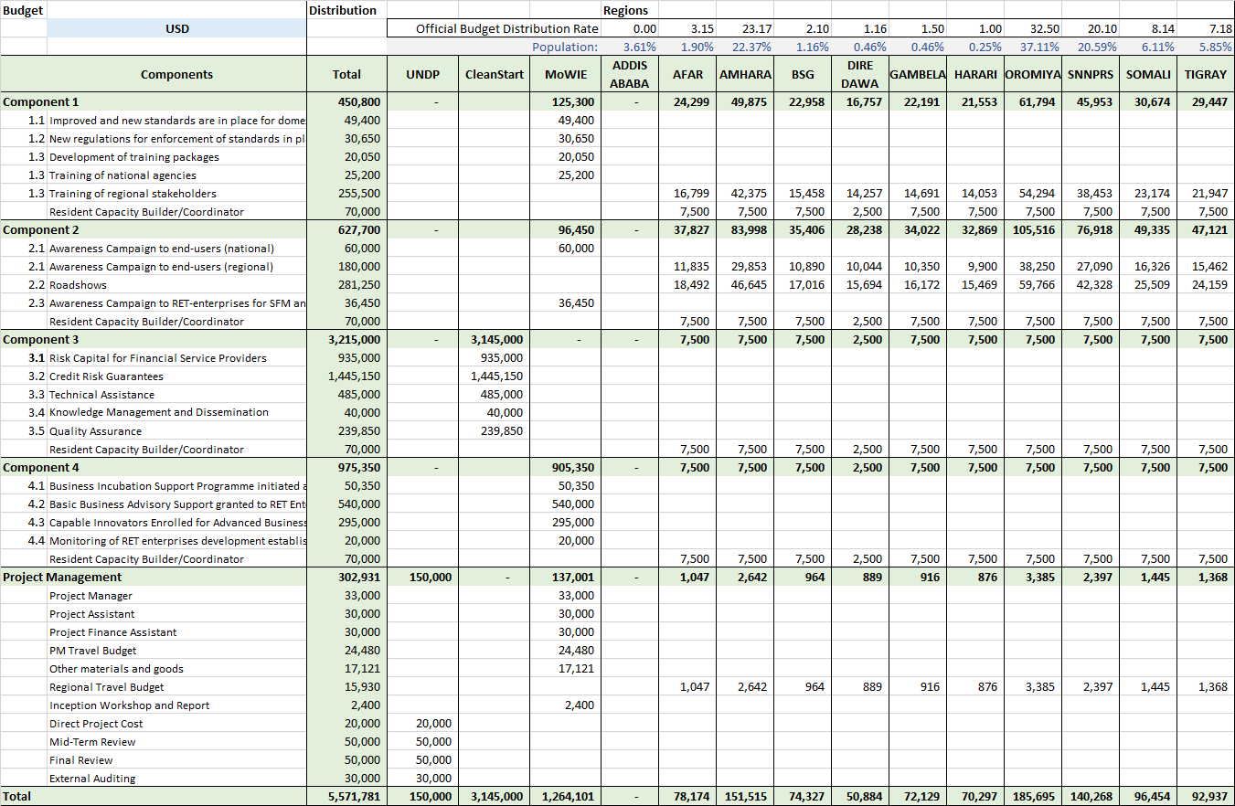
# | Budget Notes
1 | Local consultant  Technical support to standardization committees: 130 days @ USD 150 / day  Technical support to definition of new regulations: 70 days @ USD 150 / day  Consultant or Training institute to develop multifocal training packages (slides, posters, etc.): 31 days @ USD 150 / day  Local trainers: 45 days @ USD 150 / day and 590 days @ USD 150 / day
2 | International consultants  Standardisation of ICS and solar PV technology: 46 days @ USD 650 / day  Int. Expert on standards, rules and regulations for RET and trainer: 60 days @ USD 650 / day
3 | Printing and Publications of training materials
4 | Training cost - sessions in public places if required
5 | Consultants cost for Residential Capacity Builder/Coordinator in nine regions (1/4)
6 | Local consultant to support awareness campaign to RET enterprises: 43 days @ USD 150 / day
7 | Broadcasting services (TV, Radio, newspapers, web)
8 | Marketing agent for production of advertisements (TV, radio, newspaper, web)
9 | Design, publication and distribution of promotion materials and distribution
10 | Consultants cost for Residential Capacity Builder/Coordinator in nine regions (1/4)
11 | Local consultants for different TAs: 1,165 days @ USD 100 / day (see CleanStart Detailed Business Plan - Ethiopia for details)
12 | International consultants for different TA: 545 days @ USD 500 / day (see CleanStart Detailed Business Plan - Ethiopia for details)
13 | Credit risk guarantees for loans to RET suppliers by DBE and FSP (MFIs)
14 | Two full-time CleanStart project management staff based in Addis Ababa
15 | Production of promotional materials for trade fairs between FSB and RET enterprises and distribution
16 | DSA and local travel cost for the local and international consultants in Component 3
17 | Consultants cost for Residential Capacity Builder/Coordinator in nine regions (1/4)
18 | Local consultants to support the business incubation support programme at MoWIE: 69 days @ USD 150 / day  Local consultant to monitor and record the performance of the RET enterprises and administer the data base: 100 days @ USD 150 / day
19 | Micro-Capital - Kick-off capital (3 x 40 x USD 4500) and large-scale support grants (3 x 4 x USD 25,000) to RET enterprises as business incubation support
20 | Information Technology Svcs - IT service contract for programming of a monitoring database to track the performance or RET enterprises
21 | Service contracts for external training services of the RET enterprises in the business incubation process
22 | Micro Capital - Partly contribution to #19 above.
23 | Consultants cost for Residential Capacity Builder/Coordinator in nine regions (1/4)
24 | Two full-time staff for project office in Addis Ababa
25 | Travel budget for project office staff and representatives from the regions
26 | Other material and goods (reserve)
27 | DSA corresponding to travel budget for project office in Addis Ababa and the regions (ETB 350 per day)
28 | Direct Project Cost as per LoA between UNDP and MoWIE
29 | Inception workshop cost (USD 40 per person x 2 days x 30 participants)
30 | One full time staff (financial assistant) for project office in Addis Ababa
31 | Mid-term review and final evaluation
32 | Travel budget for project office staff and representatives from the regions
33 | Fees for annual financial audits (USD 6,000 per year)

Work plan
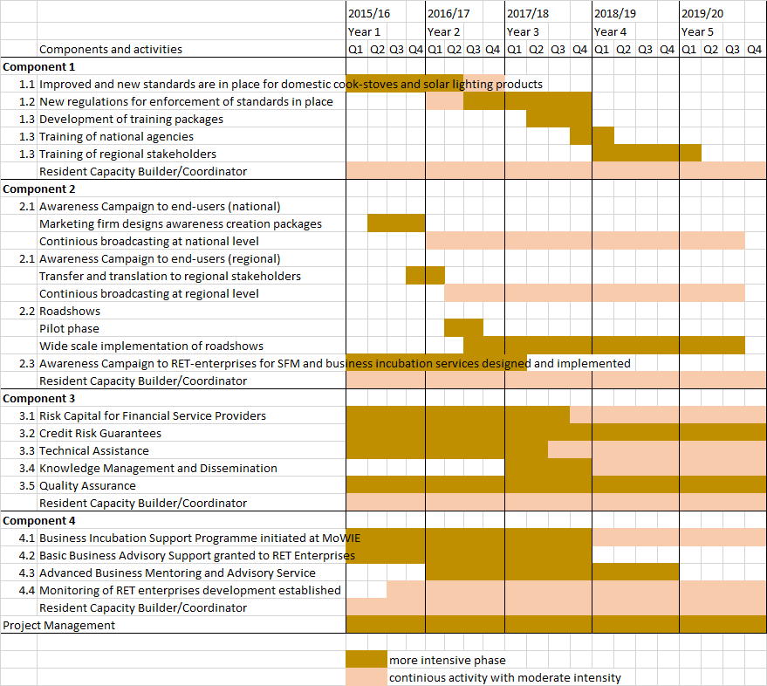

This work plan indicates an ideal sequencing of activities, yet some are relying on external circumstances (e.g. rules and regulations can only follow existing and accepted standards).

Section IV: Additional Information

List of References

[1] | Central Statistical Agency, “Population Projection of Ethiopia for All Regions at Wereda Level 2014 - 2017,” Government of Ethiopia, Aug 2013.
[2] | IMF, “World Economic Outlook,” IMF, Washington, DC, Oct. 2014.
[3] | Deloitte, “Deloitte on Africa: The "New" Economies in Africa,” Deloitte & Touche, 2013.
[4] | World Bank, “Ethiopia Overview,” The World Bank Group, 09 2014. [Online]. Available: http://www.worldbank.org/en/country/ethiopia/overview. [Accessed 2014].
[5] | Ministry of Water and Energy, “Ethiopian National Energy Policy (2nd Draft),” Federal Democratic Republic of Ethiopia, 2012.
[6] | Federal Democratic Republic of Ethiopia, “Growth and Transformation Plan 2010/11-2014/15,” Ministry of Finance and Economic Development, Addis Ababa, Nov. 2010.
[7] | FDRE, “Ethiopia's Climate-Resilient Green Economy: Green economy strategy,” Federal Democratic Republic of Ethiopia, Addis Abeba, Nov. 2011.
[8] | FDRE, “Science, Technology and Innovation Policy,” Addis Ababa, Feb. 2012.
[9] | reegle, “Ethiopia (2014),” reegle, 2014. [Online]. Available: http://www.reegle.info/policy-and-regulatory-overviews/ET. [Accessed 07 11 2014].
[10] | Ministry of Finance and Economic Development, Growth and Transformation Plan Annual Progress Report for F.Y. 2012/13, Addis Ababa, February 2014.
[11] | LA Market Study, Addis Ababa, 2013.
[12] | Federal Democratic Republic of Ethiopia, “Rural Electrification Fund Establishment Proclamation No. 317 of 2003,” Federal Negarit Gazeta No. 35, 9th year, 6 February 2003, pp 2098-2104, Addis Abeba, 2003.
[13] | Ethio Resource Group, “Solar Energy Vision for Ethiopia: Opportunities for Creating a Photovoltaic Industry in Ethiopia,” International Solar Energy Institute, Freiburg (Germany) / Addis Ababa (Ethiopia), 2012.
[14] | FDRE, Initial National Communication of Ethiopia to the United Nations Framework Convention on Climate Change (UNFCCC), Addis Ababa, 2001.
[15] | Ethio Resource Group, “Lighting Africa Program: Ethiopia Market Intelligence,” Addis Ababa, June 2013.
[16] | J. G. R. K. E. Olivetti, “Life Cycle Assessment of Alkaline Batteries with Focus on End‐Of‐Life Disposal Scenarios,” MIT, NEMA, 2011.
[17] | Ministry of Water and Energy of the FDR of Ethopia, Energy Balance and Statistics for years 2005/06-2009/10, Addis Ababa, 2011.
[18] | D. H. A. H. M. K. P. S. S. Geissler, “Biomass Energy Strategy Ethiopia,” EUEI-PDF, Eschborn, Dec. 2013.
[19] | The World Bank, Managing Water Resources to Maximize Sustainable Growth, 2006.
[20] | UNDP, “UNDP Country Programme Document 2012-2015,” UNDP, http://www.africa.undp.org/content/rba/en/home/about-us/country_programme_documents/.
[21] | MoWIE, National Programme for Improved Household Biomass Cook Stoves Development & Promotion in Ethiopia, Addis Ababa: Ministry of Water and Energy, 11.02.2013.
[22] | Ministry of Water and Energy, Fuelwood-Efficient Stoves Investment Plan 2012-2015, Addis Ababa, 2011.
[23] | Association of Ethiopian Micro-finance Institutions (AEMFI), “MFI Report,” AEMFI, Addis Ababa, June 2014.
[24] | G. N. F. M. E. Deribie, “Filling the Breach: Microfinance,” Journal of Business and Economic Management, vol. 1, 2013.
[25] | InfoDev, Climate Innovation Center Business Plan: Ethiopia, Washington: Information for Development Program (infoDev)/The World Bank, 2011.
[26] | World Bank/IFC, “Enterprise Surveys, Ethiopia,” 2011. [Online]. Available: http://www.enterprisesurveys.org/data/exploreeconomies/2011/ethiopia.
[27] | L. Stevenson and A. St-Onge, Support for Growth-Oriented Women Entrepreneurs in Ethiopia, Kenya and Tanzania, Geneva: International Labour Office, 2005.
[28] | Ministry of Water and Energy, “Proclamation Number 86/1997: A Proclamation Relating to Electricity,” Federal Democratic Republic of Ethiopia, [Online]. Available: www.mowr.gov.et/EEA/LEGAL/proclamation%20no.86-1997.pdf. [Accessed 18 12 2013].
[29] | giz, “Energy Coordination Office,” [Online]. Available: https://www.giz.de/en/worldwide/18899.html. [Accessed 20 10 2014].
[30] | Accenture, “Enhancing Markets for Delivery of Improved Cookstove Development and Promotion Support in Ethiopia,” Global Alliance for Clean Cookstoves, 2012.
[31] | M. Layec, “Ethiopia SE4All National Action Plan,” May 2014.
[32] | IMF, “IMF Country Report No. 13/308,” International Monetary Fund, Washington, D.C., 2013.
[33] | Federal Democtaric Republic of Ethiopia, Ministry of Water Resources, National Meteorological Agency, Climate Chance Technology Needs Assessment Report of Ethiopia, Addis Ababa, 2007.
[34] | World Health Organization, “WHO indoor air quality guidelines: household fuel combustion,” WHO, Geneva, 2014.
[35] | Federal Democratic Republic of Ethiopia, “Rural Development Policies and Strategies (Amharic),” FDRE, Addis Ababa, October 2002.
[36] | H. L. M. Shanko, “Household Energy Baseline Survey in SNNPR,” GIZ: ECO - Bio-Energy Department, Addis Ababa, 2011.
[37] | Energy+, “Privae Sector Consultation,” April 2, 2014. [Online]. Available: http://www.norway.org.et/Global/SiteFolders/webadd/Energy%20Plus%20Addis%20Ababa_Summary_Report_04.02.14_FINAL.pdf.
[38] | Dalberg Global Development Advisors, “Solar Lighting for the Base of the Pyramid - Overview of an Emerging Market,” Lighting Africa, Washington, DC, 2010.
[39] | National Programme for Improved Household Biomass Cook Stoves Development & Promotion in Ethiopia, Addis Ababa: Ministry of Water and Energy, 11.02.2013.
[40] | Lighting Africa, “Policy Report Note: Ethiopia,” 2012.
[41] | World Bank, “Ethiopia - Electricity Access Rural Expansion Project (PAD),” World Bank, 2008.
[42] | MoWIE, “Ethiopian National Energy Policy (2nd Draft),” MoWIE, Addis Ababa, Feb. 2013.
[43] | Central Statistical Agency, “Household Consumption and Expenditure (HCE) Survey 2010/11,” FDRE, Addis Ababa, Oct. 2012.
[44] | HIVOS, ABPP, SNV, National Biogas Programme Ethiopia - Phase II, Addis Ababa, January 2014.

List of Tables
Table 1: Overview over the regions of Ethiopia 8
Table 2: Needs of RET enterprises [25] 28
Table 3: Difficulties faced by Ethiopian women entrepreneurs of different sized companies. 28
Table 4: Ethiopia Improved Cook-stove Market Information - 2011 34
Table 5: Summary of baseline, GEF alternative and global environment benefit per component. 37
Table 6: Baseline and incremental market developments for small-scale solar technologies 39
Table 7: Baseline and incremental market developments for improved cook-stoves 39
Table 8: Payback analysis of selected technologies 41
Table 9: Exemplary stakeholders to receive training. 43
Table 10: Distribution of cash funding to implementing partners and regions. 88
Table 11: Overview of stakeholders, activities and their role in the project. 95
Table 12: Summary of relevant fast-track proposals under the CRGE Facility 98
Table 13: Bank Branches – June 2013 100
Table 14: Microfinance Institutions in Ethiopia – June 2014 102
Table 15: Baseline and incremental market developments for small-scale solar technologies (top) and improved cook-stoves (bottom) 109
Table 16: Baseline and incremental post-project market developments for small-scale solar technologies (top) and improved cook-stoves (bottom). 110
Table 17: Summary and contributions to the GEF Climate Change Mitigation Objectives as per the GEF Tracking Tool 111

List of Figures
Figure 1: Map of Ethiopia featuring the regions and major cities. 9
Figure 2: Level of GHG emissions from the forestry sector in a business-as-usual scenario up to 2030. [7] 14
Figure 3: Key assumptions taken to project the abatement potential in each sector for the CRGE Strategy [7]. 15
Figure 4: “Hot Spot” Wood Deficit Woredas and Positive Sustainable Wood Supply Woredas [18]. 17
Figure 5: Exemplary institutional set-up of the National Improved Cook-Stove Programme [22] 25
Figure 6: Micro-finance Market Growth in Ethiopia – 2003-2014 26
Figure 7: Operating scheme of the Guarantee Fund Mechanism 53
Figure 8: Implementation arrangements for Component 3 56
Figure 9: Overview of implementation arrangements 69
Figure 10: Partnership model for CleanStart Ethiopia and the UNDP-implemented, GEF-financed project 71
Figure 11: Deposits Mobilised by Banks in Ethiopia – 2012-13 99
Figure 12: Interest Rates in Ethiopia – 2002-13 100
Figure 13: Domestic Credit as a % of GDP in selected Sub-Saharan African Countries – 2011 101
Figure 14: Financial Inclusion in selected Sub-Saharan African Countries – 2011 101
Figure 15: Microfinance Market Growth in Ethiopia – 2003-2014 102
Figure 16: Largest MFIs in Ethiopia by Number of Borrowers – 2014 103
Figure 17: Smallest MFIs in Ethiopia by Number of Borrowers – 2014 104
Figure 18: Growth scenarios for small-scale solar technologies (left) and ICS (right) in units sold per year 108

List of Annexes
Annex 1: Additional Stakeholder Analysis
Annex 2: Analysis of Financial Service Providers
Annex 3: Current status of standards and regulations
Annex 4: Calculation of GHG Emission Reductions
Annex 5: Key Features for Terms of Reference of Key Project Personnel
Annex 6: UNDP Environmental and Social Screening Template
Annex 7: Co-Finance Letters
Annex 8: Letter of Agreement between UNDP and the Ministry of Water, Irrigation and Energy
Annex 9: Letter of Endorsement from the GEF Operational Focal Point

External Annex 1: Stakeholder analysis
External Annex 2: Technology selection report – cook-stoves
External Annex 3: Technology selection report - solar

Annex 1: Additional Stakeholder Analysis

Overview of Stakeholders
Table 11: Overview of stakeholders, activities and their role in the project.
Name or Title | Abbr. | Back-ground | Current goals or activities | Role in the project
Addis Ababa Institute of Technology | AAIT |  | Centre of Energy Technology (ICS, solar, hydro, geothermal, wind) | Academic back-up and guidance if required
Association of Ethiopian Micro-finance Institutions | AEMFI |  |  | Envisaged Technical Service Provider for training on SFM
BARR Foundation | BARR | - | Donor to the NBPE | None further
Ethiopian Climate Innovation Centre | ECIC | HoAREC/N, InfoDev, World Bank | Business incubation for innovative enterprises on climate | Stakeholder in Component 4 as possible provider of training services and experience
Department for International Development | DFID | United Kingdom |  | Donor of different activities through funds. Not a direct stakeholder.
Development Bank of Ethiopia | DBE |  | Lending to RET enterprises and MFIs for RET | Financial Service Providers in Component 3.  One of the implementing partners for ENREP
Electricity Network Reinforcement and Expansion Project | ENREP | EEPCO, DBE, World Bank |  | Provision of a 20 to 40 million USD loan to DBE for RETs.
Energy Coordination Office | ECO | GIZ, Supported by Germany, Netherlands, Norway, Australia, UK, Switzerland, Ireland | RET development, promotion, training, energy market development, policy, strategy and communication | Stakeholder in all components and potential provider of technical expertise, coordination and networks.
Enterpreneurship Development Centre | EDC | UNDP |  | Stakeholder in Component 4 as possible provider of training services and experience
Ethiopian Conformity Assessment Enterprise | ECAE |  | Testing of product quality | Stakeholder in Component 1 on products standards and potential partner for new regulations
Ethiopian Energy Authority | EEA | Supported by DFID |  | Stakeholder in Component 1 on product standards and potential executor of new regulations  Multiplier of awareness campaigns through its regional demonstration centres
Ethiopian Standards Authority | ESA |  | Development and issuance of standards | Facilitating the standardisation committees in Component 1
European Union | EU |  | Donor of the ACP-EC for investments in the power sector, supporting biogas together with SNV | Possible follow-up donor
Forum for Environment | FfE |  | Environmental awareness creation and advocacy activities | Stakeholder in Component 2 on awareness creation
Global Green Growth Institute | GGGI |  | Assisting the GoE with the CRGE initiative. | Coordination and oversight support to MoWIE
HIVOS |  |  | Fund manager for NBPE | Manager of funds, not a direct stakeholder
Horn of Africa Regional Environment Centre & Network | HoA-REC/N | Supported by EKN, Teri, ICCO, ACP-EU, DFID | Focus on climate change and energy and value chains for sustainable products and services | Parallel activities on RETs – thus a stakeholder and partner for the project
International Finance Corporation | IFC |  | Lighting Africa: Ethiopia | Managing SREP, which funds Lighting Africa: Ethiopia, thus an indirect stakeholder on Components 1 and 2
Irish Aid |  | Ireland |  | Possible follow-up donor
Kreditanstalt für Wiederaufbau | KfW | Germany |  | Possible follow-up donor  In dialogue with GoE
Lighting Africa - Ethiopia | LA | IFC/World Bank through SREP | Promotion of solar technologies | Stakeholder in Component 1 on solar products standards  Stakeholder in Component 2 on awareness creation
Local Economic Development Programme | LED | MoFED, UNDP, UNCDF, etc. | Strengthen public-private partnerships at regional and local levels | Stakeholder in Component 4 as possible provider of training services and experience through its Business Cluster Development Resource Centre and advisory centres
MoWIE – Bio-Fuel Development Coordination Directorate | BFDCD | MoWIE | Research & Development of biofuel technologies | Stakeholder in Component 1 on ICS products standards  Stakeholder in Component 2 on awareness creation
MSE Development Directorate |  | MoWIE | Supports the establishments of Micro and Small Enterprises | Stakeholder in Component 4
National (Domestic) Biogas Programme of Ethiopia | NBPE | MoWIE - AETDPD | Promotion and dissemination of biogas | Stakeholder in Component 1 on ICS products standards  Stakeholder in Component 2 on awareness creation
National Improved Cook-Stove Programme Ethiopia | NICSP | MoWIE, Norad, BARR | Promotion and dissemination of ICS | Stakeholder in Component 1 on ICS products standards  Stakeholder in Component 2 on awareness creation
Norwegian Aid | NORAD | Norway | Funding to CRGE on RET  Funding ECO through EnDev  Funding ECIC through InfoDev  Funding CleanStart through UNCDF | Possible follow-up donor  In dialogue with GoE on the CRGE
Regional Micro and Small Enterprise Development and Promotion Bureaus | ReMSEDA | FeMSEDA | Supporting MSEs | Stakeholder in Component 4 as possible provider of training services and experience
Rural Electrification Fund | REF | MoWIE AETDPD | Promotion of off-grid rural electrification (solar home systems) | Stakeholder in Component 1 on solar products standards  Stakeholder in Component 2 on awareness creation
Scaling-Up Renewable Energy Programme Project 2 “Clean Energy SMEs Capacity Building and Investment  Facility” | SREP | Managed by IFC, funded by Climate Investment Funds | investments in wind, geothermal, and SME renewable energy development | Not a direct stakeholder
Stichting Nederlandse Vrijwilligers (Netherlands Development Organisation) | SNV | Netherlands | Provision of technical support to the NDBP/NBPE | Stakeholder in Component 1 on ICS products standards  Stakeholder in Component 2 on awareness creation
Solar Energy Development Association - Ethiopia | SEDA-E |  | Lobby for solar technology and business | Stakeholder in representing the private sector on solar technology in all components
Solar Energy Foundation | SEF |  | Promotion and dissemination of solar technologies | Stakeholder in Components 1 on solar products standards
USAID | USAID | USA | No plans for off-grid energy services | No relevant activities
World Bank | WB |  | ENREP, InfoDev, Lighting Africa | Funding the ENREP and thus stakeholder in Component 3
World Food Programme | WFP |  | Promotion and dissemination of RETs | Parallel activities on RETs – thus a stakeholder and partner for the project
World Vision Ethiopia | WV |  | Promotion and dissemination of RET | Stakeholder in Component 2 on awareness creation

Table 12: Summary of relevant fast-track proposals under the CRGE Facility
Project title | Lead organization | Project summary | Project duration / Total funding requested
Solar power for water supply and irrigation | MoWIE  Director, Water Supply and Sanitation  and  Director, Irrigation and Drainage | An estimated 10,000 diesel pumps are in use for water abstraction in Ethiopia. There are plans in place to replace them with solar or wind power at around 500 sites – in line with the Green Economy strategy. The design work is nearing completion, but there are insufficient funds for implementation. This project therefore aims to fund the implementation and roll-out of solar water pumps for water supply and for irrigation. | 1.05.2014  To  31.12.2015
Solar power for water supply and irrigation |  |  | USD 3 million
Accelerating the National Biogas Programme Ethiopia (NPBE) | MoWIE  National Biogas Programme for Ethiopia  through the Biogas Programme Coordination Units (at national and regional level). | The National Biogas Programme aims to stimulate the development and use of biogas digesters to replace traditional fuel usage. Phase 1 (2009-2013) aimed to deliver 14,000 digesters but has only achieved 8,000. This shortfall is due to two main reasons:  - Poor understanding of the benefits of biogas  - Limited access to credit for households to purchase and install biogas digesters  Therefore, this project aims to accelerate the delivery of the NPBE Phase II (2014-2017) by enabling carbon financing of biogas to reduce costs to households; by providing financial support for construction costs; and by improving promotion of biogas to stimulate demand. | 1.05.2014  to  31.12.2015
Accelerating the National Biogas Programme Ethiopia (NPBE) |  |  | Total project budget will be USD 1,592,168  but it is anticipated to leverage a further USD 2,556,000 from the carbon market for 2015-2017.
Improving the Livelihoods and Lifestyle of Rural Community of the Emerging Regional States through the Dissemination of Solar Energy Technologies | MoWIE  AETDPD  REF | Many remote communities, especially the rural community of Emerging Regions (Ethiopian Somali, Benishangul-Gumuz, Afar and Gambela), lack basic services, including electricity, telephone, education, water supply and sanitation.  The main project activities are:  - Distribution of Solar Home System (SHS) to 5,000 households in all the four regions;  - Distribution of solar lanterns of 20,000 units in all the four regions;  - Distribution of institutional photovoltaic systems units: 20 for rural primary schools, 20 for rural health posts, 5 for farmer training centres, 16 for small-scale irrigation/productive activities.  The proposed budget to be allocated:  For SHS - USD 1,500,000; for Solar Lanterns - USD 300,000; for distribution of institutional PV system units - USD 1,000,000; for inspection, monitoring and evaluation - USD 100,000; for capacity building (Experience Sharing & Study Tour) - USD 100,000 | 01/04/2014 to 30/09/2015
 | MoWIE  AETDPD  REF |  | USD 3 million

Annex 2: Analysis of financial service providers

Ethiopia Financial Sector Overview
Ethiopia's financial sector is relatively small by global and regional standards and has been historically dominated by Government-owned financial institutions, although several private sector banks have become prominent in recent years. As of June 2013, the country’s financial sector consisted of 2 public sector commercial banks, 1 public sector specialised development bank, 16 private sector commercial banks and 31 Microfinance Institutions (MFIs). MFIs operate regionally in Ethiopia, with the largest MFIs in each region backed by their respective regional governments, although some of the largest MFIs have begun to operate outside their core regions. The non-bank financial sector is also small and consists mainly of 16 insurance companies. Foreign banks and financial institutions are not allowed to operate in Ethiopia.

In the financial year 2012-13, public sector banks mobilised 66% of all deposits in the country and disbursed 67% of all outstanding loans and advances at the end of the year. The country’s largest bank, Commercial Bank of Ethiopia (CBE), which is majority-owned by the Federal Government, disbursed 52% of all outstanding loans and advances in the country at the end of the year. In comparison, the largest private sector banks in terms of outstanding loans disbursed were Awash International Bank and Dashen Bank with just 6% and 7% share respectively, as shown in figures 10 and 11 below.

Figure 11: Deposits Mobilised by Banks in Ethiopia – 2012-13
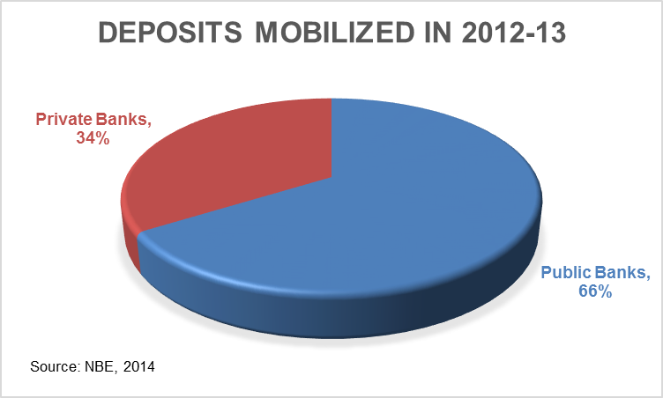
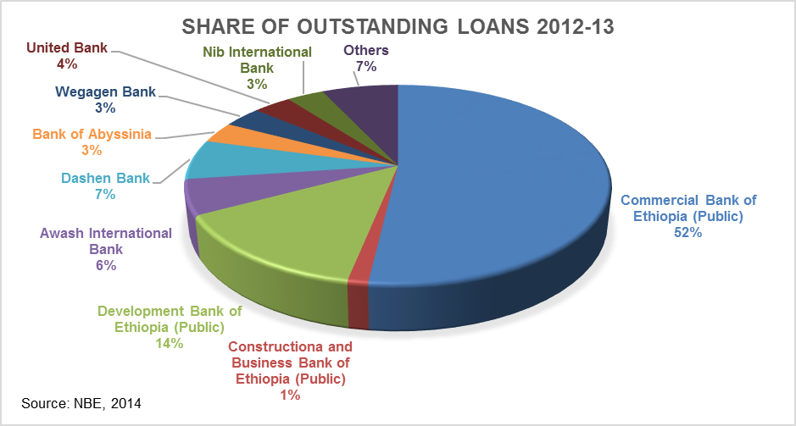

Ethiopia’s financial sector is regulated by National Bank of Ethiopia (NBE), which also regulates and supervises all foreign exchange transactions, payments and remittances. The Ethiopian financial sector was inefficient and fragile before 1991. However, since the current government came to power, several financial sector reforms have been introduced, such as allowing domestic private sector investments into the banking sector and clarifying the role of NBE as a regulator. Nonetheless, further reforms need to be introduced in the financial sector to make it more efficient and increase its outreach, so that it becomes a catalyst to the country’s rapid economic growth in the near future.

Deposit and credit interest rates are largely controlled and, hence, have remained stable since 2002, as shown in Figure 13 below. However, this controlled, low interest rate regime, in combination with high rate of inflation, has resulted in negative real interest rates, causing low yields from savings and deposits.

Figure 12: Interest Rates in Ethiopia – 2002-13
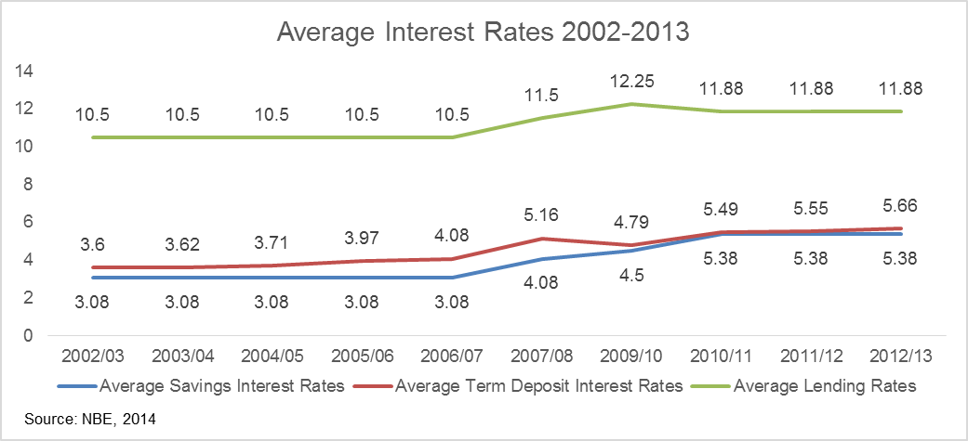

Private sector banks, albeit smaller than public sector banks, have made significant progress in setting up branches and increasing their outreach, at least in Addis Ababa. Private sector banks account for 69% of all bank branches in Addis, when compared to 31% by public sector banks. However, public sector banks, particularly CBE, have a strong presence and outreach outside Addis, accounting for 61% of branches in the regions, as shown in the table below.

Table 13: Bank Branches – June 2013
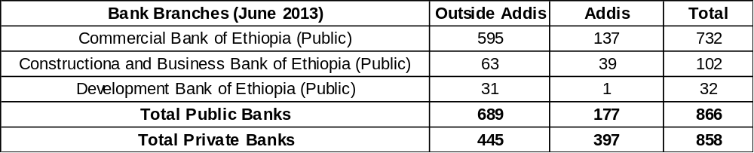
In 2011, domestic credit as a share of GDP in Ethiopia was about 17.2%, which was much lower than the Sub-Saharan Africa average of 30%. In comparison, in Kenya it was 29% and in Nigeria it was 31.1%. Financial inclusion in Ethiopia, measured as the number of bank accounts per 1,000 population, was one of the lowest among large Sub-Saharan African countries. Ethiopia had just 91.7 bank accounts per 1,000 population, in comparison to 328.4 in Kenya, 298.8 in Ghana, 245.6 in Nigeria, 169.5 in Uganda, 126.6 in Tanzania and 153.7 in Zambia. These are shown in Figures 13 and 14 below.

Figure 13: Domestic Credit as a % of GDP in selected Sub-Saharan African Countries – 2011
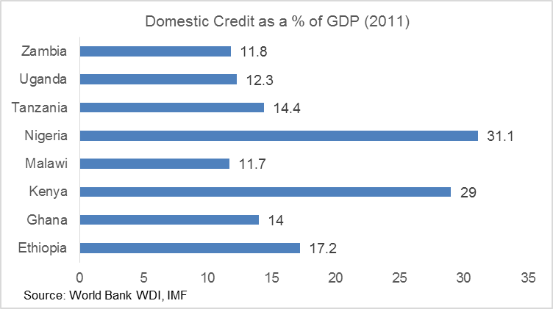

Figure 14: Financial Inclusion in selected Sub-Saharan African Countries – 2011
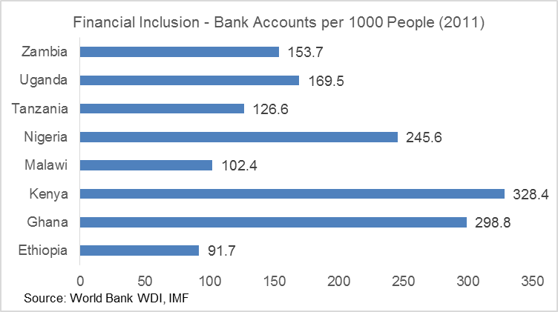

Microfinance Sector
According to data from the Association of Ethiopian Microfinance Institutions (AEMFI), as of June 2014, the 31 licensed MFIs in the country served nearly 3.27 million active borrowers and their combined outstanding loan portfolio was ETB 14.3 billion (nearly USD 715 million). These MFIs had also mobilised savings worth ETB 9.3 billion (nearly USD 465 million). The microfinance industry in Ethiopia has grown steadily since 2003, growing from serving just 746,000 customers in 2003 and a gross loan portfolio of ETB 330 million (USD 16.4 million) to 3.27 million active borrowers and a gross loan portfolio of ETB 14.3 billion in 2014, as shown in Figure 15 below. The average loan per borrower has also increased from ETB 441 in 2003 to ETB 4372 in 2014.

Table 14 below provides a list of all 31 MFIs along with the names of the regions in which they operate, their outstanding loan portfolio and the number of active borrowers they serve.

Figure 15: Microfinance Market Growth in Ethiopia – 2003-2014

Table 14: Microfinance Institutions in Ethiopia – June 2014
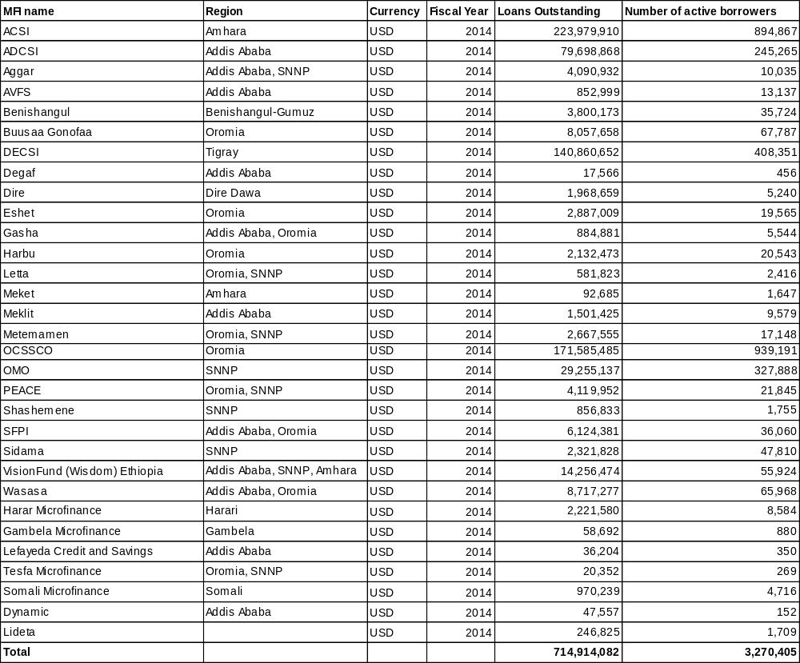
As explained earlier, most of Ethiopia’s largest MFIs operate within specific regions but in large regions such as Oromia, Amhara, SNNP and Addis Ababa, where demand for micro-credit is high, several privately-owned MFIs operate as well. For example, 11 MFIs operate in Addis Ababa, although the largest MFI there is still the local government-backed Addis Credit and Savings Institution (ADCSI, 245,265 active borrowers). Similarly, 8 MFIs operate in Oromia region, although the regional government-backed Oromia Credit and Savings Share Company (OCSSCo, 939,191 active borrowers) is still the largest. OCSSCo is also Ethiopia’s largest MFI in terms of number of active borrowers although Amhara Credit and Savings Institution (ACSI) has the largest outstanding MFI loan portfolio in Ethiopia. Three MFIs operate in Amhara region (regional government-backed ACSI is the largest) and 8 MFIs operate in the Southern Nations region (regional government-backed OMO Microfinance is the largest). Tigray region, which has a well-developed microfinance market, has just one large regional government-backed MFI, Debit Credit and Savings Institution (DECSI, 408,351 active borrowers) operational.

Several private sector MFIs operate in Oromia, Amhara, Addis Ababa and SNNP regions. Among them, Wasasa (operates in Oromia and Addis, has 65,968 active borrowers), Buusa Gonofaa (operates in Oromia, has 67,787 active borrowers), Wisdom (operates in SNNP, Addis and Amhara, has 55,924 active borrowers) and Sidama (operates in SNNP, has 47,810 active borrowers) are prominent examples.

In contrast, smaller regions such as Harari, the City of Dire Dawa and the emerging regions of Benishangul-Gumuz, Gambela, Somali and Afar have single, small MFIs operational and all these MFIs are backed by their regional governments. In fact, the MFI in Afar has only recently been established and it is yet to begin operations. The MFI in Somali region was established only in 2011 but has made progress, acquiring 4,716 customers since then. Microfinance markets and MFIs in emerging regions of Benishangul-Gumuz, Gambela, Somali and Afar are under-developed and these MFIs are small in terms of their loan portfolios and outreach. These MFIs are also yet to stabilise their core lending operations for income-generating activities such as agriculture or trading. Figures 17 and 18 below show the largest and smallest MFIs in Ethiopia based on their outreach (number of active borrowers).

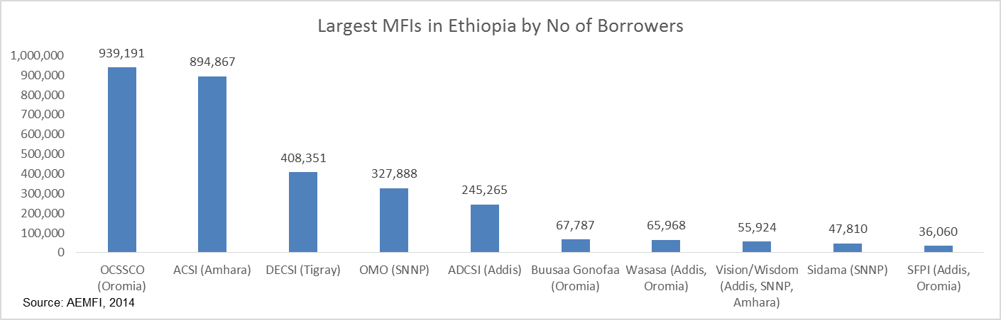
Figure 16: Largest MFIs in Ethiopia by Number of Borrowers – 2014

Figure 17: Smallest MFIs in Ethiopia by Number of Borrowers – 2014
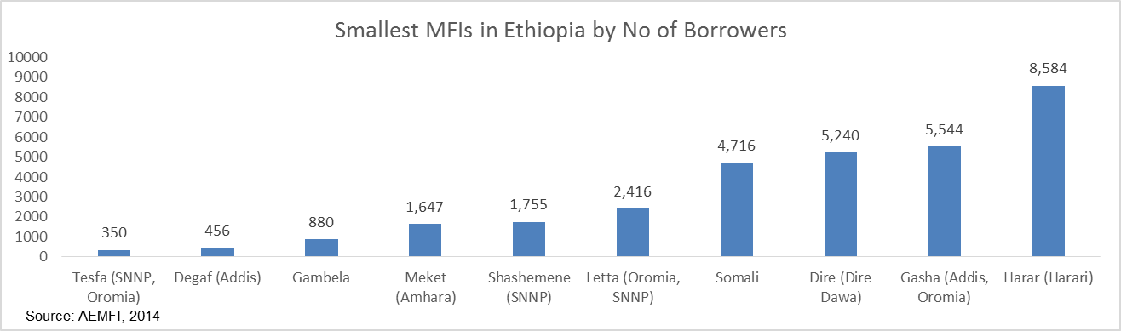

Ethiopia’s financial sector also consists of a number of Savings and Credit Cooperatives (SACCOs), which operate within small geographical areas and within small rural communities, often providing savings and credit services to their small groups of members. Many of these SACCOs use savings and, at times, credit services provided by MFIs, although they tend to operate as separate entities with very limited formal interaction with MFIs or banks. According to some estimates, there are over 39,000 cooperatives of many kinds, including 4,500 rural SACCOs and about 212 credit unions, active in Ethiopia. Rural SACCOs primarily serve farming communities, including remote and pastoralist communities. Many of these SACCOs access loans from credit unions and have played an important role in delivering credit for fertilizer and food security programmes. Although SACCOS have existed for over fifty years in Ethiopia, performance and expansion is still relatively low compared with neighbouring countries such as Kenya. Ethiopian SACCOs often suffer from limited outreach, weak management, limited access to capital and severe challenges with financial sustainability. Lack of a formal SACCO federation has constrained Ethiopian SACCOs from being engaged in the development and revision of financial products and promotion of financial literacy. Ethiopia has no formal structures in place to monitor the performance or to supervise the operation of SACCOs.

Ethiopia’s microfinance industry, including SACCOs, has largely provided group-based lending and savings products for agriculture and other income-generating activities, although individual lending products have become increasingly common. Asset/housing loan products, micro-insurance products and money transfer/pension services are also being offered widely these days. The typical MFI loan tenor is less than 2 years and interest rates range between 10% and 24%, although regional government-backed MFIs typically offer loans at lower interest rates than privately-owned MFIs.

Ethiopia’s microfinance industry has faced similar challenges as the country’s banking sector, such as limited availability of liquidity, stagnant interest rates vis-à-vis high inflation and, hence, limited ability to achieve improvements in financial profitability and efficiency measures. Nonetheless, the sector continues to grow and, with an outreach of nearly 3.3 million (reaching 4% of the country’s total population), it is one of the largest microfinance sectors in Africa.

Annex 3: Current status of standards and regulations
The stove standard is developed under Technical Committee 49 (Tractors, machinery for agriculture and forestry and mechanical handling equipment).

The standard being developed is for biomass stoves (not for all stoves). The standard is to be issued with the title “Biomass stove performance requirements and test methods for household biomass stoves.”

The members of the biomass stove technical sub-committee are:

- MOWIE/AETDPD – Chair
- Ethiopian Standards Agency (ESA) – Secretary
- Ethiopian Energy Authority (EEA)
- Addis Ababa University (AAU, Mechanical Engineering Department)
- FeMSEDA
- Ministry of Environment and Forest (MEF)
- Ministry of Science and Technology (MoST)
- Ethiopian Institute of Agricultural Research (EIAR)

Solar system component standards are developed under Technical Committee (TC) 62 (Electrical Conductors and Power Supply System). The standards are developed for PV panels, batteries, inverters, test methods.

The members of the sub-committee for solar components are:

- MOWIE/REF – Chair
- Ethiopian Standards Agency (ESA) – Secretary
- Ethiopian Energy Authority (EEA)
- Addis Ababa University (Electrical Engineering Department)
- Ethiopian Electric Power (formerly EEPCO)
- Ethiopian Electric Utility (formerly EEPCO)
- Electrical work contractors (selected companies)
- Ethiopian Society of Electrical Engineers
- Metals and Engineering Corporation (METEC)
- Ethiopian Conformity Assessment Enterprise (ECAE)
- Solar Energy Foundation (SEF)

The procedure for standard development and approval
- Each TC (Biomass stoves, solar PV components) has membership as shown above. Usually, TCs create Working Groups (WGs – i.e. sub-committees) that develop the technical standards in detail. In the case of the biomass stove standards, for example, the WG was composed of AETDPD, AAU, ESA and FeMSEDA.
- WGs submit draft technical standards to the TC for approval
- Upon approval by the TC, the standard is documented as the Draft Standard and submitted to the National Council of Standards (NCS), which approves the standard (or asks for review, or rejects)
- Upon approval by the NCS, the standard is sent to the Prime Minister’s Office for final approval and national adoption

The National Council of Standards (NCS) is chaired by the Minister of the Ministry of Science and Technology (MoST) with high-level representation (Ministers, State Ministers and senior officials):

- Ministry of Science and Technology (MoST) – Minister, Chair
- Ministry of Trade (MoT)
- Ministry of Agriculture (MoA)
- Ministry of Works and Urban Development (MoWUD)
- Ethiopian Leather Institute
- National Metrological Institute
- Addis Ababa University

Funding for standard development
The Ethiopian Standards Agency is developing standards – not only the two energy-related standards but also other standards which number more than 100 – with support from GIZ. The GIZ fund covers basic costs of TC meetings and standard development (e.g. member transport costs, etc. to a total of about Birr 2,000 per member from beginning to end; 4 to 5 meetings are held per standard).

The support from GIZ will end in March 2015.

Standard development
Both the biomass stove and the solar PV component standards are adopted from international and selected country standards. The biomass stove standard was adopted after review of similar standards from Kenya, India and China. The standards for PV components are derived from IEC standards.

The draft standards have already been completed by the TCs. The TC members consulted (ESA, AETDPD, REF; ESA is Secretary for both) say that the draft standards are ready for submission to the National Council of Standards.

Required support
ESA sees a need to publicise (public, enterprise awareness development) the standards and train enterprises to use the standards. ESA also needs support to expand stove standards to include non-biomass stoves (electric, petroleum, and liquid biofuels).

Discussions with the ESA and MoWIE have indicated that the standards under development require further refining and diversification. For example, they have draft standards only for cooking (not baking) and only for solid biomass fuels. They want to develop more standards and refine existing ones.

- Skill development for ESA (and TC member institutions)
- Visits to countries with working standards for stoves, solar PV
- Consultant inputs (both international and local)
- Refine existing draft standards
- Develop new standards for Injera baking
- Develop new standards for liquid fuels and electricity
- Provide standard development training for standard setting committee member institutions

Annex 4: Calculation of GHG Emission Reductions
Fuel wood consumption is the main source of GHG emissions in Ethiopia. The wood is mainly used for residential baking and cooking purposes. As most of the households, particularly in rural areas, use highly energy-inefficient technologies (e.g. open fire or three-stone technology), the improvement potential is significant. The dissemination of technologies leading to a reduction in fuel wood consumption, either by making more efficient use of it or by shifting to other, less carbon-intense fuels such as biogas or biofuels, can be a major lever for GHG abatement.

The pattern of stove usage varies between regions and according to cooking/baking traditions. One common feature, however, is that most households need both a stove for cooking (sauces, coffee, etc.) and a stove for baking (Injera).
Fuel-efficient stoves include (for example) the Mirt for baking Injera bread, and the Tikikil for cooking.

The total abatement potential for each stove-type is calculated based on the efficiency improvement: i.e. the percentage of fuel wood that can be saved by employing different technologies. The calculation is based on efficiency evaluations and testing data from MoWIE, as well as donor organisations active in the promotion of efficient stoves (e.g., ECO-GIZ).

The Technology Selection Report for Cook-Stoves (Annex II) features different types of stoves and the results of performance and efficiency testing. The potential savings are 50% (average for both cooking and baking) for fuel wood-efficient stoves. Further analysis in the Fuel Wood-Efficient Stoves Investment Plan 2012-2015 [22] includes the effects of forest degradation (use of non-renewable biomass) and the effects of forests as carbon sink, and yields an abatement potential of 0.6 – 1.4 tCO2e/stove/year, depending on the stove-type. The World Vision ICS CDM PoA of includes the effects of deforestation and estimates GHG reductions of 1.08 tCO2e/year for Mirt, and 1.14 tCO2e/year for Tikikil – thus, an average of 1.1 tCO2e/year.

The lifetime of ICS depends first of all on the type of stove, ranging from 1.5 to 4.5 years for typical usage in a household. Following the CDM PoA, a lifetime of 3 years has been used for the calculations of the direct emission reductions.

For calculating the effects of small-scale solar technologies, the key assumption is that each solar product replaces the kerosene lamp(s) in a household. There might be a share of a solar lanterns purchased for the purpose of back-up during power failures: thus, the full operating hours of a kerosene lamp cannot be included in the calculations. On the other hand, solar home systems with 2 or 3 LED bulbs can replace not only the kerosene lamps in a household but also candles and torches or firewood as source of light. An average Ethiopian household uses 22.8 litres of kerosene per year [15], plus candles and batteries for torches. A CDM PoA for solar lanterns estimates 32 litres of kerosene per household per year for Kenya.

The solar hardware lifetime is calculated as three years, which is highly conservative. The emission factor of kerosene is 2.41 kg CO₂e per litre.

As described in the Baseline Analysis section, based on actual market developments a baseline scenario has been developed with an estimated growth scenario for the small-scale solar technology market of 23% compound annual growth rate (CAGR) and the ICS market with 17% CAGR per year, both between 2014 and 2019.

As described in the Rationale and Summary of GEF Alternative section, it is estimated that, with project support, the small-scale solar technologies market will grow by 28.4% compound annual growth rate (CAGR) and the ICS market by 24.8% CAGR between 2014 and 2019. This incorporates both a bottom-up approach of direct investments through the sustainable financing mechanism and a top-down approach of market impact due to the other GEF project activities. The following graphs outline these developments.

Figure 18: Growth scenarios for small-scale solar technologies (left) and ICS (right) in units sold per year
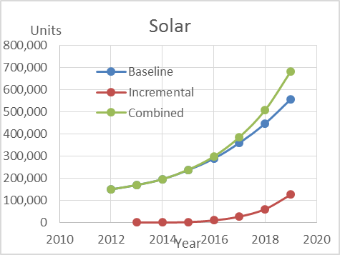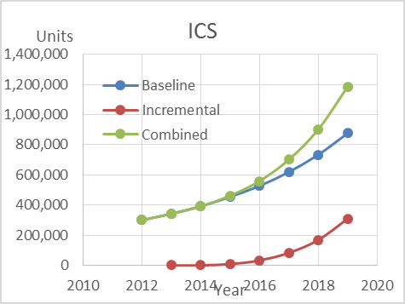

For example, for 2017 the calculation is as follows: 25% per annum baseline growth for small-scale solar technologies means that, in 2017, 359,804 solar units are sold. With an additional growth rate of 5 percent points on top of the baseline due to the effects of the project, the units sold are 386,626 in 2017. The difference or increment is 26,822 units. 26,822 solar units replaces the kerosene of 26,822 households, thus avoiding 22.8 litres of kerosene. Over a lifetime of 3 years, and an emission factor of 2.41 kg CO₂e per litre kerosene, the GHG emission reductions are calculated as 26,822 x 22.8 x 3 x 2.41 = 4,421,445 kg CO₂e, or 4,421 t CO₂e for all small-scale solar technologies sold in 2017.

The calculation for ICS and all the other years is similar. Hence, the total direct incremental GHG emission reductions from solar products are approximately 37 kilo tonnes of CO₂e, and the 600,000 additional ICS would avoid 1.98 Mt CO₂e over their lifetime of 3 years. The following table features the full calculation on an annual basis.

Table 15: Baseline and incremental market developments for small-scale solar technologies (top) and improved cook-stoves (bottom)

Besides the growth in units, an indicative investment volume has been calculated using average prices per item. An overview of price per item is presented in Table 8: Payback analysis of selected technologies. Stove cost varies by model and by source or quote from disseminating agencies (e.g., MoWIE, GIZ and World Vision). ETB 300 or USD 15 has been used for the purpose of this calculation on ICS.

The cost of solar products ranges widely, depending mainly on the capacity of the PV panel and battery. The average price per item was calculated as USD 39 per unit, based on total turnover (USD 5.9 million) and market volume figures (USD 150,000) given in a recent market study [15]. While the average price was kept stable throughout the scenario, the average system capacity, starting at 6.5 Wp per unit in 2012, was increased moderately to reflect the globally falling cost of photovoltaic panels in price per Watt peak, improved affordability, and a general increase in energy demand per capita. Hence, it is calculated that the total additional capacity in PV added during the project period is 2.55 MWp.

Assuming that the credit-risk guarantees put in place in component 3 will stay effective for at least 10 years after the project period and will leverage investments of at least USD 7 million, the direct post-project investments are calculated to be 300,000 solar products and 560,000 ICS. Including effects of extended lifetime (see below) the calculation (E.g. 300,000 solar products x 0.05 t CO₂e/year x 4 years = 0.069 Mt CO₂e plus 560,000 ICS x 1.1 t CO₂e/year x 4 years = 2.53 Mt CO₂e) of the lifetime direct post-project GHG emissions avoided indicates a total 2.53 Mt of CO₂e.

The indirect post-project emission reductions are calculated with a decelerating additional growth rate for the products, as the effects of awareness creation (top-down) and financing (bottom-up) transition into a new business-as-usual scenario. Further, due to implementation of new product standards and regulations, it is estimated that the quality, and thus durability, of the incremental sales of products on the market will be increased to at least 4 years. Thus, for the next 5 years after the project, the emission reductions will be 16.8 Mt of CO₂e, taking into account an extended life time of 1 year (four instead of three years) for the incremental sales achieved on the market, and the GHG effects of the incremental sold units. Details are provided in the table below.

Table 16: Baseline and incremental post-project market developments for small-scale solar technologies (top) and improved cook-stoves (bottom).
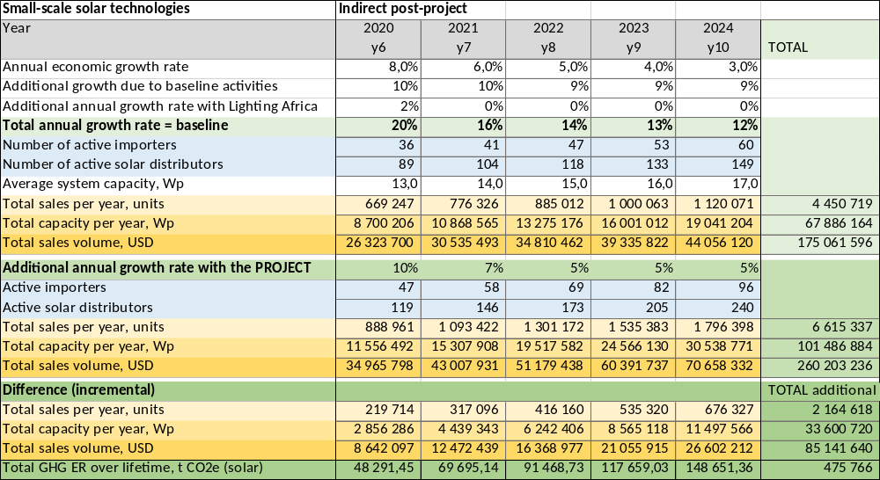

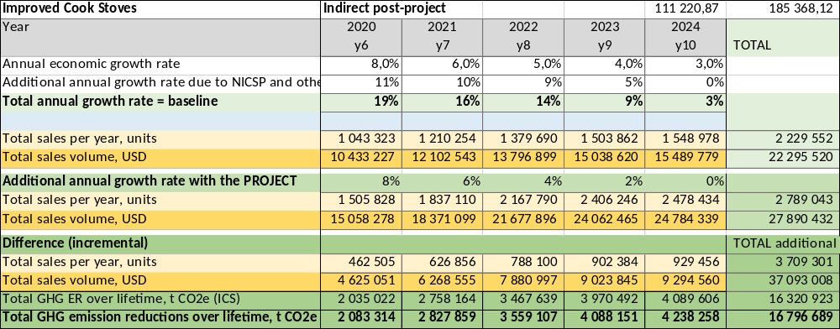

Table 17: Summary and contributions to the GEF Climate Change Mitigation Objectives as per the GEF Tracking Tool
Objective 2: Energy Efficiency
Lifetime energy saved (ICS only) | 35,478,000,000 | MJ
Lifetime direct GHG emissions avoided | 1,978,389 | tonnes CO2eq
Lifetime direct post-project GHG emissions avoided | 2,464,000 | tonnes CO2eq
Lifetime indirect GHG emissions avoided (bottom-up) | 6 to 10 million (1) | tonnes CO2eq
Lifetime indirect GHG emissions avoided (top-down) | 16,796,689 | tonnes CO2eq
Objective 3: Renewable Energy
Installed capacity per technology directly resulting from the project
Photovoltaic (small scale solar technologies) | 2.5 | MW
Lifetime energy production per technology directly resulting from the project
Photovoltaic (small scale solar technologies) | 10,950 | MWh
Lifetime direct GHG emissions avoided | 37,074 | tonnes CO2eq
Lifetime direct post-project GHG emissions avoided | 69,235 | tonnes CO2eq
Lifetime indirect GHG emissions avoided (bottom-up) | 111,000 to 185,000 (1) | tonnes CO2eq
Lifetime indirect GHG emissions avoided (top-down) | 475,766 | tonnes CO2eq
      - Not calculated separately because separating the effects of the individual components and activities according to defined GEF procedures is not possible. Using simple metrics: with a replication factor of 3 to 5, the bottom up indirect values would be 6 to 10 million metric tonnes in total.

Annex 5: Key Features for Terms of Reference of Key Project Personnel

Project Manager
Under the direct supervision of the AETDPD at MoWIE, and in close cooperation with the Climate Change Programme Coordinator, UNDP CO Head of Environment & Energy Unit, the Project Manager is responsible for the day-to-day management and implementation of the UNDP-implemented, GEF-financed project, including all project administrative matters. All work of the Project Manager will be carried out in line with the Country Programme Action Plan and in full compliance with UNDP Rules and Regulations. The management and coordination process will be pursued through undertaking appropriate actions in project formulation, implementation and evaluation. Strong emphasis will be made on ensuring cohesion with other UNDP initiatives.

The Project Manager is the focal point for day-to-day operations of the UNCDF CleanStart programme.

Job Content
- Manage the project implementation in accordance with objectives, schedule and planned budget;
- Manage all project activity, staff, consultants and etc., for timely implementation of requirements on Monitoring and Evaluation;
- Coordinate awareness creation on all project activities;
- Coordinate the project activities with relevant activities and initiatives of AETDPD, MoWIE and other Government institutions;
- Ensure cooperation between the participating institutions of the project;
- Network with stakeholders
- Ensure timely preparation of annual project reports, work plans and other relevant project documents.
- Oversee financial and administrative performance (financial plan, allocation and transfer of funds, oversee finance and administration officer)
- Prepare Terms of Reference for technical assistance (TA) providers (consultants); oversee their performance
- Hire, train, supervise and manage staff under the project office
- Lead monitoring and evaluation of project outputs
- Organise and chair review meetings
- Serve as secretary to the National Steering Committee

Qualifications
- At least 8 years work experience in project management. Previous work in international project management is an advantage
- University education in Engineering, Energy, Physics, Business Management or a relevant field. A post-graduate degree (MSc, MPhil, PhD, etc.) is an advantage
- Strong interpersonal and communication skills
- Ability to take decisions
- Excellent working knowledge of English
- Strong computer skills (Microsoft Office, Internet, e-mail)
- Ethiopian Nationality preferred

Project Finance Assistant
The Project Finance Assistant is responsible for the management of administrative and financial matters of the project office. The Administrative and Finance Assistant will work under the direct supervision of the Project Manager and provide assistance to project implementation in the mobilisation of inputs, the organisation of training activities and financial management and reporting.

Job content
- Prepare annual budget
- Prepare annual and quarterly financial reports
- Ensure timely replenishment and out-flow of budget to the project and transfer to regions and MFIs
- Manage project accounts; provide current information on accounts and balances
- Assist in the recruitment and procurement processes, checking the conformity with UNDP and the Government rules and procedures
- Oversee purchase of technical assistance works, equipment, materials
- Oversee payments (payroll) to project staff and to TA providers (consultants)
- Manage project petty cash
- Manage personnel, equipment and materials of the project (hire, supervise project personnel, technical assistance providers (consultants)
- Furnish financial and administrative information for audits and evaluations
- Prepare all payment requests, financial record-keeping and preparation of financial reports required in line with NEX financial rules and procedures
- Assist in the organisation of in-country training activities, ensuring logistical arrangements
- Prepare internal and external travel arrangements for project personnel
- Maintain equipment ledgers and other data base for the project
- Take record of projects meetings and draft correspondence as required
- Maintain project filing
- Other duties which may be required

Qualifications
- At least five years administrative experience
- University degree in Business Administration (Finance or Accounting)
- Good organisational skills
- Excellent working knowledge of English
- Good computer skills, including spreadsheets and databases

Resident Capacity Builders/Coordinators
These are experienced technical experts in the regional Energy Bureaus. They are responsible for coordination and communication between the Project Office in Addis Ababa and the regional offices, and between the many regional stakeholders including the regional bureaus of other line ministries such as youth, children and women’s affairs, health, industry or environment, further regional MFIs and local agencies (e.g. ReMSEDA), and organisations including NGOs (e.g. ECO) and bilateral projects. Thus, they act as the regional focal point for the activities of the project.

Job Content
- Coordinate awareness creation on all project activities with local/regional stakeholders
- Coordinate the project activities with relevant activities and initiatives of the regional bureaus
- Ensure cooperation between the participating institutions of the project at regional level
- Network with stakeholders at regional and national level
- Assist in monitoring and evaluation of project outputs
- Provide technical expertise on RETs
- Assist in technical trainings
- Review any selection or award criteria defined and used in the project for technologies, TA, financial products or services for consistency with local/regional practices and culture
- Provide comments on standards, rules and regulations

Qualifications
- At least 10 years work experience in projects on promotion of RETs
- University education in Engineering, Energy, Physics, or relevant technical field. A post-graduate degree (MSc, MPhil, PhD, etc.) is an advantage.
- Very strong interpersonal and communication skills
- A pro-active, outreaching mind-set
- Demonstrable excellent verbal and written communications skills
- Excellent working knowledge of English
- Strong computer skills (Microsoft Office, Internet, e-mail)

Annex 6: UNDP Environmental and Social Screening Template

Social and Environmental Screening Template

The completed template, which constitutes the Social and Environmental Screening Report, must be included as an annex to the Project Document. Please refer to the Social and Environmental Screening Procedure for guidance on how to answer the 6 questions.]
Project Information

Project Information
- Project Title | Promoting Sustainable Rural Energy Technologies (RETs) for Household and Productive Uses
- Project Number | PIMS 5200 / Project ID 00087770
- Location (Global/Region/Country) | Ethiopia

Part A. Integrating Overarching Principles to Strengthen Social and Environmental Sustainability

QUESTION 1: How Does the Project Integrate the Overarching Principles in order to Strengthen Social and Environmental Sustainability?
Briefly describe in the space below how the Project mainstreams the human-rights based approach

Of the three principles of the human rights-based approach (human rights, gender equality and environmental sustainability), the project addresses environmental sustainability directly (through targeted actions to reduce greenhouse gas emissions) and gender equality indirectly through the reduced biomass energy needs and reduced indoor air pollution (see the responses to gender equality and environmental mainstreaming below).

Briefly describe in the space below how the Project is likely to improve gender equality and women’s empowerment
In most regional states of Ethiopia, substantial time must be devoted to the collection of firewood for cooking. For instance, a study has shown that households collecting firewood in the Southern Nations, Nationalities and Peoples’ Region (SNNPR) perceive progressively increasing time and effort needed to collect firewood. The reasons for this include: (1) increasing scarcity of wood due to land clearing for agriculture, and (2) higher demand for fuel wood due to increased household energy consumption. It is clear that the burden (higher in rural households) of firewood collection falls heavily on adult women and female children under 15 years of age. Recent results of a survey revealed that:

“The supply of traditional fuels in SNNPR is highly gendered, as it is elsewhere in Ethiopia. Irrespective of woody biomass endowment and whether fuels are purchased or freely collected, results of the survey revealed that the traditional fuels supply scene is dominated by women followed distantly by girls”.

Inefficient cooking fuels and technologies produce high levels of household air pollution with a range of health-damaging pollutants, including small soot particles that penetrate deep into the lungs. In poorly-ventilated dwellings, indoor smoke can be 100 times higher than acceptable levels. Exposure is particularly high among women and young children, who spend time near the domestic hearth.

Introducing improved (i.e. energy-efficient) cook-stoves on a large scale will have direct gender-differentiated impacts in favour of adult women and girls.

Briefly describe in the space below how the Project mainstreams environmental sustainability
Regarding environmental sustainability, the UNDP-implemented, GEF-financed project complements the Ethiopian Energy Policy, the Ethiopian Climate Resilient Green Economy Strategy, the Initial National Communication of Ethiopia to the UNFCCC and the Sustainable Energy for All (SE4All) initiative. The project aims to reduce Ethiopia’s energy-related CO2 emissions by approximately 2 million tonnes CO2e by promoting renewable energy and low greenhouse gas (GHG)-producing technologies as a substitute for fossil fuels and non-sustainable biomass utilisation in the country, with a focus on rural household appliances for cooking, lighting and heating. The activities proposed in the project are designed to remove barriers that hamper the wide-scale use of off-grid renewable energy technologies in households and productive uses in rural areas of Ethiopia, where extending the grid is simply not feasible in the short-run and where the ability to pay for larger-scale solutions is often limited.

The project consists of four components and will be implemented over a period of five years.

Component 1: Strengthened Regulatory and Legal Framework based on National Standards
Component 2: Rural Public Awareness Campaign on Renewable Energy Technologies
Component 3: Sustainable Financial Mechanism (SFM) for RETs for rural households – UNCDF CleanStart
Component 4: Business Incubator to Promote Greater Entrepreneurship for Investment in RETs

The project will seek to implement a more private sector-driven and market-based approach towards promoting renewable energy technologies in rural communities in Ethiopia. The four components consist of a combination of de-risking instruments (Component 1) and market-enabling activities (Component 2 and Component 4) that will combine together with a financial support mechanism (Component 3) to help transform the market for off-grid renewable energy technologies in rural communities.

Approximately 800,000 additional households (4 million people) will benefit from the project by being enabled to invest in approximately 200,000 small-scale solar PV products (about 2.5 MWp total capacity) and approximately 600,000 improved cook-stoves.

Part B. Identifying and Managing Social and Environmental Risks

QUESTION 2: What are the Potential Social and Environmental Risks?  Note: Describe briefly potential social and environmental risks identified in Attachment 1 – Risk Screening Checklist (based on any “Yes” responses). | QUESTION 3: What is the level of significance of the potential social and environmental risks?  Note: Respond to Questions 4 and 5 below before proceeding to Question 6 |  |  |  | QUESTION 6: What social and environmental assessment and management measures have been conducted and/or are required to address potential risks (for Risks with Moderate and High Significance)?
Risk Description | Impact and Probability (1-5) | Significance  (Low, Moderate, High) | Comments |  | Description of assessment and management measures as reflected in the Project design. If ESIA or SESA is required note that the assessment should consider all potential impacts and risks.
The project does not lead to anticipated results and therefore GHG mitigation potential is not realised | I = 5  P = 2 | Moderate |  |  | The project will lead to significant climate change mitigation benefits through the delivery of enhanced, reliable energy supply, which will promote energy access among the poor. Without proper hardware standards/labels, awareness and financing mechanisms, which the project is specifically promoting to support RET enterprises and individual consumers to use these technologies, RET enterprises will achieve only minimal market penetration; likewise, the project would not be able to achieve its anticipated significant lifetime indirect GHG emission reductions.  Climate-related risks are considered low. As Ethiopia’s Initial National Communication to the UNFCCC notes, biomass resources may experience stress as temperature and precipitation regimes evolve, and hydro-power resources may be at risk of reduced rainfall and higher evaporation rates. The project will serve to reduce both stresses by reducing demands on biomass (through the use of more efficient cook-stoves) and promoting the use of solar energy.
Waste Disposal Issues: Photovoltaic panels and batteries may contain hazardous materials, and although they are sealed under normal operating conditions, there is the potential for environmental contamination if they were damaged or improperly disposed upon decommissioning. | I = 4  P = 3 | Moderate |  |  | The new standards and regulations for renewable energy hardware (Component 1) will include rules and criteria that lead to a reduction of dangerous inputs (primarily lead, lead acid and other heavy metals).  In the awareness-raising campaigns under Component 2, collection of used materials will be a topic that is covered with stakeholders. These campaigns will be conducted in partnership with other advertisers facing similar challenges to share costs while maximising outreach by leveraging different brands’ awareness (e.g. Samsung, GE, etc.).  Loans to RET enterprises in the solar business (Component 3) will only be given if they commit themselves to take back used systems and components, collect and hand them over to already existing e-waste and battery collectors and recyclers in the country. (e.g. http://www.pagrik.com).  Financial support to RET enterprises (Component 4) will only be given if they provide a concept for after-sales services, including waste collection and safe disposal or recycling.  The market itself will help, since it is expected that the cost of more environment-friendly lithium ion batteries, currently costing up to four times more per kWh than lead acid cells, will progressively fall, thus replacing the demand for lead acid batteries.  For improved cookstoves, no activity is required as they have only positive environmental benefits including, in particular, less clear-cutting of wood.
[add additional rows as needed]
 | QUESTION 4: What is the overall Project risk categorization?
 | Select one (see SESP for guidance) |  |  |  |  | Comments
 | Low Risk |  |  | ☐
 | Moderate Risk |  |  | ☒ |  | The project is specifically designed to reduce environmental stresses on biomass resources and on atmospheric carbon loading. Design measures have been put in place to ensure a participatory and private sector-driven approach linking policy, market and household interventions, thereby reducing implementation risks and securing, as much as possible, the greenhouse gas emission reduction potential of the project. The issue of safe disposal of PV panels and batteries has been identified and specifically addressed. Overall, the project risk is considered moderate: i.e. it “includes activities with potential adverse social and environmental risks and impacts, that are limited in scale, can be identified with a reasonable degree of certainty, and can be addressed through application of standard best practice, mitigation measures and stakeholder engagement during Project implementation.”  .
 | High Risk |  |  | ☐
 | QUESTION 5: Based on the identified risks and risk categorization, what requirements of the SES are relevant?
 | Check all that apply |  |  |  |  | Comments
 | Principle 1: Human Rights |  |  | ☐
 | Principle 2: Gender Equality and Women’s Empowerment |  |  | ☒ |  | Positive gender impacts to be monitored and reported on by the project.
 | 1. Biodiversity Conservation and Natural Resource Management |  |  | ☐
 | 2. Climate Change Mitigation and Adaptation |  |  | ☒ |  | GHG reduction benefits of the project to be assured through project design (and adaptive measures during project implementation if necessary) and to be reported on using the relevant GEF methodology.
 | 3. Community Health, Safety and Working Conditions |  |  | ☐
 | 4. Cultural Heritage |  |  | ☐
 | 5. Displacement and Resettlement |  |  | ☐
 | 6. Indigenous Peoples |  |  | ☐
 | 7. Pollution Prevention and Resource Efficiency |  |  | ☒ |  | Waste disposal issues associated with PV equipment to be addressed through project design and proactive monitoring to ensure the mitigation measures are working as envisaged.

Final Sign Off
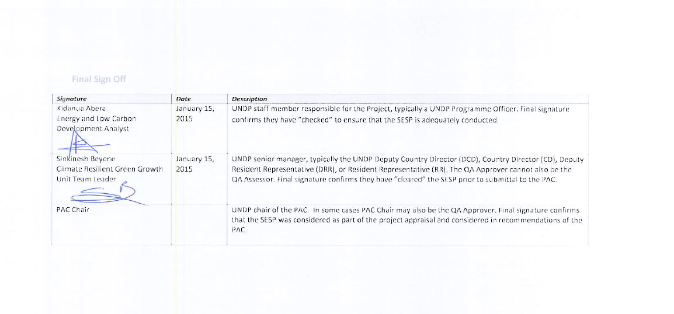

SESP Attachment 1. Social and Environmental Risk Screening Checklist

Checklist Potential Social and Environmental Risks
Principles 1: Human Rights | Answer  (Yes/No)
1. Could the Project lead to adverse impacts on enjoyment of the human rights (civil, political, economic, social or cultural) of the affected population and particularly of marginalized groups? | No
2. Is there a likelihood that the Project would have inequitable or discriminatory adverse impacts on affected populations, particularly people living in poverty or marginalized or excluded individuals or groups? | No
3. Could the Project potentially restrict availability, quality of and access to resources or basic services, in particular to marginalized individuals or groups? | No
4. Is there a likelihood that the Project would exclude any potentially affected stakeholders, in particular marginalized groups, from fully participating in decisions that may affect them? | No
5. Are there measures or mechanisms in place to respond to local community grievances? | No
6. Is there a risk that duty-bearers do not have the capacity to meet their obligations in the Project? | No
7. Is there a risk that rights-holders do not have the capacity to claim their rights? | No
8. Have local communities or individuals, given the opportunity, raised human rights concerns regarding the Project during the stakeholder engagement process? | No
9. Is there a risk that the Project would exacerbate conflicts among and/or the risk of violence to project-affected communities and individuals? | No
Principle 2: Gender Equality and Women’s Empowerment
1. Is there a likelihood that the proposed Project would have adverse impacts on gender equality and/or the situation of women and girls? | No
2. Would the Project potentially reproduce discriminations against women based on gender, especially regarding participation in design and implementation or access to opportunities and benefits? | No
3. Have women’s groups/leaders raised gender equality concerns regarding the Project during the stakeholder engagement process and has this been included in the overall Project proposal and in the risk assessment? | No
3. Would the Project potentially limit women’s ability to use, develop and protect natural resources, taking into account different roles and positions of women and men in accessing environmental goods and services?  For example, activities that could lead to natural resources degradation or depletion in communities who depend on these resources for their livelihoods and well being | No
Principle 3: Environmental Sustainability: Screening questions regarding environmental risks are encompassed by the specific Standard-related questions below
Standard 1: Biodiversity Conservation and Sustainable Natural Resource Management
1.1 Would the Project potentially cause adverse impacts to habitats (e.g. modified, natural, and critical habitats) and/or ecosystems and ecosystem services?  For example, through habitat loss, conversion or degradation, fragmentation, hydrological changes | No
1.2 Are any Project activities proposed within or adjacent to critical habitats and/or environmentally sensitive areas, including legally protected areas (e.g. nature reserve, national park), areas proposed for protection, or recognized as such by authoritative sources and/or indigenous peoples or local communities? | No
1.3 Does the Project involve changes to the use of lands and resources that may have adverse impacts on habitats, ecosystems, and/or livelihoods? (Note: if restrictions and/or limitations of access to lands would apply, refer to Standard 5) | No
1.4 Would Project activities pose risks to endangered species? | No
1.5 Would the Project pose a risk of introducing invasive alien species? | No
1.6 Does the Project involve harvesting of natural forests, plantation development, or reforestation? | No
1.7 Does the Project involve the production and/or harvesting of fish populations or other aquatic species? | No
1.8 Does the Project involve significant extraction, diversion or containment of surface or ground water?  For example, construction of dams, reservoirs, river basin developments, groundwater extraction | No
1.9 Does the Project involve utilization of genetic resources? (e.g. collection and/or harvesting, commercial development) | No
1.10 Would the Project generate potential adverse transboundary or global environmental concerns? | No
1.11 Would the Project result in secondary or consequential development activities which could lead to adverse social and environmental effects, or would it generate cumulative impacts with other known existing or planned activities in the area?  For example, a new road through forested lands will generate direct environmental and social impacts (e.g. felling of trees, earthworks, potential relocation of inhabitants). The new road may also facilitate encroachment on lands by illegal settlers or generate unplanned commercial development along the route, potentially in sensitive areas. These are indirect, secondary, or induced impacts that need to be considered. Also, if similar developments in the same forested area are planned, then cumulative impacts of multiple activities (even if not part of the same Project) need to be considered. | No
Standard 2: Climate Change Mitigation and Adaptation
2.1 Will the proposed Project result in significant greenhouse gas emissions or may exacerbate climate change? | No
2.2 Would the potential outcomes of the Project be sensitive or vulnerable to potential impacts of climate change? | No
2.3 Is the proposed Project likely to directly or indirectly increase social and environmental vulnerability to climate change now or in the future (also known as maladaptive practices)?  For example, changes to land use planning may encourage further development of floodplains, potentially increasing the population’s vulnerability to climate change, specifically flooding | No
Standard 3: Community Health, Safety and Working Conditions
3.1 Would elements of Project construction, operation, or decommissioning pose potential safety risks to local communities? | No
3.2 Would the Project pose potential risks to community health and safety due to the transport, storage, and use and/or disposal of hazardous or dangerous materials (e.g. explosives, fuel and other chemicals during construction and operation)? | No
3.3 Does the Project involve large-scale infrastructure development (e.g. dams, roads, buildings)? | No
3.4 Would failure of structural elements of the Project pose risks to communities? (e.g. collapse of buildings or infrastructure) | No
3.5 Would the proposed Project be susceptible to or lead to increased vulnerability to earthquakes, subsidence, landslides, erosion, flooding or extreme climatic conditions? | No
3.6 Would the Project result in potential increased health risks (e.g. from water-borne or other vector-borne diseases or communicable infections such as HIV/AIDS)? | No
3.7 Does the Project pose potential risks and vulnerabilities related to occupational health and safety due to physical, chemical, biological, and radiological hazards during Project construction, operation, or decommissioning? | No
3.8 Does the Project involve support for employment or livelihoods that may fail to comply with national and international labor standards (i.e. principles and standards of ILO fundamental conventions)? | No
3.9 Does the Project engage security personnel that may pose a potential risk to health and safety of communities and/or individuals (e.g. due to a lack of adequate training or accountability)? | No
Standard 4: Cultural Heritage
4.1 Will the proposed Project result in interventions that would potentially adversely impact sites, structures, or objects with historical, cultural, artistic, traditional or religious values or intangible forms of culture (e.g. knowledge, innovations, practices)? (Note: Projects intended to protect and conserve Cultural Heritage may also have inadvertent adverse impacts) | No
4.2 Does the Project propose utilizing tangible and/or intangible forms of cultural heritage for commercial or other purposes? | No
Standard 5: Displacement and Resettlement
5.1 Would the Project potentially involve temporary or permanent and full or partial physical displacement? | No
5.2 Would the Project possibly result in economic displacement (e.g. loss of assets or access to resources due to land acquisition or access restrictions – even in the absence of physical relocation)? | No
5.3 Is there a risk that the Project would lead to forced evictions? | No
5.4 Would the proposed Project possibly affect land tenure arrangements and/or community based property rights/customary rights to land, territories and/or resources? | No
Standard 6: Indigenous Peoples
6.1 Are indigenous peoples present in the Project area (including Project area of influence)? | No
6.2 Is it likely that the Project or portions of the Project will be located on lands and territories claimed by indigenous peoples? | No
6.3 Would the proposed Project potentially affect the rights, lands and territories of indigenous peoples (regardless of whether Indigenous Peoples possess the legal titles to such areas)? | No
6.4 Has there been an absence of culturally appropriate consultations carried out with the objective of achieving FPIC on matters that may affect the rights and interests, lands, resources, territories and traditional livelihoods of the indigenous peoples concerned? | No
6.4 Does the proposed Project involve the utilization and/or commercial development of natural resources on lands and territories claimed by indigenous peoples? | No
6.5 Is there a potential for forced eviction or the whole or partial physical or economic displacement of indigenous peoples, including through access restrictions to lands, territories, and resources? | No
6.6 Would the Project adversely affect the development priorities of indigenous peoples as defined by them? | No
6.7 Would the Project potentially affect the traditional livelihoods, physical and cultural survival of indigenous peoples? | No
6.8 Would the Project potentially affect the Cultural Heritage of indigenous peoples, including through the commercialization or use of their traditional knowledge and practices? | No
Standard 7: Pollution Prevention and Resource Efficiency
7.1 Would the Project potentially result in the release of pollutants to the environment due to routine or non-routine circumstances with the potential for adverse local, regional, and/or transboundary impacts? | No
7.2 Would the proposed Project potentially result in the generation of waste (both hazardous and non-hazardous)? | Yes
7.3 Will the proposed Project potentially involve the manufacture, trade, release, and/or use of hazardous chemicals and/or materials? Does the Project propose use of chemicals or materials subject to international bans or phase-outs?  For example, DDT, PCBs and other chemicals listed in international conventions such as the Stockholm Conventions on Persistent Organic Pollutants or the Montreal Protocol | No
7.4 Will the proposed Project involve the application of pesticides that may have a negative effect on the environment or human health? | No
7.5 Does the Project include activities that require significant consumption of raw materials, energy, and/or water? | No

Annex 7: Co-Finance Letters
1. UNDP
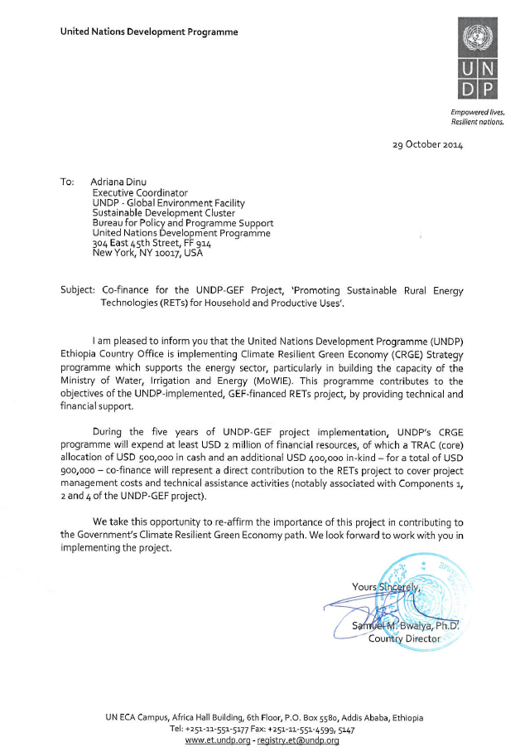

2. UNCDF
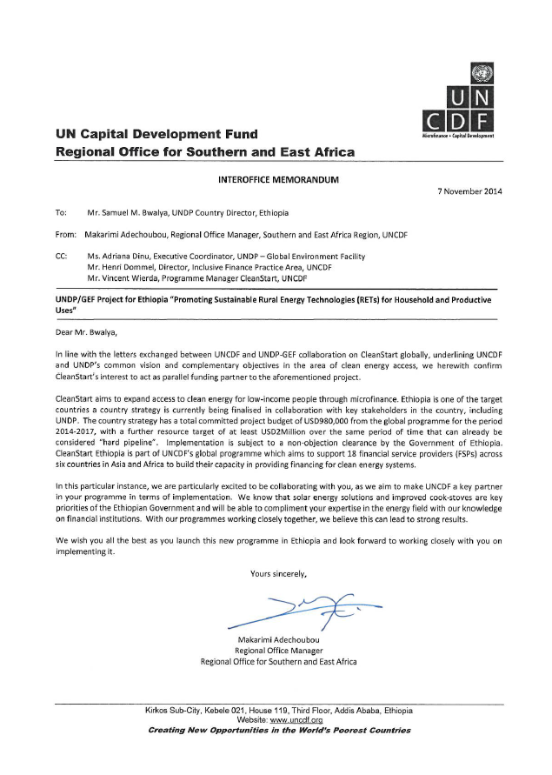

3. MoWIE

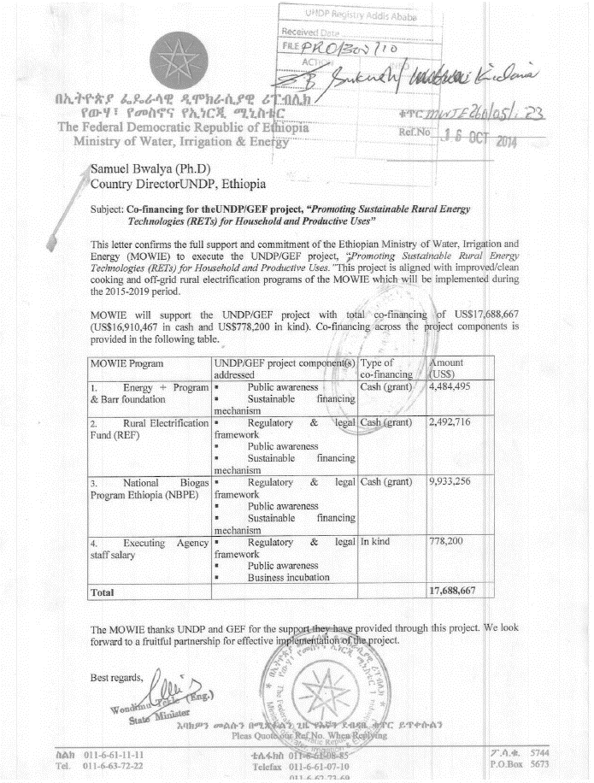

4. RET ENTERPRISES
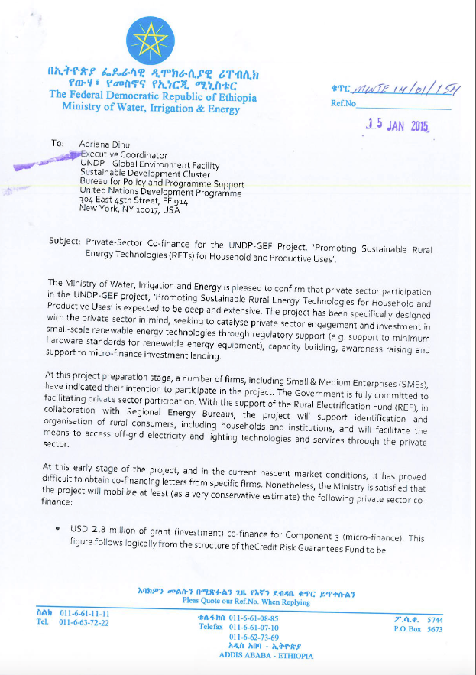

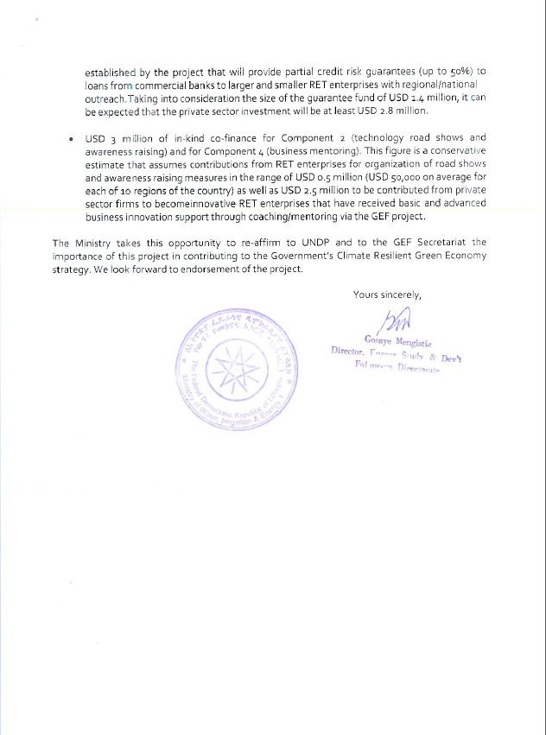

5. MoFED
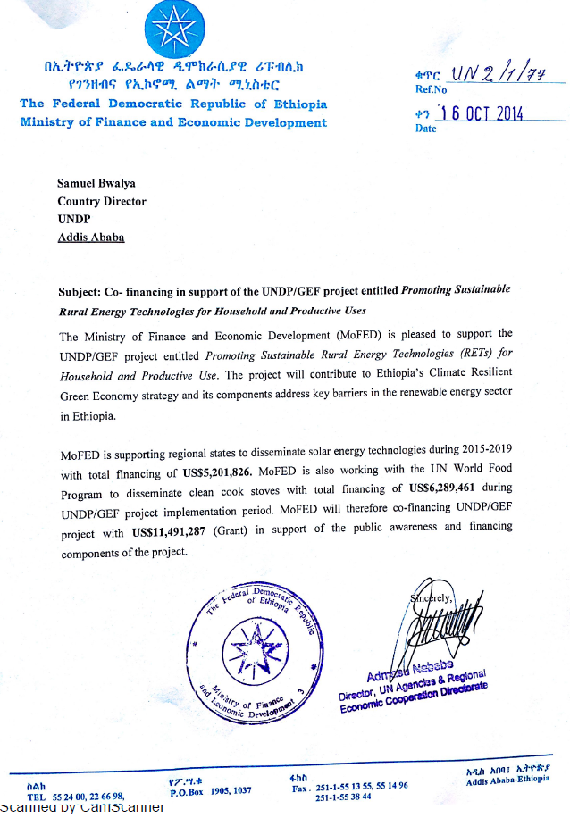

6. DBE
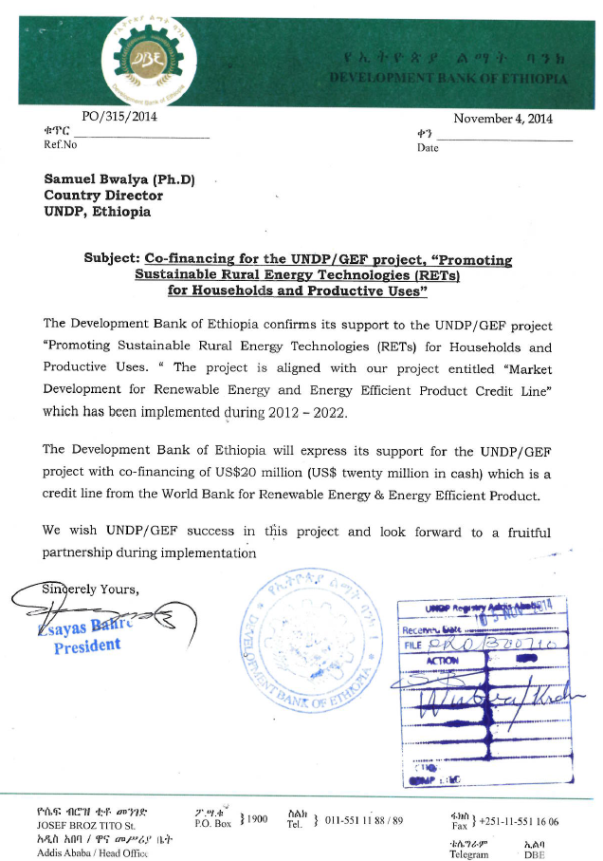

7. FeMSEDA
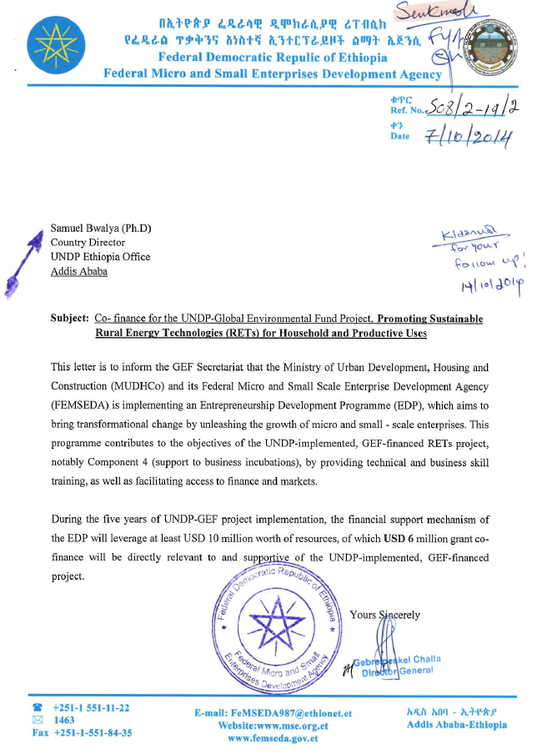

8. HIVOS
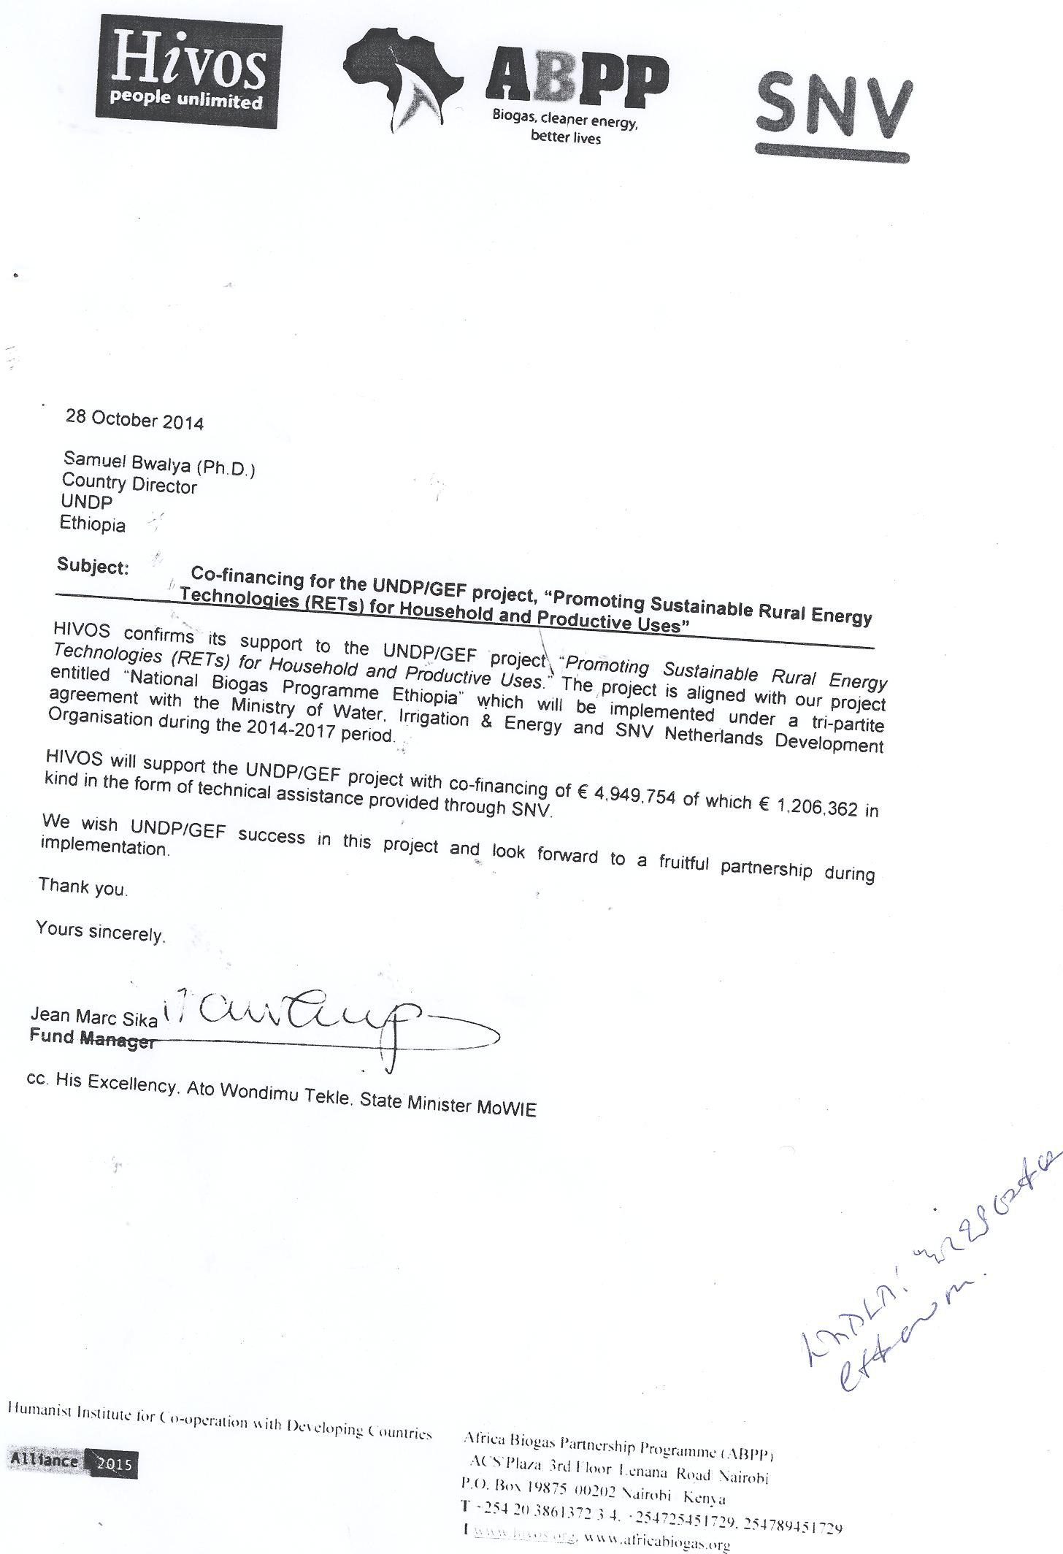

Annex 8: Letter of Agreement between UNDP and MoWIE

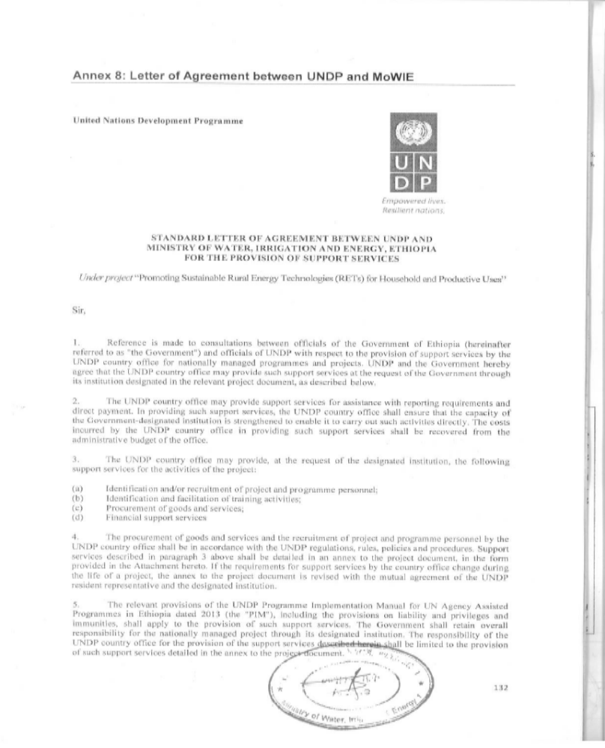

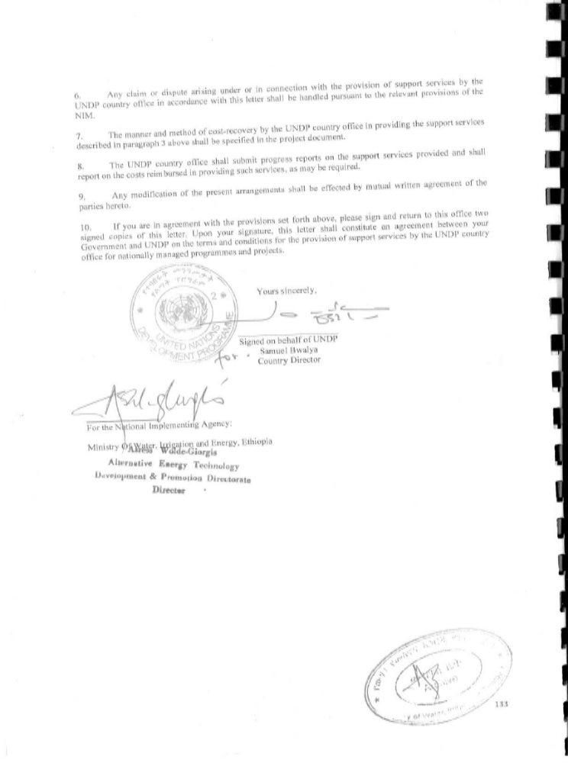

Attachment 1

DESCRIPTION OF UNDP COUNTRY OFFICE SUPPORT SERVICES
- In accordance with the provisions of the letter of agreement and the project document, the UNDP country office shall provide support services for the project “Promoting Sustainable Rural Energy Technologies (RETs) for Household and Productive Uses” as described below.
- Support services to be provided:
Support services | Schedule for the provision of the support services | Cost to UNDP of providing such support services (where appropriate) | Amount and method of reimbursement of UNDP (where appropriate)
Services related to procurement (including but not limited to):  Procurement of goods  Procurement of services  - Consultant recruitment  - Advertising  - Short-listing & selection  - Contract issuance | Throughout project implementation when applicable | As per the pro-forma costs:  50 days over 60 months of GS 5 Procurement Assistant: $4,000  15 days over 60 months of NOB Procurement Manager: $2,000 | UNDP will directly charge the project upon receipt of request of services from the Implementing Partner (IP)
Services related to finance (including but not limited to):  - Payments | Ongoing throughout implementation when applicable | As per the pro-forma costs:  118 days over 60 months of GS 5 Finance Associate: $12,000  15 days over 48 months of NOB Finance Manager: $2,000 | As above
Total |  | $ 20,000

- For procurement services, the Implementing Partner and UNDP will agree on the needed services in advance on a quarterly basis.
- UNDP service fees will be according to UN Universal Price List (UPL).

Annex 9: Letter of Endorsement from GEF Operational Focal Point

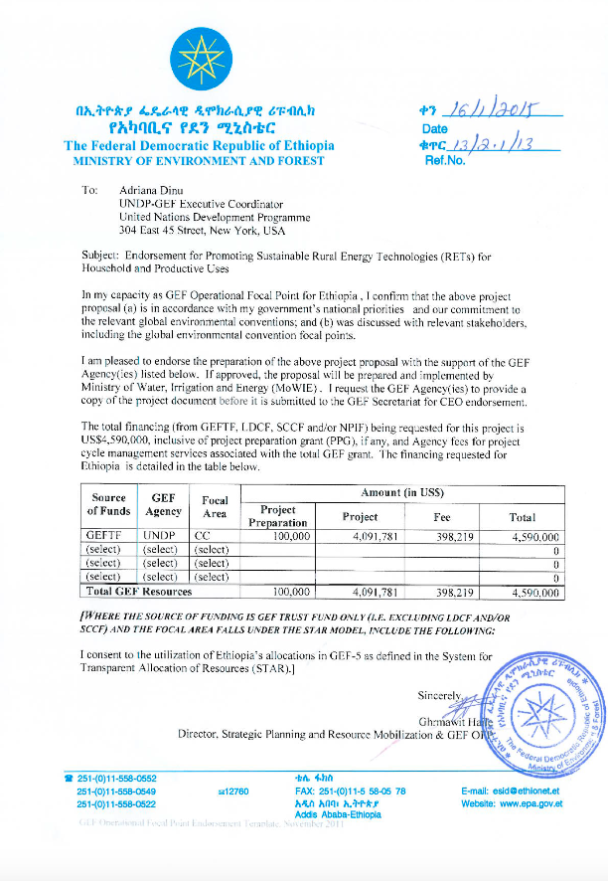

For UNDP-supported, GEF-funded projects as this includes GEF-specific requirements.
See Part I: Situation Analyses, Section IV. Stakeholder Analysis as well as Annex 1: Additional Stakeholder Analysis.
1988-2006: World Bank financed Energy I project, which developed and disseminated the Lakech and Mirt stoves. 1988/89 was also the year when the first rural village solar PV system was installed (a 31.5 kWp PV system installed by the Ministry of Mines and Energy).
http://www.uncdf.org/en/cleanstart
The MFIs receive funding for biogas and other RET products from the Development Bank of Ethiopia (DBE); DBE in receives this funding from a World Bank-supported project, the Scaling-up Renewable Energy Project (SREP).
https://hivos.org/
See http://www.ethiopiacic.org/
InfoDev, a global multi-donor programme in the World Bank Group, assists entrepreneurs to secure appropriate early-stage financing; convening entrepreneurs, investors, policy-makers, mentors and other stakeholders for dialogue and action. See www.infodev.org.
These figures are based on reports on sales volumes for some of the main importers and estimates for the remainder. Sales and value added for distributors and retailers are based on sales to distributors and their margins.
A Solar Lighting report estimated a moderate growth of 45% compounded annual growth rate for 2009-2015 as a base case scenario [38].
Total direct GHG emission reductions are calculated to be 2 Mt CO₂e.
Together, Components 2 and 3 are expected to result in an additional 200,000 units of small-scale solar technologies and the dissemination of an additional 590,000 improved cook-stoves.
http://cdm.unfccc.int/ProgrammeOfActivities/poa_db/5TE6HLP1Z4KOABSDI873YQCFGXW2RM/view
The average household expenditure for the lowest quintile was USD 44.79 in the Household Consumption and Expenditure Survey 2010/11 [43]. Of this expenditure, 21% was spent on fuel and power. With an average inflation rate of approximately 7% (over 3 years), this translates into actual expenditure of approximately USD 55 per month.
Development Agents are assigned extension workers in the rural areas at Kebele level who promote modern agricultural practices and inputs.
CleanStart is currently in the process of raising additional funding from its existing set of bilateral donors and funding partners.
These arrangements will also include product assessment criteria such as quality (standards) and environmental friendliness (waste collection concept).
Financial support to RET enterprises will only be given if the applicants, particularly from the solar sector, provide a concept for after-sales services, including waste collection and safe disposal or recycling.
http://unfccc.int/files/meetings/cop_15/copenhagen_accord/application/pdf/ethiopiacphaccord_app2.pdf.
Amounts in brackets are total public sector and additional financing requirements for the mid-2014 – end-2020 period.
Objective (Atlas output) monitored quarterly ERBM and annually in APR/PIR
All outcomes monitored annually in the APR/PIR. It is highly recommended not to have more than 4 outcomes.
Summary table should include all financing of all kinds: GEF financing, cofinancing, cash, in-kind, etc...
RET enterprises are expected to invest at least USD 2.8 million into energy technologies (backed by the project-supported guarantee fund under Component 3), while in-kind contributions for awareness-raising measures/road shows (Component 2) and enrolment into business advisory services and advanced business mentoring is expected in the amount of USD 3 million. These figures are conservative. Additional private-sector resources mobilised in support of the project will be reported as leveraged finance in subsequent PIRs.
National Bank of Ethiopia, “Annual Report 2012-13”, 2014
Source: Association of Ethiopian Microfinance Institutions (AEMFI), June 2014.
Source: Association of Ethiopian Microfinance Institutions (AEMFI), June 2014.
Several TCs are formed under each TC category (e.g. TC 49). TC 49 may have, for example, a TC working on standards for tractors, another TC working on forest equipment, still another TC working on biomass stoves.
http://cdm.unfccc.int/ProgrammeOfActivities/poa_db/5TE6HLP1Z4KOABSDI873YQCFGXW2RM/view
TATS Solar Lantern Programme of Activities, PoA 9071, Kenya, Reg. Date 31.12.2012
A Solar Lighting report estimated a moderate growth of 45 % compounded annual growth rate for 2009-2015 as a base case scenario [38]
Assuming 60% for solar products (i.e. USD 4.2 million; @ unit price of USD 40 about 105,000 units can be sold, assuming a turnover factor of at least 3 times of the investment of the sold units this accounts for approx. 300,000 solar products for direct post-project investment) and 40% for ICS (i.e. USD 2.8 million; @ unit price of USD 15 about 187,000 units can be sold; assuming a turnover factor of at least 3 times of the investment of the sold units this accounts for approx. 560,000 ICS).
Prohibited grounds of discrimination include race, ethnicity, gender, age, language, disability, sexual orientation, religion, political or other opinion, national or social or geographical origin, property, birth or other status including as an indigenous person or as a member of a minority. References to “women and men” or similar is understood to include women and men, boys and girls, and other groups discriminated against based on their gender identities, such as transgender people and transsexuals.
In regards to CO_{2,} ‘significant emissions’ corresponds generally to more than 25,000 tons per year (from both direct and indirect sources). [The Guidance Note on Climate Change Mitigation and Adaptation provides additional information on GHG emissions.]
Forced evictions include acts and/or omissions involving the coerced or involuntary displacement of individuals, groups, or communities from homes and/or lands and common property resources that were occupied or depended upon, thus eliminating the ability of an individual, group, or community to reside or work in a particular dwelling, residence, or location without the provision of, and access to, appropriate forms of legal or other protections.

